Annex 1: Stockpile Elimination Report Brief Motivation of Decisions of final destruction

Table of Contents

Page

- Introduction……………………………………………………………………………………..3

- Export of waste versus treatment in Vietnam…………………………………………………..3

- Why is destruction of waste in Vietnam the preferred option?....................................................3

- Recommended strategy for destruction of the POPs pesticides...................................................4

- Annexes…………………………………………………………………………………………6

Annex 1: Visit to Nam Son Waste Treatment Complex near Hanoi ………………………6

Annex 2: Information of incinerator owned by the Ministry of Defence…………………..10

Annex 3: Visit Holcim Cement kiln in Hon Chong and Incinerators of the Green Environment Company in Binh Chanh (HCMC) and Binh Duong……………………………………….14

Annex 4: Information collected Pesticides Treatment Plant in Long An based on Fenton Reaction developed within the GEF Small Grant Project…………………………………..23

Introduction

This summary report gives a short overview of the considerations made on the recommendation for final destruction of obsolete and POPs pesticides waste. In order to make these recommendations a number of facilities in Vietnam have been visited and for one installation the information has been gathered and briefly evaluated based on an exchange with the inventor.

Export of waste versus treatment in Vietnam
The issue if all pesticides waste is collected, repacked and treated in Vietnam or shipped overseas and treated in a dedicated hazardous waste incinerator is of the highest importance for Vietnam.

The export option which is a kind of “pack and go” is often a favourable solution if there are no feasible options for treatment in the country or in the short run existing installations could be modified for the purpose. Further has to be taken into account if the use and modifications of available installations will and the process of treatment works and the organizational impact have definitely a major contribution to permanent capacity building and environmental sustainable management process in Vietnam after the project has been completed. If such conditions are fulfilled then treatment in Vietnam should be definitely the preferred option.

Why is destruction of waste in Vietnam the preferred option?

How is the situation in Vietnam?
Vietnam has certain experiences in the field of pesticides repackaging, transport and destruction, as in the last years around 150 tons of POPs and illegal pesticide have been destroyed at the incineration plant owned by the Ministry of Defence in the northern Backan province.

Secondly from several locations also pesticides waste has been transported to and destroyed at the Green Environment Company in Binh Chanh (HCMC) and Binh Duong (how many tons?). Finally with the support of GEF funds, a new installation has been established in Long An. The process consists of two steps:
1. Chemical-biological degradation of pollutants in water media and
2. Incineration of rinsed packages by a two stage incinerator with an air control device.

Further tests, in 2005 at the cement kiln at HOLCIM, were successful in the destruction of Fenobucarb and Fipronil. The insecticides were fed to the main burner of the kiln at a rate of 2,000 litres per hour and approximately 40,000 litres were co-processed and safely destroyed in less than 20 hours. The insecticides were solved in a mix of aromatic solvents and the energy content of the mix substituted the equivalence of 2.5 tonnes of coal; i.e. the destruction also revered the energy in the toxic waste. the destruction and removal efficiency was measured to be better than 99.999997% and 99.999985% for Fenobucarb and Fipronil respectively and showed that the destruction had been complete and irreversible, i.e. no new formation of dioxins, furans or PCB’s i.e. all analysis result for PCDD/F’s, HCB and dioxin like PCB’s were below the detection limit.

For a number of options a comprehensive assessment has been made by visits or if not possible by phone calls and collection of the necessary information.

Conclusions
With the present development in the hazardous waste treatment market and the achievements made till present and the expected progress in the coming years, it is strongly recommended to treat the POPs and obsolete pesticides in Vietnam. A major issue is that there is already a lot of capacity built in Vietnam and it is now the issue to bring that capacity on the necessary level of Environmental Sound Management. It is strongly believed that by executing all treatment works in Vietnam, this project will give a strong stimulation to the present actors to improve the level of management and treatment and thus be setting new and long-term standards in Vietnam on hazardous waste treatment.

Recommended strategy for destruction of the POPs pesticides

As can be seen, 5 options have been taken into account for treatment in Vietnam:

Incinerator owned by the Ministry of Defence in the Backan province

Nam Son Waste Treatment Complex near Hanoi

Pesticides Treatment Plant in Long An based on Fenton Reaction

Green Environment Company Incinerators in Binh Chanh (HCMC) and Binh Duong

Holcim Cement kiln in Hon Chong, Kien Giang.

Ad 1. Incinerator owned by the Ministry of Defence in the Backan province

In spite of the fact that the mobile incineration plan has treated 150 tons of obsolete pesticides and thus has a considerable numbers of years of experience with the handling of obsolete pesticides, the plant and the management of the plant is not fulfilling the criteria for environmental sound management of pesticides waste. There are a lot of doubts on the sustainability of this plant, specifically due to fears for strong dioxin emissions and therefore not suitable for treatment of POPs and obsolete pesticides within the framework of this project. Further details can be seen in Annex 1.

Ad 2. Nam Son Waste Treatment Complex near Hanoi

Till present no pesticides waste has been treated at Nam Son. Both incinerators are not suitable for the treatment of pesticides and the flue gas treatment is doubtful. No continuous monitoring activities are executed. The available method for stabilization cannot be applied within the framework of the Stockholm Convention. See also Annex 2.

Ad 3. Pesticides Treatment Plant in Long An based on Fenton Reaction

This recent plant is an interesting development and in the long run should be able to relieve some of the problems of POPs and obsolete pesticides. However the discussions with the inventor indicate that there are not yet enough experiences related to DRE and treatment of POPs pesticides.

Ad 4. Green Environment Company Incinerators in Binh Chanh (HCMC) and Binh Duong

Green Environment Company has been treating obsolete and POPs pesticides over the last years. It looks that the plant is also in the process of improving works and final cleaning steps, but although improvements are taking place, monitoring of the process and data collection and comparative analyses have not been made. In order to participate in the project independent monitoring during the treatment of obsolete pesticides and specifically DDT and other chlorinated ones are a must. Only on the basis of high quality data the Incinerators can be incorporated. For further details see Annex 4.

Ad 5. Holcim Cement kiln in Hon Chong

The HOLCIM cement kiln south west of Ho Chi Minh City is a modern cement kiln and during the year 2005 the first tests were performed successfully for pesticides treatment and results were based on a full monitoring programme and the guidance of an international expert. Based on these experiences and further treatments a test and further treatment is recommended if the test is successful at this plant under similar conditions and the same stringent monitoring programme.

Conclusion:

The evaluation is only limited and based on collection of data, very short visits and telephone conversations.
Three installations being:

Incinerator owned by the Ministry of Defence in the Backan province

Nam Son Waste Treatment Complex near Hanoi

Pesticides Treatment Plant in Long An based on Fenton Reaction

cannot be considered for the project.

The Pesticides Treatment Plant in Long An based on Fenton Reaction, which is only recently developed and functioning, misses the necessary experience for chlorinated pesticides, but it is expected that over the next years this experience will increase and the necessary proof according to international standards by independent international supervisors and monitoring and the various independent and certified laboratories will be brought forward.

The Green Environment Company Incinerators in Binh Chanh (HCMC) and Binh Duong lacks the necessary tests and verification according to international standards by independent international supervisors and monitoring and the various independent and certified laboratories. If the plant can prove to fulfil the necessary international conditions, then this plant could be considered in the future.

Only the Holcim Cement kiln in Hon Chong, Kien Giang has been able to perform for pesticides treatment with results based on a full monitoring programme and the guidance of an international expert. Based on these experiences and further treatments a test and further treatment is recommended if the test are successful at this plant under similar conditions and the same stringent monitoring programme.

5. Annexes

5.1 Annex 1: Visit to Nam Son Waste Treatment Complex near Hanoi

Visit by John Vijgen and Vu Huyen Phuong

Short introduction of complex
Visit to Stabilization hall
Visit to 2 incinerators
Water treatment plant and sludge treatment

Nam Son Waste Treatment Complex belongs to Urban Environment Limited Co. (URENCO), which used to be a governmental company, is now transferred to be a one-member limited liability company.

The business registration certification of URENCO: No. 0104000215 dated 17/01/2007 (transfer to be one-member limited liability company). Scope of business includes transportation and treatment service of industrial and hazardous waste in all provinces of Vietnam.

The registration form for treatment and destruction of hazardous waste has been submitted to VEPA for issuing permit.

Nam Son Waste Treatment Complex is located in Soc Son District - suburb of Hanoi city, 46km far away from center of Hanoi city. Industrial waste and hazardous waste are collected, stored, pre-treated and final-treated in the area of 5.15 ha. Pre-treatment is 5000m² in area and incinerators cover an area of 2000 m².

Procedure for Waste is transported to plant by specialized vehicles and registered before

Incinerator in Nam son (Urenco Hanoi)
- Capacity: 750-800 kg/h
- Temperature of the primary combustion chamber: 750-850ºC
- Temperature of the secondary combustion chamber: 950-1050ºC
- Retention time in the secondary chamber: 1 sec
- Temperature of flue gas: 120-140ºC
- Air emission control device is included:
o heat recovery tower
o wet (water) scrubber for dust removal (efficiency of 70-80%)
o demister
o active carbon adsorption tower.

Nam Son has not been treating any obsolete and or illegal pesticides. The company is also not very much interested in incineration of pesticides as the stabilization of hazardous wastes is a much more economical solution for the company

Overview of photos taken during visit:

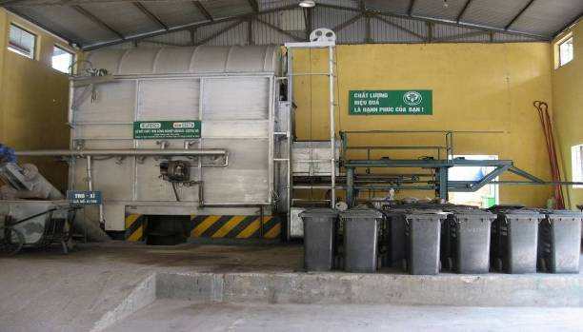
Impression main incinerator, on left side recovery of ashes, on right side feeding system by means of small hoist

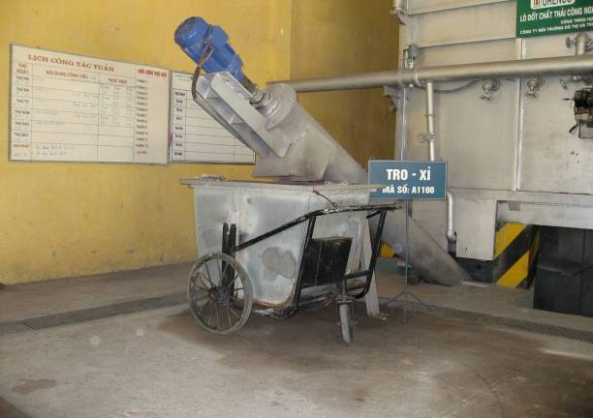
Continuous ash recovery unit

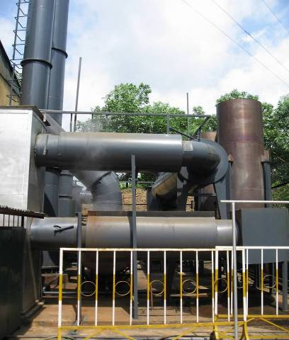
Flue gas treatment and stack

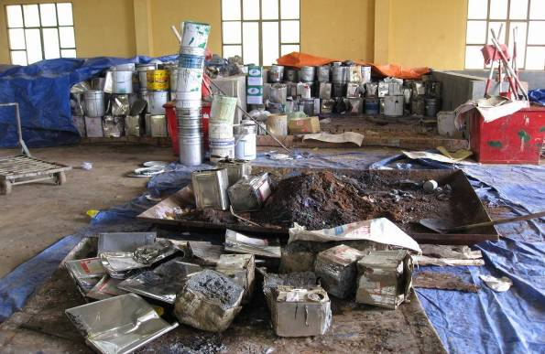
Mixing of hazardous waste for stabilization purposes

5.2 Annex 2: Information of incinerator owned by the Ministry of Defence

Visit made by Center for environmental treatment technology

Two-stage mobile incinerator

Pesticide destruction by mobile incinerator is a project of Ministry of Defence. The project was appraised by VEPA and Ministry of Defence. Now, the incinerator has been operating in military area of Backan province for military waste destruction.

- Technology: pesticide destruction at high temperature by multi-stage incinerator with presence of additives and catalysts.

Obsolete, banned pesticides

Obsolete, banned pesticides

Pesticide Powder
Liquid Pesticide
Pesticide and solvent
Packages

Mixing with additives and catalyst
Pre-treatment
Pre-treatment
Pre-treatment

Two-stage incineration
Incineration
Incineration

Stabilization
Waste water treatment
Absorption
Bury
Disposal
Emit to the air

- Amount of destructed pesticide: approximately 150 tons

- On-site incineration at some provinces:
Incineration of illegal imported pesticide in Langson province, December 1999
Incineration of obsolete pesticide in Langson province, March-April, 2002
Incineration of obsolete pesticide in Hanoi, October 2002
Incineration of obsolete pesticide in Sonla province, December 2001
Incineration of obsolete pesticide in Vinhphuc province, December 2001
Incineration of obsolete pesticide in Hoabinh province, January 2002
Incineration of obsolete pesticide in Hatay province, November 2002
Incineration of obsolete pesticide in Hagiang province, January 2001
Incineration of obsolete pesticide in Backan province, May 2002
Incineration of obsolete pesticide in Thainguyen province, January 2002
Incineration of obsolete pesticide in Hungyen province, December 2002
Incineration of obsolete pesticide in Haiphong province, December 2002
Incineration of obsolete pesticide in Haiduong province, December 2003
Incineration of obsolete pesticide in Quangninh province, December 2003
Incineration of obsolete pesticide in Bacgiang province, December 2000
Incineration of obsolete pesticide in Bacninh province, February 2003
Incineration of obsolete pesticide in Thaibinh province, November 2002
Incineration of obsolete pesticide in Hanam province, December 2001
Incineration of obsolete pesticide in Nghean province, March 2003
Incineration of obsolete pesticide in Thanhhoa province, September 2003
Incineration of obsolete pesticide in Danang city, 2002
Incineration of obsolete pesticide in Quanngai province, 2002
Incineration of obsolete pesticide in Binhdinh province, 2002
Incineration of obsolete pesticide in Thuathien-Hue province, February 2004

- Main pesticides for destruction:
- Obsolete pesticide: (still remains since war time): DDT, Lindane, Wofatox
- Illegally imported pesticides: Monitor

- Operation parameters:
Capacity: 20 kg/h
Temperature of primary chamber: 500ºC
Temperature of secondary chamber: 1000ºC
Catalyst: Cu2O/AC 5%
Additive: Activated carbon 30%

- Cost for destruction of pesticide (including collection, transportation and incineration): 40,000,000 VND - 50,000,000 VND

- Disadvantages of incinerator: Pesticide incineration, especially organic chlorinated pesticides causes strong corrosion of the equipment and wall of incinerator. Though the wall of the incinerator is made of inox 30mm thick, but after each treatment of 20 tons of pesticides the incinerator has to be replaced by a new one. This had led to extreme high costs for pesticide destruction.

- Flue gas cleaning system: filter tower using water vapour film and absorption solution treats Flue gas. Used absorption solution is recycled, approximately 1-2m³ of absorption solution for each 20 tons of pesticides destroyed.

- Amount of slag and ash is approximately 0.1 - 0.2 m³/ ton of pesticide. Slag and ash is stabilized by CaO and kept at least during three months for monitoring.

- Analytical results during burning of DDT and CS

Order | Name of congeners | TEQ
 |  | M1 | M2 | M3 | M4 | M5
 | 2,3,7,8- TCDD | 0 | 0 | 0 | 0 | 0
 | 1,2,3,7,8-PeCDD | 0 | 0 | 0 | 0 | 0
 | 1,2,3,4,7,8- HxCDD | 5.25 | 39.5 | 1.29 | 3.25 | 0
 | 1,2,3,6,7,8-HxCDD | 4.23 | 122.1 | 0.98 | 4.21 | 0
 | 1,2,3,7,8,9- HxCDD | 6.19 | 109.2 | 0.13 | 6.16 | 0.74
 | 1,2,3,4,6,7,8- HpCDD | 1.697 | 52.530 | 0.248 | 1.697 | 0
 | OCDD | 0.048 | 0.5468 | 0.0011 | 0.0483 | 0
 | 2,3,7,8-TCDF | 32.25 | 16.54 | 6.96 | 2.40 | 0.28
 | 1,2,3,7,8-PeCDF | 4.295 | 0 | 0 | 0 | 0
 | 2,3,4,7,8-PeCDF | 109.90 | 0 | 0 | 0 | 0
 | 1,2,3,4,7,8-HxCDF | 109.42 | 21.38 | 11.77 | 2.70 | 0
 | 1,2,3,6,7,8-HxCDF | 32.93 | 5.92 | 3.26 | 1.20 | 0
 | 1,2,3,7,8,9-HxCDF | 1.94 | 0.78 | 0.27 | 0 | 0
 | 2,3,4,6,7,8-HxCDF | 34.63 | 6.36 | 3.65 | 0 | 0
 | 1,2,3,4,6,7,8-HpCDF | 21.71 | 4.79 | 2.23 | 0.84 | 0
 | 1,2,3,4,7,8,9- HpCDF | 1.063 | 0.592 | 0.146 | 0 | 0
 | OCDF | 0.0717 | 0.0319 | 0.0127 | 0.0108 | 0
 | TEQ of 2,3,7,8-TCDD and 1,2,3,7,8-PeDD (Pg/m3) | 0 | 0 | 0 | 0 | 0
 | TEQ of PCDD and PCDF (Pg/m3) | 373.7247 | 58.8116 | 30.9478 | 7.1562 | 1.02

Note:
- M1: sample took on the top of the stack when burning DDT with presence of additives and catalysts
- M2: sample took at distance 100m far away from incinerator (following wind) when burning DDT with presence of additives and catalysts
- M3: sample took at distance 100m far away from incinerator (following wind) when burning CS with presence of additives and catalysts
- M4: sample took at distance 500m far away from incinerator (following wind) when burning DDT with presence of additives and catalysts
- M5: sample took at distance 500m far away from incinerator (following wind) when burning CS when burning with presence of additives and catalysts
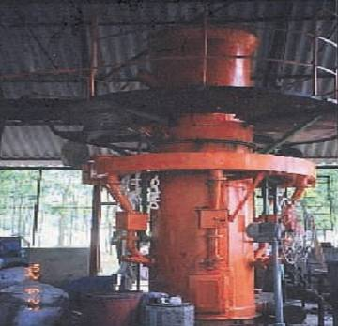

Impression of incinerator

5.3 Annex 3: Visit Holcim Cement kiln in Hon Chong and Incinerators of the Green Environment Company in Binh Chanh (HCMC) and Binh Duong
Brief report on the mission:
Name: Mr. Do Thanh Bai
Position: Local consultant in POP project
Date: 24, 25, 26 27 June, 2007
Site: HCMC, Binh Duong and Hon Chong-Kien Giang

Mission programme:

- 24th June: in HCMC
- 25th June:
  - 09:00 – 11:00 Work Mr. Paul Hayes, Business Development Director of Holcim cement company on the existing procedures and issues for hazardous wastes handling including obsolete pesticides
  - 12:00 – 16:00 Visit two incinerators of Green Environment Company in Binh Chanh (HCMC) and Binh Duong that have been using their incinerators for disposing obsolete pesticides
  - 17:00 going to Hon Chong (Kien giang) by car
- 26th June: 8:00 – 13:00 Visit Holcim cement kiln (including hazardous waste receiving station, storage and pre-treatment sites) in Hon Chong
- 26th June: 15:00 Come back HCMC by car
- 27th June: 09:00 – 11:00 Work with the institute on catalysis incineration
- 27th June: 12:00 Return to Hanoi.

The facts found:

- Regarding Holcim cement kiln

For Holcim, the wastes have been fed into the system at three locations of the kiln:
- Directly in the heart of rotary kiln (high temperature zone)
- At the mount of rotary kiln (feeding site)
- At the pre-heating towers (different sites depending on types of wastes)

- Holcim has a good organization and financial mechanism for receiving and disposing hazardous wastes with their cement kiln. The hazardous waste have been received by Holcim at Cat Lai port: Cat Lai has an area of 60 ha and located in HCMC. Cat Lai Port last year received more than one million twenty-foot-equivalent units (TEU), making up 51% of total throughput in TEUs in southern ports, and nearly 40% of the country's total. Cat Lai Port's output in first four months of this year was 460,000 TEUs, and is expected to amount to 1,400,000 TEUs this year. In Cat Lai port, Holcim has had their dedicated ships to transport hazardous wastes to Hon Chong port. The hazardous wastes are transported to Cat Lai port by hazardous waste owners from the different sources and are received by Holcim at Cat Lai. Holcim has provided special packages for the wastes. These packaged wastes then are stored in the special containers of the ships.
- At Holcim, the wastes are stored in different storing sites depending types of wastes
- Wastes then will be conveyed to different location of the kiln: solid raw material tanks (pre-heating chambers) or have been directly injected into the combustion zones of the kiln (liquid wastes).
- The wastes have been re-classified by Holcim technical staff before being put into the kiln.
- The storing sites seem not have good design or lay-outs for different wastes categories, as well as not have good facilities to manage leaks.
- The workers directly work with the wastes preparation have been normally contracted with short term services, and they normally are trained by technical staff of Holcim
- Actually, Holcim have had two activities for disposal of pesticides:
    - Trial test done with 40 m³ obsolete pesticides Fenobucarb and Fipronil (not chlorinated ones) provided by Bayer Company and the disposal was supervised by NEA and two international organizations.
    - A contract with Kien Giang Custom Office: to dispose illegally imported pesticides (see detailed list further on)
  - The actual costs have not been calculated for pesticides.
  - The transportation cost from Cat Lai to Holcim is about 25-30 USD/ton.
  - If there is contract, Holcim is ready to provide standardized packages.

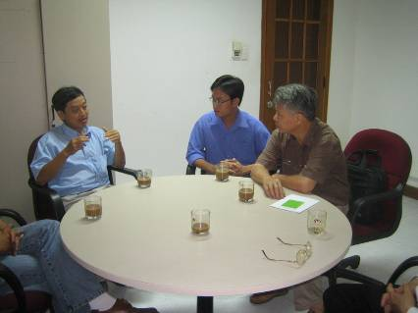
(Discussion with technical staff of Holcim cement kiln in Hon Chong, Kien Giang)

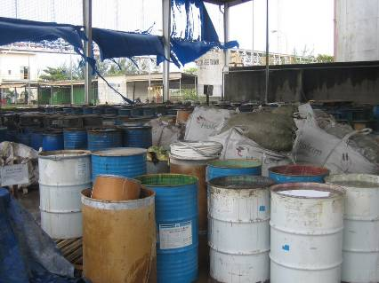
(The site for receiving and re-classifying wastes in Holcim)

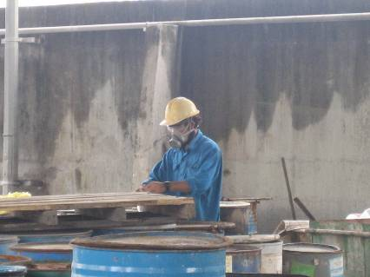
(Local worker is handling hazardous wastes in the wastes receiving site)

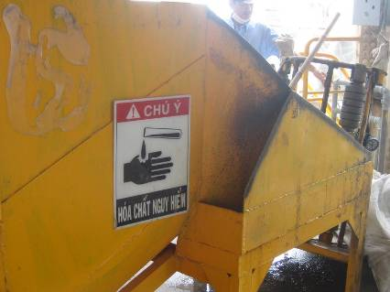
(Position to feed hazardous wastes directly into the kiln)

- Regarding the incinerators of Green Environment Company

Scheme of waste incineration in Green Environment Company in Binh Chanh:

Overview on data on Incinerator in Binh Chanh (HCMC):
- Capacity: 300kg/h
- Temperature of the primary combustion chamber: 600-800ºC
- Temperature of the secondary combustion chamber: >1100ºC
- Retention time in the secondary chamber: 2.5 sec
- Temperature of flue gas: <200ºC
- Air emission control device is included:
- heat recovery tower (cooling water is cooled down by ice if necessary)
- alkaline solution scrubber (two scrubbers in serial connection) for dust and acid gases (SOx, NOx, HCl...) removal
- demister
- active carbon adsorption tower.

Incinerator in Binh Duong has not been operating.

- The Green Environment Company has been operating incinerators for hazardous wastes in general and pesticides in particular. It could be seen as biggest unit in Vietnam to collect and dispose obsolete pesticides. There are facilities associated to their incinerator (located in Binh Chanh- HCMC) such as: pre-treatment, solvents distillation for recovery, incinerator emission treatment (scrubbers, adsorption, wastewater treatment)
- Green Environment Company now is investing to build a bigger incinerator designed for using air quenching and catalysts to completely remove toxicants in the flue gases from incinerators.
- All the facilities for collecting and packaging obsolete pesticides to transport to the incinerators have been provided by Green Environment Company. The actual costs for collection, transportation and incineration have varied case by case.
- It is informed that the technical staff of the company in charge of handling pesticides is trained by the related local experts.
- The documents dealing with pesticides disposing by incinerators will be submitted to the POP office as requested.

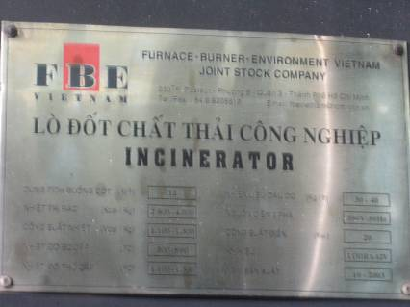
(Incinerator of Green Environment Company in Binh Chanh- HCMC)

\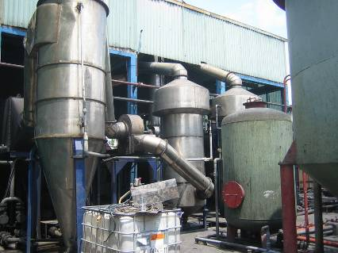
(A part of Emission treatment devices of the Binh Chanh incinerator)

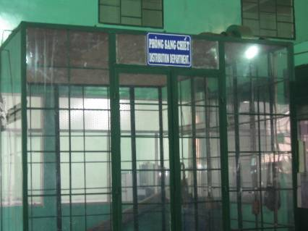
(pre-treatment before disposing in incinerator)

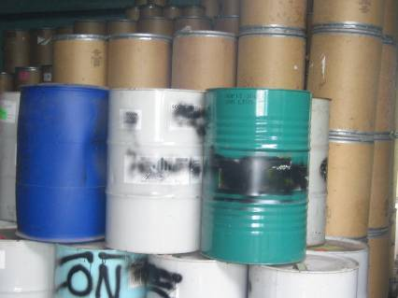
( packages for pesticides handling)

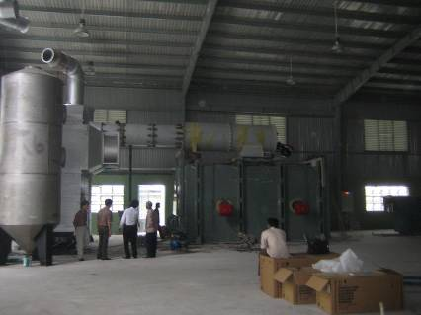
(The new incinerator in Binh Duong has been installed together with solvent distillation workshop)

- Possibility to use catalyst for incinerating pesticides:

A group of Vietnamese scientists of the Institute of New Materials in HCMC is now making a contract with Green Environment Company to apply their catalyst in industrial scale for a complete removal of chlorinated compounds from the burning emission. It is necessary to verify these results. This catalyst will be installed in the incinerator built in Binh Duong. In this incinerator, properly designed emission control devices (wet scrubbers, cyclones, air quenching, temperature control…) have to be installed.

Overview of pesticides treated:

Contractor | Type of pesticide | Name of pesticide | Amount of pesticide (kg)
Dongthap Department of Plant Protection | obsolete, banned pesticides, liquid pesticides, pesticides powder, contaminated containers (carton, plastic, glass) |  | 9,434.50
Soctrang Department of Plant Protection | obsolete, banned liquid pesticide |  | 486.00
Baria-Vungtau Department of Plant Protection | obsolete, banned pesticides | DDT | 1,200.00
Ninh Thuan Department of Plant Protection | all kind of pesticides |  | 3,271.00
Angiang Department of Plant Protection | all kind of pesticides | Mancozeb | 7.00
 |  | Nerestoxin | 23.00
 |  | alpha-Cypermethrin | 7.30
 |  | Cypermethrin | 24.50
 |  | Permethrin | 12.00
 |  | Abanmectin | 8.00
 |  | Metolachlor | 10.00
 |  | Endosulfan | 28.80
 |  | Fenvalerate | 7.50
 |  | Fenthazamide+propanil | 4.00
 |  | Fenoxaprop+P.Ethyl | 30.00
 |  | Pure pesticide for analyzing in the lab | 233.90
 |  | Total: | 392.00
 | obsolete, banned pesticides |  | 400.00
 | pesticides, pesticides waste, contaminated soil, sand |  | 9,800.00
 | all kind of pesticides |  | 460.00
BAYER Vietnam Company | pesticides waste, pesticides | solid waste (cloth, packing contaminated pesticides)
 |  | waste pesticides (liter)
 |  | water from pesticide manufacture (liter)
Fenobucarb and Fipronil
un-useful liquid pesticide (liter)
 |  | Total: | 40,000.00
Kiengiang Department of Plant Protection | solid waste contaminated with pesticides |  | 18,000.00
SYNGENTA Vietnam Company | liquid pesticide waste | contaminated materials
 |  | alcohol-based liquid contaminated by pesticide
 |  | aqueous-based liquid contaminated by pesticide
 |  | Total: | 15,438.00
Lamdong Department of Plant Protection | obsolete, banned pesticide |  | 835.00
Tiengiang Agricultural materials Stock co. | obsolete, banned pesticide | Dimethoate 40EC | 12,057.70
 |  | Tigithion 40EC | 169.00
 |  | D-B mixture | 763.20
 |  | Total: | 12,989.90
Quangnam Department of Plant Protection | obsolete, banned pesticide |  | 1,378.00

5.4 Annex 4: Information collected Pesticides Treatment Plant in Long An based on Fenton Reaction developed within the GEF Small Grant Project

During the discussion with UNDP, it was brought forward by Ms. Kim Anh that in the GEF Small Grant Project results from a pesticides treatment projects are available and that at present a number of pesticides have been treated and that provinces are bringing obsolete pesticides to this plant. Therefore efforts have been made to find out the status of this technology and opportunities for destruction of POPs and other obsolete pesticides within the project:

Afterwards facts were collected by telephone conversation between Dr. Bai and Dr. Tran Manh Tri and the evaluation of project brochures and below follows the report made by Dr. Bai.

As far as I understand, the treatment plant established by Dr. Tran Manh Tri in Long An, consists of 2 components:
- chemical-biological degradation of pollutants in water media
- incineration of rinsed packages by a two stage incinerator with an air control device.

In the first component, all pesticides (wastes) are dissolved in clean water, and this pesticide water is passed through 5 reactors: 2 for chemical oxidation and 2 for biological degradation and 1 for activated carbon filtration.

Long An Green Environment Station Overview scheme

The reagents for chemical oxidation are:
- H₂O₂/O₃
- Fenton (H₂O₂ and FeSO₄)

According to the Project Author, main actor for advanced oxidation process is hydroxyl radical (OH.), which produced from both oxidation reagents mentioned above. The treated water then passes through the biological filters. The biological degradation is taken place on serial three kinds of biological media (biofilters): GAC (Fluidized Bed Reactor: aerobic), PLASDEX (Trickling Activated Biofilter: aerobic) and FLOCOR (Submerged Media Biofilter: an-aerobic).

I have the following comments:
- It is clear that no one can confirm that the chemical oxidations will be complete up to CO₂ and H₂O as the author said. So it is quite difficult to be sure that the reaction products will be safe.
- All chlorinated pesticides are not well dissolved in water, so it is difficult to make pesticides degradable by both chemicals and biological stuffs.
- There are no data from the project confirming the results of pesticides removal or degradations. The data just address on COD and BOD levels, not on pesticides residues. No data on DRE for both water and air treatment.
- The emission data are also limited with SO2, NOx, dust, CO and THC, no data dealing with halogen or dioxins/furans
- The costs of the treatment given are to my opinion too cheap in relation to normal costs for pesticides treatment, so I estimate them to be quite doubtful:
  - 14624 VND for one kg of pesticide (any type)
  - 5162 VND for 1 kg of pesticide package.
- The list of treated pesticide is shown, but no DDT found in the list.

Components treated:
No. | Name of Pesticide | Quantity |  | No. | Name of Pesticide | Quantity
 |  | Kg | Lít |  |  | Kg | Lít
01 | Carbendazim | 8,7 | 7,9 | 83 | Thiophanate-methyl | 11,18
02 | Tricyclazole | 0,85 |  | 84 | Metiram-complex | 0,5
03 | Propineb | 0,3 |  | 85 | Prochloraz | 0,8
04 | Epoxiconazol |  | 5,9 | 86 | Pencycuron |  | 1,72
05 | Benomyl carbamate | 4,3 | 2,5 | 87 | Iprobenphos | 2,4 | 0,5
06 | O,O di-isopropyl.s.benzyl- thiophosphate cypermathyl | 24,1 |  | 88 | Kitazin |  | 11,0
07 | Validamycin | 1,245 | 16,4 | 89 | Metalaxyl | 7,15
08 | Metalaxyl +Mancozeb | 4,7 |  | 90 | Isoprothiotane |  | 1,5
09 | Iprodione | 0,03 |  | 91 | Kasugamycin | 1,24
10 | Kasugaamycin+Ethalide | 0,1 |  | 92 | Kasugamycin+copper oxychloride | 6,5
11 | Aminoacetic acid | 0,2 |  | 93 | Zinethylene | 41,2
12 | Bisdithlocarbamate | 0,2 |  | 94 | Zineb+bordeau khô | 8,1
13 | Zineb+Benomyl | 2,975 |  | 95 | Copper hydroxide | 2,9
14 | Mancozeb | 0,75 |  | 96 | Sulfur | 0,1
15 | Chlorothalonil | 0,215 | 1,25 | 97 | MAF |  | 3,5
16 | Triadimefon | 0,4 |  | 98 | Propiconazol |  | 1
17 | Difenconazol |  | 0,1 | 99 | Kitazin |  | 0,5
18 | Fenitrothion |  | 0,05 | 100 | Biostiline | 1,5
19 | Curaterr Kipzin | 0,9 |  | 101 | Cyproconazole |  | 0,1
20 | Solan | 0,3 |  | 102 | Propargite |  | 0,1
21 | Folpel/phthalimide | 9,48 |  | 103 | Metyl 1-2 benzindaze | 0,6
22 | Zineb | 2 |  | 104 | Dithiocarbamat | 0,3
23 | IPB |  | 6,5 | 105 | Benomyl | 0,1
24 | Fenpropathrin |  | 0,6 | 106 | Alpha-cypermethrin |  | 60,4
25 | Deltamethrin+dichlovos |  | 0,5 | 107 | Cypermethrin |  | 67,4
26 | Cypermethrin+phosalone |  | 0,4 | 108 | Cypermethrin+profenofor |  | 0,9
27 | Permethrin |  | 5,7 | 109 | Tralomethrin |  | 5,0
28 | Lambdacyhalothrin |  | 15 | 110 | Cyfluthrine | 0,3 | 1,9
29 | Deltamethrin |  | 5,45 | 111 | Fenvalerate |  | 1,7
30 | Omethoat+fenvalrate |  | 11,8 | 112 | Esfenvalerate |  | 24,6
31 | (RD)-a-cyano-3-phenoxybenzyl(RS)-2-(4-Chlorophenyl)-3-methylbutylrate |  | 2,7 | 113 | Chiorpyrifos |  | 4,6
32 | 2-N-N-Dimetylamino | 7 |  | 114 | 2-N-N-Dimetylamino-1-Sodium-thiosulphanate |  | 1,0
33 | Thiosulfonic |  | 0,5 | 115 | Cyclopropane carboxylic |  | 0,72
34 | 2-(4-ethoxyphenyl)-2-methylpropyl-3-phenoxybenzinl- ether |  | 1,5 | 116 | Methyl-parathion |  | 9
35 | Cympus |  | 27,5 | 117 | O,O-Dimethyl-O-(2-isopropyl-3-methyl-4-pyrimidinyl)phosphothioate |  | 5
36 | Pyridaphenthion |  | 1,4 | 118 | Dimethoate |  | 145,5
37 | O,O-dimethyl-s-methyl carbanoylmethyl phosphosodithioate |  | 2,9 | 119 | Fenitrothion |  | 3,3
38 | Fenitrothion+esfen valerate |  | 0,2 | 120 | Esfenvaterate |  | 0,2
39 | Isoprocarb | 1,5 |  | 121 | 2-izopropyl phenyl+N-metyl carbamat |  | 12
40 | O.S-Dimethyl photphoamidthioat |  | 30 | 122 | Methamidophos |  | 70,35
41 | Monocrotophos |  | 20 | 123 | Methamidophos |  | 2,9
42 | 2-(4-ethoxyphenyl)-2-methylpropyl-3-phenoxybenzyl ether |  | 0,2 | 124 | O,O-dimethyl O-p-nitrophenylphos metaphos |  | 1,5
43 | Zine Phosphide | 3,16 |  | 125 | Methamidophos monitor |  | 0,5
44 | Malathion | 0,1 |  | 126 | Imidachloprid |  | 0,17
45 | Tebufenozide | 0,02 | 0,08 | 127 | Acetamiprid |  | 1
46 | Fipronil | 1,012 | 0,412 | 128 | Etofenphox |  | 0,3
47 | Thiosulfonic propanic | 0,1 |  | 129 | Atabron | 0,1
48 | Glyphosate |  | 3,87 | 130 | Glyphosate isopropylamine |  | 0,6
49 | Whips+2,4D+MCPA |  | 4,3 | 131 | Sethoxydim |  | 1,7
50 | Solvents and emulsifier |  | 5,0 | 132 | Anilofos |  | 2,3
51 | Pretilachlor + Fenchlorin |  | 1,4 | 133 | Fenoxaprop-p-ethyl |  | 0,2
52 | Ametryn |  | 0,5 | 134 | Glufosinate-ammonium |  | 0,4
53 | 2,4-Dimethylamin | 4,1 | 30,8 | 135 | Oxadiazon |  | 52,3
54 | Oxadiazon+Propanil |  | 3,3 | 136 | Propanil+thiobencard |  | 10,5
55 | Butachlor+Propanil |  | 12,4 | 137 | Butachlor |  | 40,85
56 | Diflufenican+propanil |  | 6,15 | 138 | Bensulforon methyl | 0,5
57 | S-(4-Chlorophenyl) methy diethyl carbamothiote |  | 1,0 | 139 | Fluazifop butyl |  | 0,1
58 | Pyrazossulfuron | 0,1 |  | 140 | 2,4 Dichlorophenoxy |  | 0,5
59 | Nereistoxin |  | 1,35 | 141 | Quinclorac |  | 0,1
60 | Gliphosate |  | 1,5 | 142 | Esfenvalerate |  | 0,4
61 | Gliphosate isopropylamine+2-4D isopropylamine |  | 0,5 | 143 | Carbanyl | 4,9
62 | Methomyl | 0,1 |  | 144 | Fenobucarb |  | 4
63 | Benomyl | 3,6 |  | 145 | Fenobucarb+Alphacyper |  | 0,75
64 | Carbamate |  | 12,5 | 146 | 2-(I-methylethyl) phenyl methyl carbamate | 3 | 5,6
65 | Phenthoate+Fenobucarb |  | 0,75 | 147 | Fenitrothion+fenoburcarb |  | 0,1
66 | 2-sec-butylphenyl |  | 2,1 | 148 | Fenvalerate |  | 1,2
67 | Carbamothioate |  | 0,25 | 149 | Endosulfan |  | 40
68 | BPMC |  | 4 | 150 | Fenobucarb |  | 1,26
69 | Phenthoate |  | 0,5 | 151 | Methyl carbamate | 0,2
70 | Chlopyrifost |  | 3,7 | 152 | Diazinon |  | 2,7
71 | BPMC:DDVP |  | 3,0 | 153 | Parathion-methyl |  | 0,5
72 | Lindan |  | 7 | 154 | Zine phosphide | 20,2
73 | Propargit |  | 1,0 | 155 | Wasfarin |  | 0,858
74 | Buprofezin+Mipc | 4,8 |  | 156 | Tebufenozide |  | 0,1
75 | Propargit |  | 0,3 | 157 | Thiosulphatepropane | 0,2
76 | Triazophos |  | 0,2 | 158 | Benfuracarb |  | 0,2
77 | Biostiline | 9,1 |  | 159 | Pencycuron |  | 0,3
78 | O,O-Dimethyl-O,4-nitro-M-toyl-phosphorothioate |  | 0,5 | 160 | Kasugamycin hydrochloride |  | 0,2
79 | Prochioraz | 0,05 |  | 161 | Chlofluazuron | 0,2
80 | Saikuzuo |  | 0,3 | 162 | 2-methyl pronylphenyl methyl carbamate | 40 | 0,25
81 | Fenvalerate+Dimethoate |  | 0,1 | 163 | Bacillus thuringiensis | 0,45
82 | Hexachlorocyclohexane | 31,2 |  | 164 | Không nhãn mác (no label) | 74 | 633,4

