

PROJECT DEVELOPMENT FACILITY
Request for PDF Block A for FSP

(UNDP PROJECT INITIATION DOCUMENT)
Record of endorsement on behalf of the Government(s):

Please see next page

This proposal has been prepared in accordance with GEF policies and procedures and meets the standards of the GEF Project Review Criteria for PDF Block A approval.
Frank Pinto  Executive. Coordinator  UNDP/GEF  Date: 3 January 2006 | Manuel L. Soriano  Regional Technical Advisor  UNDP-GEF Asia & the Pacific  Tel. 66-2-2882722/2882260  Email: manuel.soriano@undp.org

Agency’s Project ID: PIMS 3327
GEFSEC Project ID:
Country: Bangladesh, China, Indonesia, Malaysia, Nepal, Pakistan, Philippines, South Korea, Sri Lanka, Thailand, Viet Nam
Country Eligibility: UNFCCC ratified: Bangladesh (22 June 1994); China (16 May 1994); Indonesia (29 June 1994); Malaysia (4 May 1994); Nepal (10 August 1994); Pakistan (4 August 1994); Philippines (16 June 1994); South Korea (3 May 1994); Sri Lanka (26 May 1994); Thailand (30 June 1994); and, Viet Nam (12 May 1994).
Project Title: Asia: Barrier Removal to the Cost-Effective Development and Implementation of Energy Efficiency Standards and Labeling Project (BRESL)
GEF Agency: United Nations Development Programme (UNDP)
Other Executing Agency: None
Duration: 3 months
GEF Focal Area(s): Climate Change
GEF Operational Program(s): OP 5: Removal of Barriers to Energy Conservation and Energy Efficiency
GEF Strategic Priority(ies): CC-1: Transformation of markets for high-volume, commercial, low GHG products or processes
Estimated Starting Date: January 2006
Financing Plan (US$)
GEF Project/Component
PDF A | 50,000

Sub-Total GEF

Co-financing
GEF Agency (UNDP) | 20,000
National Contribution
In Cash
In Kind
Others (International Copper Association)
Sub-Total Co-financing: | 20,000
Total Project Financing: | 70,000
GOVERNMENT ENDORSEMENT

Country Energy Focal Point | Contact Information | Endorsement Letter Signed
Bangladesh | Jafar Ahmed Chowdury, GEF OFP & Secretary  Ministry of Environment & Forest, Peoples Republic of Bangladesh | 16 Nov 2005
China | Wu Jinkang, GEF OFP,  Ministry of Finance, Peoples Republic of China | 30 Nov 2005
Indonesia | Agus Purnomo, GEF OFP & Special Asst to the Minister for International Environmental Issues and Partnerships  State Ministry of Environment, Republic of Indonesia  Tel: +62-21-8580067 | 19 Oct 2005
Malaysia | Nadzri Yahaya, GEF OFP & Secretary General  Conservation& Environmental Management Div., Ministry of Natural Resources and Environment, Malaysia  Tel: 60-3-88858000 | 26 Oct 2005
Nepal
Pakistan
Philippines | Analiza Rebuelta-Teh, GEF OFP & Asst Secretary  Department of Environment and Natural Resources  Tel: 63-2-9296626 to 29 | 12 Dec 2005
South Korea
Sri Lanka
Thailand
Vietnam

- Global Significance and Problem Statement

Asia accounts for 28% of world energy use, with China, Japan, India and South Korea using 73% of the total energy used in the region. The average rate of growth in energy use in Asia over the past decade has been 3.7%, more than double the 1.6% world average. Expectedly, with the rapid economic growth in many countries in the region, the demand for major appliances and equipment would continue to grow. These appliances/equipment rely mostly on fossil fuel based power generation, which is one of the major sources of greenhouse gas (GHG) emissions. Subsequently, the GHG emissions in the region would tremendously increase commensurately with rapid economic growth. If the global climate is to be stabilized, the GHG emissions have to be reduced. Better utilization of energy efficient technologies and reduction of energy consumed by appliances and equipment throughout Asia would result in the reduction of the GHG emissions eventually.

Nearly half of all energy standard and labeling (ES&L) programs worldwide are within Asia. There is a high variability in the level of activity and program quality within those countries undertaking ES&L programs. Some countries such as China, Thailand, and the Philippines have fairly well developed standard and labeling programs for several products, but are at variance from each other. Others have programs in their incipient stages or no programs at all. Presently, ES&L programs are developing at different rates and with different results across Asia. These are carried out at the national level without the benefit of exchange of both technical and human capital with other countries in the region. So far, the slow progress in national level ES&L programs and the growing regional trade in “white goods” have resulted in region-wide interest in regional harmonization initiatives. The ASEAN initiative, ASEAN Label Project, works toward regional harmonization of the energy efficiency label/logo. Countries in South Asia are also working on a Harmonization Road Map regarding test protocols and appliance/equipment energy standards and labeling. Despite these initiatives of regional harmonization of ES&L, real progress hasn’t been achieved due to the existence of a number of financial, policy and regulatory, technical, and information barriers that hinder the development and implementation of regional harmonization of ES&L in the Asia context.

- Project Linkage to National Priorities, Action Plan and Programmes and CP/GCF/RCF, CCA and UNDAF situation analysis

The proposed regional project is in line with CCFs of the participating Asian countries in terms of objectives concerning energy efficiency and sustainable use of energy. The proposed project is also envisioned to serve the interests of all countries involved, whether they are well advanced or just starting in their development and implementation of a national ES&L program. Specifically, the proposed regional project is in step with the long-term objective of promoting cooperation in the area of ES&L programs. Such cooperation is envisioned as something that will yield the benefits of greater market transformation towards the use of energy efficient appliances/equipment, reduce costs for product testing, enhanced prospects for trade and technology transfer, reduced costs for developing government and utility energy efficiency programs, and open trading of energy efficient appliance/equipment.

The proposed regional project also in line with the participating countries’ strategies for addressing global climate change and pollution as stated in their CPs and CCFs. While some of these countries are minor GHG emitters, in both a relative and absolute sense, by working collectively as a region, they can contribute significantly in global climate stabilization, as well as regional sustainable economic growth.

- Stakeholders and Beneficiaries involved in Project

The target stakeholders of the project include: (1) Asian Government Ministries; (2) Government Corporations; (3) Non Governmental Organizations; (4) Academic Institutions; (5) Private Sector; and, (6) Other development agencies that are actively working in the region. On behalf of the participating Asian Governments, a lead country will be identified during the PDF-A exercise to execute this proposed regional project.

- Rationale for GEF Involvement and Fit with GEF Operational Programmes and Strategic Priorities

The proposed project is consistent with the guidelines/requirements of Operation Programme No 5: Removal of Barriers to Energy Conservation and Energy Efficiency. It will address the GEF strategic priority on market transformation, i.e., SP-1: Transformation of markets for high-volume, commercial, low GHG products or processes.

The project is designed to build on the present capacity of the Asian countries on ES&L, as well as on the outputs and lessons learned from previous and ongoing ES&L initiatives in the region, which are mostly sub-regional collaborations. There are significant advantages in adopting program components based on what are already in use successfully in other countries. The most obvious advantage involves the time and resources necessary to develop a complex regional program. It should not be necessary to repeat all of the research that has previously been done by others; rather it may be possible to benefit from the experiences of others by finding out about the successes and challenges they had. Learning from, and adopting, successful aspects of the practice of the other countries in the region may free up resources to concentrate on whatever areas each individual country would like to consider on its own. In this regard, the harmonization of some aspects of ES&L, will likely speed up the process of building ES&L in the countries in the region.

The proposed BRESL project will address the existing barriers to the widespread development and implementation of ES&L programs, which if not removed will hinder the realization of the desired market transformation for energy efficient appliances and equipment in the Asian region. The project will involve the ongoing and planned ES&L activities of the various countries in the region, as well as the incremental activities for removing barriers, in order to achieve the envisioned regional harmonization in the field of energy efficiency standards and labeling.

- Expected Goal, Objectives and Outcomes of Final Project and Relevance to Outcomes of CPD and UNDAF

Overall, the project is expected to improve the capacity of Asian countries to develop and implement effective ES&L programs. It would contribute ultimately to the goal of reducing greenhouse gas (GHG) emissions from the major energy consuming sectors in the participating Asian economies. A detailed plan of project activities will be developed as part of the PDF-A exercise. Although the framework, mechanics and components of the intended project are yet to be defined, it is possible to at least have an idea of what could be its outcomes based on previous similar project implementations. The following are some the possible outcomes of the planned FSP:

- Enhanced capacity on ES&L program development and implementation in each participating country and enhanced regional ES&L harmonization.
- Enhanced institutional structures and functions to better address issues concerning transformation of market for energy efficient equipment/appliances in Asian countries and in the Asian region.
- Established and enforced framework for regional cooperation and harmonization in ES&L across the national economies in Asia
- ES&L policies well integrated into sustainable development objectives
- Selected pilot ES&L development and implementation activities implemented, monitored and evaluated, and adequately documented and disseminated
- Enhanced technical support at local and national level to enable achievement of national and regional ES&L objectives
- Tools, guidelines and manuals for capacity development and implementation of ES&L programs.

- Description of Preparatory Inception Stage

The objective of the proposed PDF-A exercise is for defining, formulating and finalizing a GEF Full Project (FP) brief for a proposed regional project on removing barriers to the cost-effective development and implementation of ES&L programs in Asia. The FP brief will be based on the conclusions drawn and recommendations made after the completion of the project development activities. The PDF-A exercise will take 3 months to complete and include the following: (a) Review and updating of the status and ongoing and planned ES&L activities in each participating Asian countries; (b) Identification of potential demonstration projects for piloting ES&L development and applications; (c) Identification of project stakeholders/partners and documentation of all stakeholder consultation meetings; (d) Conduct of a regional logical framework analysis (LFA) workshop to analyze the identified issues/barriers/problems to the widespread implementation of ES&L measures to identify the project goal, purpose, outputs and activities; (e) Design activities that would promote capacity building on ES&L development and implementation, create and facilitate enabling environments; (f) Assessment and definition of the institutional framework that will support the project development and implementation, as well as sustain the project objectives in each Asian country; (g) Consultations on project co-financing; (h) Conduct of Regional Project Assessment Committee (RPAC) Meeting; and, (i) Preparation of the executive summary and FSP brief for the planned BRESL Project.

- Output Budget and Work Plan [US$]

See Annex 1

- Management Arrangements

The BRESL will be Nationally-Executed (NEX) on behalf of the participating Asian countries by a lead country that will be identified under this proposed PDF-A exercise. For this PDF-A exercise, the consultants who will design and develop the project will work closely with the UNDP-China Country Office in accordance with agreed to work plan and the production of a FSP Brief for submission to GEF. It will assume the overall responsibility of ensuring that all activities are executed accordingly. Progress will be monitored and evaluated according to UNDP/GEF rules and procedures with the submission of report(s) and financial statements.

9. Monitoring & Evaluation:

Monitoring responsibilities and events

A detailed schedule of project reviews meetings will be developed by the project management, in consultation with project implementation partners and stakeholder representatives and incorporated in the Project Inception Report. Such a schedule will include: (i) tentative time frames for Tripartite Reviews, Steering Committee Meetings, (or relevant advisory and/or coordination mechanisms) and (ii) project related Monitoring and Evaluation activities.

Day to day monitoring of implementation progress will be the responsibility of the Project Coordinator, Director or CTA (depending on the established project structure) based on the project's Annual Workplan and its indicators. The Project Team will inform the UNDP-CO of any delays or difficulties faced during implementation so that the appropriate support or corrective measures can be adopted in a timely and remedial fashion.

10. Legal Context

This Project Document shall be the instrument referred to as such in Article I of the Standard Basic Assistance Agreement between the Government of (please see table below) and the United Nations Development Programme, signed by the parties on (please see below). The host country implementing agency shall, for the purpose of the Standard Basic Assistance Agreement (SBAA), refer to the government co-operating agency described in that Agreement.

Country | SBAA signed date
Bangladesh | 26 November 1986
China | 29 June 1979
Indonesia | Non-SBAA
Malaysia
Nepal | 23 February 1984
Pakistan | 25 February 1960
Philippines | 21 July 1971
South Korea | 14 December 1978
Sri Lanka | 20 March 1990
Thailand
Vietnam | 21 March 1978

Annex 1
Annual Work Plan 2006
Award ID: tbd
Award Title: PIMS 3327 CC PDF A: BRESL
Project ID: tbd
Project Title: PIMS 3327 CC PDF A: Barrier Removal to the Cost Effective Development and Implementation of Energy Efficiency
Standards and Labeling Project (BRESL)

Executing Agency: Nationally-Executed (NEX) on behalf of the participating Asian Countries

GEF Outcome/Atlas Activity | Responsible Party | Source of Funds | Atlas Code | ERP/ATLAS Budget Description/Input | Amount (USD) 2006 | Total (USD)
Review and updating of the status and ongoing and planned ES&L activities in each participating Asian countries | International consultant/National GEF focal points | GEF | 71200 | Consultant | 28,000 | 28,000
 | International consultant/National GEF focal points |  |  | Sub-total | 28,000 | 28,000
Identification of potential demonstration projects for piloting ES&L development and applications | International consultant/National GEF focal points | GEF | 71200 | consultant | 15,000 | 15,000
 | International consultant/National GEF focal points |  |  | Sub-total | 15,000 | 15,000
Identification of project stakeholder partners and stakeholder meetings documentation |  | UNDP | 71200 | Consultant | 2,500 | 2,500
 |  |  |  | Sub-total | 2,500 | 2,500
Conduct LFA & design interventions to promote ES&L development & implementation; and incremental cost analysis |  | UNDP | 74500 | Workshop | 10,000 | 10,000
 |  | UNDP | 72500 | Materials | 2,500 | 2,500
 |  |  |  | Sub-total | 12,500 | 12,500
Assessment & Definition of the institutional framework |  | UNDP | 74500 | Consultant | 2,500 | 2,500
Assessment & Definition of the institutional framework |  |  |  | Sub-total | 2,500 | 2,500
Consultations on project co-funding and co-financing requirements |  | UNDP | 74500 | Consultant | 2,000 | 2,000
 |  |  |  | Sub-total | 2,000 | 2,000
Preparation of the FSP brief & Executive Summary | International consultant | GEF | 74500 | Consultant | 3,000 | 3,000
Preparation of the FSP brief & Executive Summary | International consultant |  |  | Sub-total | 3,000 | 3,000
Preparation of the FSP document | International consultant | GEF | 74500 | Printing & Reproduction | 1,500 | 1,500
Preparation of the FSP document | International consultant |  |  | Consultant | 3,000 | 3,000
Preparation of the FSP document | International consultant |  |  | Sub-total | 4,500 | 4,500
 | Source of fund |  |  | GEF |  | 50,000
 |  |  |  | UNDP |  | 20,000
 |  |  |  | GRAND TOTAL |  | 70,000

Annex 2

Endorsement Letters

a) Letter of Endorsement from Indonesia

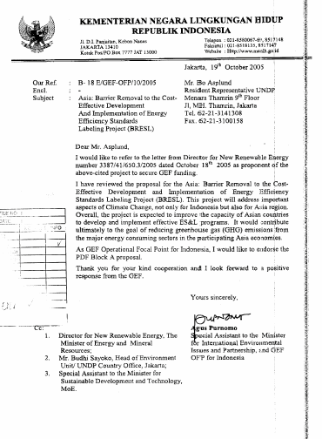

b) Letter of Endorsement from Bangladesh

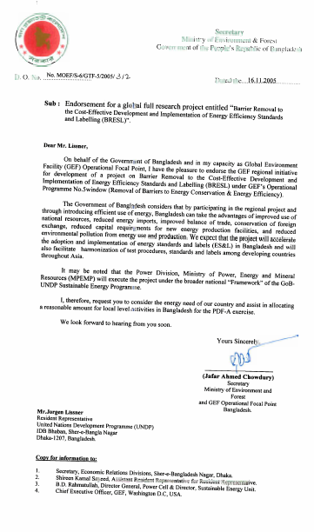

c) Letter of Endorsement from Malaysia

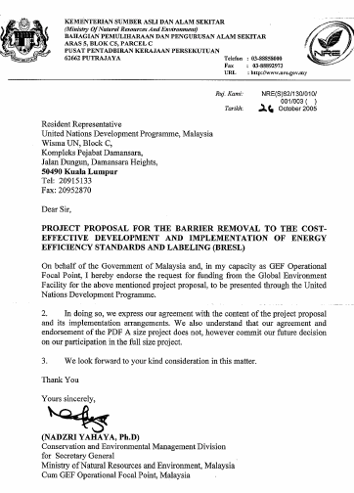

Letter of Endorsement from China

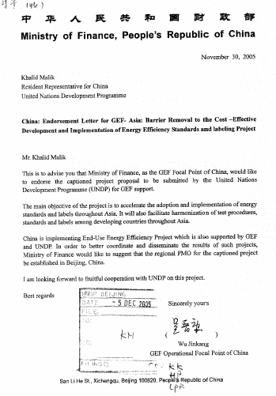

Letter of Endorsement from Philippines

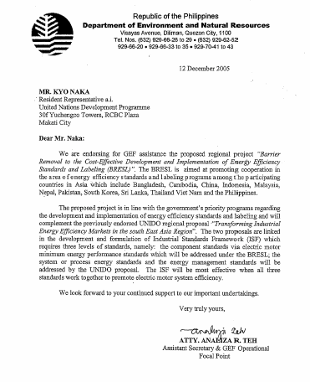

Annex 3

Energy Standards & Labeling Consultant(s)
Terms of Reference
The following are the proposed terms of reference for an International Consultant on Energy Standards and Labeling (ES&L) who is expected to provide the necessary background information on the present status of, and plans on, ES&L programs/initiatives of the different developing countries in the Asian region. The consultant is also expected to provide relevant recommendations on the preparation of a proposal for a project development exercise that will be funded using GEF PDF Block B funds for the design of a regional GEF OP-5 full size project (FSP) on ES&L. This assignment is for a period of 44 working days starting January 2006.

- Information on the Status of, and Planned Energy Standards and Labeling (ES&L) Initiatives in the Asian Region

Consultant is expected to carry out both desk research and missions to specific countries in the Asian region to come up with the following necessary information:

- Ongoing national and regional ES&L projects in the Asian region (proponent and location, objectives, coverage, benefits so far, current status) – both GEF and non-GEF funded.
- Planned national and regional ES&L projects in the Asian region (proponent and location, objectives, coverage, benefits so far), particularly those that address the widespread promotion of ES&L through interventions that address barriers/problems encountered in previous similar projects.
- Current status of present national ES&L programs of Asian countries (including plans for such programs)
- Current status of ongoing sub-regional collaborations on ES&L (particularly on harmonization of standards and test procedures)
- Ongoing and planned activities of the Asian countries, the sub-regional collaborations and the different international organizations (e.g., IIEC, IEA, AGO) that can be considered as baseline activities that the proposed regional ES&L project can build on to realize further global environmental benefits. Details of these activities (e.g., schedule, budget, implementers) are required for the financial planning for the regional ES&L project.
- Costs involved in the design, development, implementation, and M&E of these ongoing sub-regional and national ES&L programs in Asia
- Energy consumption trend forecast on the utilization of energy-consuming equipment/appliances in the region (without and with regional ES&L project)
- GHG emissions reduction potentials as a result of a regional ES&L project (direct and indirect)
- Examples of ES&L demonstration schemes that showcase the development, financing, implementation, institutionalization of ES&L programs (or at least specific components of such programs), including costs involved in the design, implementation, operation, M&E of these demonstrations.

- Barriers to ES&L

- List, analyze, prioritize and elaborate in detail all the significant barriers, which are hindering the widespread development and implementation of ES&L programs, and regional harmonization of EE S&L in Asian countries.

- Key policy barriers, existing policy initiatives, and the gaps specific to ES&L program development and implementation
- Key market barriers to EE equipment/appliance utilization, and summary of existing initiatives on EE equipment/appliances market transformation
- Existing financing barriers to ES&L program development and implementation

- Other barriers that relevant stakeholders in the government (e.g., energy, trade and commerce) and in the private sector (e.g., local equipment manufacturers/suppliers) think are hindering the development and implementation of ES&L programs, and in the harmonization of EE S&L (e.g., policies, incentives, testing procedures/protocols).
- Determine the inter-relationships (cause and effect) of the identified barriers through a logical framework analysis.
- Identify and evaluate means/measures employed by the countries for overcoming the barriers and estimate the transaction cost of barrier removal, including full assessment of the risks involved and likelihood of success.
- Determine and recommend capacity development needs in the area of ES&L program development and implementation, as well as ES&L policy formulation and planning
- Specify objectives that have to be achieved in developing and implementing the intended UNDP-GEF ES&L project.

- Key Players on ES&L in the Region

- Identify the key players in the region and in each country and analyze their present roles in the development and implementation of ES&L programs

- Government agencies (Energy, Trade/Commerce and Industry, etc)
- Appliance and equipment manufacturers (national and multi-national)
- Local appliance and equipment suppliers/dealers
- Appliance/Equipment Testing Laboratories
- International, regional/sub-regional, national institutions
- Banks and financing institutions
- Others

- Determine, document and analyze implementation modalities and practices on ES&L in the region.

- Present operational modalities applied in ongoing sub-regional ES&L programs, particularly between sub-regional ES&L Project Team and National Focal Points in the participating countries
- Current practices (particularly best practices) regarding ES&L information and public awareness campaigns
- Lessons learned from ongoing and previous ES&L initiatives regarding the needs/requirements for information dissemination and public awareness, and institutional strengthening needs

- Evaluate the present and possible future roles of the key players in ES&L promotion in the Asian countries, including their possible roles in the Asia: BRESL Project.
- Provide guidance in the identification of potential project partners (e.g., demo scheme hosts).
- Analyze and highlight the potential impacts of the envisioned regional project in dealing with the issue of energy consuming products market transformation in each Asian country and in the region.
- Analyze and highlight the potential impacts of the envisioned regional harmonization of EE S&L (e.g., policies, incentives, and testing procedures/protocols) among the Asian countries.

- Market for Energy Efficient Appliances & Equipment

- Determine and document the current and future market of EE appliances & equipment in Asian countries and in the region

- Market share of EE appliances & equipment in each Asian country, and in the region (overall)
- Market opportunities for EE equipment/appliances in each Asian country and in the region
- Export/Import trends within the region of commonly traded equipment/appliances
- Present EE equipment/appliances market development strategies applied by Asian countries (developed and developing)
- Different models for ES&L program development and implementation and harmonization, including support programs for the implementation of the practical and feasible models in the Asian countries

- Estimate the potential levels of market transformation for EE appliances and equipment in the region
- Recommend activities that can be implemented in a regional project that can facilitate the realization of the estimated potential levels of market transformation for EE appliances and equipment in the region.

- ES&L Policies

- Assess the existing national development polices that are related and relevant to ES&L development in the Asian countries.
- Review the existing policies/plans/programs on energy conservation & energy efficiency (EC&EE), in general and ES&L (if any), in particular.
- Assess pertinent EC&EE policies that could form as bases for national ES&L policies.
- Evaluate lessons learned from past and ongoing EC&EE programs of the governments in the region that are related to ES&L.
- Recommend activities/interventions that have to be carried out in the planned regional project that would promote and demonstrate the benefits of regional harmonization of EE S&Ls (at least on testing procedures/protocols, at the start)
- Recommend project development activities that need to be conducted in designing the interventions for promoting the envisioned regional harmonization.

- Financing ES&L Projects

- Determine and evaluate the following:

- Present financing mechanisms for supporting and sustaining ES&L programs (best practices)
- Requirements for ES&L technical support to national governments, consumers and EE equipment/appliance manufacturers and suppliers
- Institutions (local, regional, international) that are interested in financing regional ES&L projects
- Applicability and feasibility of a regional funding for financing regional ES&L projects.
- Requirements of financing/banking institutions for financially supporting regional ES&L projects, and financing manufacturers who are interested in improving production processes and product designs in compliance with energy standard/label requirements.

- Based on findings from the above, prepare and submit a recommended regional financing scheme for supporting ES&L programs.
- Based on findings from the above, and also the relevant interested key players in the region, prepare a plan for potential co-financing for the proposed regional ES&L project.

- Level of Awareness on ES&L Programs

- Determine and evaluate existing level of awareness in the Asian countries about ES&L, as well as initiatives currently being implemented (or being planned) to improve awareness

- Regional/national ES&L database systems
- Regional ES&L information sharing network (website maintenance, newsletter, conference participation and papers, journal articles, media communications, consolidation of available information on ES&L programs, e.g., success stories, best practices, etc.)
- Regional workshops on collaborative harmonization initiatives, and capacity building (training) on the development and implementation of ES&L programs
- Regional training workshops/programs in selected ES&L testing facilities on the development and implementation ES&L programs, and on the testing protocols for different equipment/appliances
- Database of EE equipment/appliance manufacturers

- Based on findings from the above, prepare and submit a recommended regional ES&L awareness-raising scheme.

- Others

- Prepare and submit to UNDP-GEF (Asia-Pacific RCU) mission reports, minutes of all meetings attended/conducted, and the consultancy assignment report.

OUTPUTS

- Documentation of the information gathered (including analyses and recommendations) on the current status and planned ES&L initiatives in the Asian region
- Documentation on the findings on the barriers to ES&L program development and implementation in the Asian region (and in specifically in each country) including recommendations to remove such barriers in order to facilitate market transformation for EE appliances & equipment in the region
- Documentation of the evaluation of the present market and market prospects for EE products including the key players in the area of ES&L, and requirements (e.g., policies, financing) for facilitating significant realization of the market prospects
- Documentation of the recommended regional financing scheme for supporting ES&L programs.
- Documentation of the plan for the co-financing for the proposed regional ES&L project
- Documentation of the recommended regional ES&L awareness-raising scheme.
- Minutes meetings attended/conducted during missions
- Consultancy Assignment Report

QUALIFICATIONS

- Minimum Masters Degree in engineering, economics, or applied sciences; PhD in the same or any other relevant field would be an advantage.
- Minimum 5 years experience in institutional and technical capacity building in the energy sector and energy project financing;
- Proven track record in consulting for ES&L projects such as in meeting deadlines, timely submission of acceptable deliverables, etc.;
- Excellent English communication skills, both written and verbal;
- With very good knowledge of and strong links with the appliance/equipment manufacturing industry in the Asian region
- With very good and strong links with international, regional and sub-regional energy organizations that are engaged in the development and promotion of ES&L programs
- With very good knowledge and strong links with national government agencies involved in EC&EE, in general, and ES&L (or product standards), in particular
- With satisfactory skills on the use of office software packages such as MS Word, Excel and Power Point

SIGNATURE PAGE
Countries: Bangladesh, China, Indonesia, Malaysia, Nepal, Pakistan, Philippines, South Korea, Sri Lanka, Thailand and Vietnam

UNDAF Outcome(s)/Indicator(s):

Expected Outcome(s)/Indicator (s):
Outcome 1: Common country strategies for addressing global climate change and pollution as stated in the CPs and CCFs.
Indicator:
Outcome 2: Common country objectives concerning energy efficiency and sustainable use of energy
Indicator:

Expected Output(s) & Indicator(s):
Output 1: Project Brief developed, endorsed and approved by GEF.
Indicator: Endorsement by Asian Governments of the full project brief and approval by GEF

Implementing partner: UNDP China

Other Partners: National Development and Reform Commission (NDRC),China
Government Counterpart: Ministry of Finance (MOF), China

Total Budget: USD 70,000

Allocated resources:
GEF USD 50,000
Others: UNDP USD 20,000

Programme Period: 2005 to 2010
Programme Component:
Change CC-1 (Market Transformation)
Project Title: Barrier Removal to the Cost-Effective Development and Implementation of Energy Efficiency Standards and Labeling (BRESL)
Project Code: PIMS 3722
Project Duration: 3 months
months Months

Agreed by the Government of China: _____________________________________________
Wu Jinkang, GEF Operational Focal Point, MOF

Date: _____________________________________________

Agreed by National Executing Agency: ____________________________________________
Zhao Jiarong, Director General, Department of
Environment and Resource Conservation, NDRC

Date: _____________________________________________

Agreed by UNDP: ____________________________________________
Khalid Malik, Resident Representative, UNDP China

Date: ______________________________________________

In the case of a consulting firm, the staff members who will work on the assignment should have the required stated qualifications.

