PROJECT DEVELOPMENT FACILITY


GEF
Request for PDF-B Approval

FINANCING PLAN (US$)
GEF Allocation
Project (estimated) | 10,800,000
Project Co-financing (estimated) | 20,000,000
PDF A*
PDF B* | 700,000
PDF C
Sub-total GEF PDF | 700,000
PDF Co-Financing
GEF Agency
National Contribution |  | 237,900
Others |  | 66,300
Sub-Total PDF Co-financing: |  | 304,200
Total PDF Project Financing: |  | 1,004,200
Agency’s Project ID: 3469
GEFSEC ID:
Project Title: Implementation of the Sustainable Development Strategy for the Seas of East Asia
Country: Regional – East Asia Participating Countries: Cambodia, China, DPR Korea, Indonesia, Lao PDR, Malaysia, Myanmar, Philippines, Thailand, Timor Leste, and Vietnam, with Brunei Darussalam, Japan, RO Korea and Singapore participating on a cost-sharing basis
GEF Agency: UNDP
Other Executing Agencies: IMO (pdf-b); UNOPS (FSP)
Duration: 3.5 years
GEF Focal Area: International Waters
GEF Operational Program: OP 9 – Integrated Land and Water Multiple Focal Area Program
GEF Strategic Priority: IW-1: Catalyzing financial resources for the implementation of agreed actions
Estimated Starting Date: January 2007
Estimated WP Entry Date: November 2006
Pipeline Entry Date: April 2005

Record of Endorsement on Behalf of the Government

This PDF-B Application has been endorsed by the following countries: Cambodia, China, Indonesia, Lao PDR, Philippines, Thailand, Timor Leste and Vietnam. Letters of endorsement are attached as Annex 2.

This proposal has been prepared in accordance with GEF policies and procedures and meets the standards of the GEF Project Review Criteria for approval.

Name & Signature
Yannick Glemarec
UNDP/GEF Deputy Executive Coordinator Project Contact Person: Randall Purcell, Regional Technical Advisor, International Waters/Land Degradation
Date 13 January 2006 Tel. and email: 662-288-2730
randall.purcell@undp.org
TABLE OF CONTENTS

Part I – Project Concept …………………………………………………………………… 3

A – Summary…………………………………………………………………………………… 3
- Project Framework………………………………………………………………………. 3
- Project Rationale………………………………………………………………………… 4
- Objectives………………………………………………………………………………... 7
- Outputs…………………………………………………………………………………… 9

B – Country Ownership………………………………………………………………………. 15
- Country Eligibility……………………………………………………………………….. 15
- Country Drivenness………………………………………………………………………. 15

C – Program and Policy Conformity……………………………………………………… 15
- Program Design and Conformity…………………………………………………………. 15
- Project Design…………………………………………………………………………….. 17
- Sustainability (including financial sustainability)………………………………………… 19
- Replicability………………………………………………………………………………. 20
- Stakeholder Involvement/Intended Beneficiaries………………………………………… 22

D – Financing…………………………………………………………………………………… 24
- Financing Plan……………………………………………………………………………. 24
- Co-financing……………………………………………………………………………… 26

E – Institutional Coordination and Support……………………………………………. 28
- Core Commitments and Linkages………………………………………………………... 28
- Consultation, Coordination, and Collaboration between and
among Implementing Agencies, Executing Agencies and the GEF Secretariat…. 29
- Implementation and Execution Arrangements……………………………………………. 31
- Monitoring and Evaluation………………………………………………………………... 31

Appendix 1: Sustainable Development Strategy for the
Seas of East Asia and the Putrajaya Declaration…………………………………. 33
Appendix 2: Project Activities for the Full Project………………………………………………… 45

PART II – Project Development Preparation……………………………………………. 57

A – Description of Proposed PDF-B Activities……………………………………………. 57

B – PDF B Outputs………………………………………………………………………………... 62

C – Institutional Arrangements……………………………………………………………. 62

D – Timeline and Budget………………………………………………………………………. 63

Annex 1 – Timeline and Budget: PDF- B for the Implementation of the
Sustainable Development Strategy for the Seas of East Asia…………… 64
Annex 2 – Letters of Endorsement………………………………………………………... 66
PART 1 – PROJECT CONCEPT

A - Summary

- Project framework
The geographic scope of the project is the six large marine ecosystems (LME’s) of the East Asian Seas and their associated watershed areas.

The project’s objective is to facilitate implementation of the Sustainable Development Strategy for the Seas of East Asia (SDS-SEA), as adopted by East Asian countries in December 2003, through mobilization of the necessary partnership arrangements, operating mechanisms, intellectual capital, support services and resources for the achievement of their shared vision of sustainable use of coastal and marine resources of the region and the development targets of the WSSD Plan of Implementation (Appendix 1, Table 1). The project will serve as the capacity building element of the broader GEF Strategic Partnership in support of implementation of the SDS-SEA and the World Bank Pollution Reduction Investment Fund for the LMEs of East Asia.

The implementation of the Strategy will be a significant test of multi-stakeholder collaboration, coordination and capacity enhancement, in order to achieve practical and affordable solutions to recognized marine and coastal environmental problems at the local level, and to accelerate on-the-ground implementation measures to reverse pollution and degradation and destruction of marine and coastal resources at the national and regional levels. The major outcomes of the project would be:
- a suite of stakeholder-owned regional mechanisms for SDS-SEA implementation, consisting of an intergovernmental and multi-sectoral EAS Partnership Council, a PEMSEA Resource Facility, a voluntary regional Partnership Fund in support of in-country and cross-country capacity building for SDS-SEA implementation, and a tri-annual East Asian Seas Congress, to oversee, guide, coordinate, sustain, monitor and improve the implementation of the SDS-SEA;
- national policies and action plans for sustainable coastal and ocean development, as committed to in the SDS-SEA, developed, adopted and implemented in at least 33% of the countries by 2009 and 70% by 2015;
- scaled up ICM programs at national and sub-national levels, as committed to in SDS-SEA, covering at least 5% of the region’s coastlines by 2009 and 20% by 2015, reducing vulnerability to natural hazards and improving the health of human beings, ecosystems and the natural resource base;
- optimum utilization of regional intellectual capital and resources for integrated management and sustainable use of the environment and resources, through national and international stakeholder participation, mobilization of scientific and technical institutions and organizations, and information-sharing, knowledge transfer and capacity building at the community level; and
- innovative financing mechanisms to help countries leverage public and private sector investments, in line with their commitments under SDS-SEA, in municipal sewage, water and sanitation facilities and services, and industrial and agricultural pollution prevention and reduction systems, in collaboration with World Bank and other IFIs, participating national governments, donors and the financial industry.

The project will form part of the larger GEF Strategic Partnership Programme for the Seas of East Asia comprising the participating governments, GEF, UNDP, World Bank, UNEP, IMO and other stakeholders in implementing activities of the SDS-SEA. The project will be developed and implemented in parallel and in close co-ordination with the Pollution Reduction Investment Fund for the Large Marine Ecosystems of East Asia, a major GEF/World Bank initiative supporting the implementation of the SDS-SEA.

The duration of the project is 10 years, consisting of a transition period (2007-2009), a transformation period (2010-2012), and a sustainable operation period (2013-2016). The first three years will be mainly supported by GEF, which may also fund the second 3 years to ensure the completion of the transformation of institutional arrangements. The participating governments and stakeholder partners will be responsible for the sustainable operation of regional arrangements for the implementation of the SDS-SEA.

- Project Rationale
The Seas of East Asia are home to 30% of world coral reefs and mangroves, about 40% of world fish catch, 84% of the world aquaculture production, and is considered as one of the world’s center for marine biodiversity (e.g., 400-500 hard coral species in the Southeast Asian region in comparison with 395 in the Great Barrier Reef and 100-200 in Caribbean region). In sea born trade tonnage, Asian countries account 16% of the world total in 2003. Some 1.9 billion people in the region is expected to increase to 3 billion by 2015 and more than half of this population live in the coastal area. Growing populations and their migration to coastal areas, dynamic economic growth, and rising global demands for fishery and aquaculture products, largely met by export products from the East Asian Seas and rapidly increasing shipping traffic, have combined to exert tremendous pressure on East Asia’s marine environment and coastal resources. Decades of advocacy, political commitments and conservation efforts at national and regional levels have not prevented the Seas of East Asia from degrading at an ever-increasing pace. For example, mangrove area in Cambodia, China, Indonesia, Malaysia, Philippines Thailand and Vietnam decreased by over 16 % from 4.8 million in 1990 ha to 4 million ha in 2000, in comparison with 10% decrease of the world’s total mangrove area in the same period. Arresting and reversing the decline is an urgent task that requires a new approach, a new paradigm. That paradigm is a strategic partnership of governments, international organizations and donors, and stakeholders from all sectors of society, from within and outside of the East Asian Region, working together to achieve a shared vision of a sustainable resource system in the Seas of East Asia.

Within the partnership arrangement, utmost consideration is given to the disparities in capacity, perceptions of value, and priorities that different stakeholders have with regard to management of such resources. By employing integrated approaches to more effectively address conflicting uses of marine and coastal resources, the strategic partnership arrangement aims to harness the strengths of the different sectors, enhance synergies and linkages in capacity building and investment initiatives, and mobilize all stakeholders – including government agencies, international financial institutions, international organizations, regional organizations and programmes, donors, the financial industry, the private sector, non-government organizations, scientists, academe, communities, and other members of civil society – to discharge their social responsibilities and actively participate in sustainable development programs.

On 12 December 2003, the 12 coastal nations of the Seas of East Asia signed the Putrajaya Declaration of Regional Cooperation for the Sustainable Development of the Seas of East Asia, thereby adopting a common strategy for sustainable coastal and marine development, the Sustainable Development Strategy for the Seas of East Asia, or SDS-SEA. The SDS-SEA provides a common platform for regional cooperation, and a framework for policy and program development and implementation at the local and national levels. Additional information on the Putrajaya Declaration and the SDS-SEA may be found in Appendix 1.

The countries of the region are now ready to implement the SDS-SEA, as confirmed at an intergovernmental meeting of PEMSEA participating countries in August 2004, with 15 countries (i.e., the 12 participating countries of PEMSEA, plus Lao PDR, Myanmar and Timor Leste) expressing their desire to move forward. The proposed project is an essential step in the early implementation of the SDS-SEA. While the SDS-SEA has attracted high-level country commitment, its successful implementation requires enhanced coastal and marine planning and management at the local, national, sub-regional and regional levels, a dedicated effort to strengthen local capabilities in integrated coastal management (ICM), and the mobilization of significant international, regional and domestic financial investments in pollution control.

The project would build upon the ongoing initiatives and capacities at the local, national and regional levels. Essentially, the project will serve as a catalyst for bringing together different levels of government and collaborating sectors, with their local, national, regional and global perspectives, and their inherent mandates and capacities, in order to implement the SDS-SEA in an effective and sustainable manner.

The project would be linked to and coordinated closely with a number of ongoing GEF initiatives in the LMEs of East Asia. In particular, the World Bank/Global Environment Facility Pollution Reduction Investment Fund for Large Marine Ecosystems of East Asia, which forms the other principal element of the GEF Strategic Partnership for the implementation of SDS-SEA. The UNDP-GEF project would identify required improvements in environmental infrastructure and services at ICM sites throughout the region, facilitate a policy and investment climate that promotes private sector participation, engage interested private companies in investment projects, and enable access to an affordable and replicating financing mechanism and best practices by collaborating with World Bank, other IFIs, national governments, donors and the financial industry on the development of the Investment Fund.

In addition, the GEF is currently co-financing large marine ecosystem strategic action planning and management projects for the Yellow Sea and the South China Sea and the Gulf of Thailand that are producing country-driven pollution reduction, fisheries management and other programs and new commitments for reform and investment in the participating countries. The implementation of both projects is contributing to fulfilling of the SDS-SEA objective of improving governance of the coastal and marine resources. In particular, the Yellow Sea project has a special focus on living resource management, which is consistent with the SDS-SEA requirements in the responsible use of living resources, and the enhancement of transboundary cooperation in subregional seas for fisheries management. Whereas the South China Sea project will help SDS-SEA implementation with regards to biodiversity conservation, restoration of threatened habitats and the protection of marine environment from the harmful effects of land-based human activities (Table 1 of Appendix 1). Nonetheless, the country consultations facilitated by these projects have revealed that, without new pollution-reduction awareness-raising initiatives and new financial incentives and mechanisms, insufficient additional investment resources and reforms will be catalyzed to even begin to reverse current destruction and degradation trends.

The transfer of information, experiences and case studies across GEF IW projects is a basic objective of the project. Utilizing regional expertise, the project would analyze successful practices in integrated management and sustainable development of marine and coastal resources including sustainable financing mechanisms, and package that material as good practices for application in other areas of the region, and elsewhere. Consistent with the goals and programmes of the GEF IW Learn Exchange and Resource Network, the project would contribute such information to an IW metadata directory, and participate in IW Learn initiatives aimed at transferring capacities, skills and knowledge across IW projects and regions.

By strengthening collaboration among countries, setting priorities related to the most serious transboundary problems, and jointly agreeing on what interventions are needed to address the top priorities through their strategies and programmes of action, the three ongoing GEF regional projects (i.e., PEMSEA, Yellow Sea, and South China Sea/Gulf of Thailand) are in fact building the foundation for the proposed new strategic partnership for SDS-SEA implementation. Other major players engaged in the partnership would include UNDP, UNEP-GPA, IMO, ADB, ASEAN, FAO, and IOC/UNESCO, as well as donors, the private sector, the financial industry, the academe, and international NGOs including APFEJ, CI, SOF, WI, IUCN, WorldFish Center, WRI and WWF. Their specific roles in the partnership and this project are being defined through discussion and negotiation. A major part of the proposed PDF Block B project will focus on consultation and formulation of roles and commitments, to develop a common understanding among the countries, IAs, the GEF Secretariat, donors, and other organizations wishing to assist the countries, so that coordination and collaboration may be achieved, rather than duplication or creation of gaps.

The project would complement the activities of the countries, the three GEF regional projects, UNDP, UNEP-GPA, the World Bank, the Asian Development Bank, bilateral projects aimed at similar objectives, as well as fit programmatically with existing and proposed GEF projects in the region, including for example: Management of Livestock Wastes in East Asia; Implementation of Public-Private Partnerships in Environmental Investments; the Mekong River Wetland Biodiversity Conservation and Sustainable Use Program; Biodiversity Management in the Coastal Area of China’s South Sea; Hai River Basin Integrated Water Resources Management; Guangdong - Pearl River Delta Urban Environment; and the Marine Electronic Highway Demonstration Project (Straits of Malacca); and Conserving Marine Biodiversity through Enhanced Marine Park Management and Inclusive Sustainable Island Development (Malaysia).

- Objectives
The overall objective of the project would be to facilitate implementation of the Sustainable Development Strategy for the Seas of East Asia (SDS-SEA) through mobilization of the necessary partnership arrangements, operating mechanisms, intellectual capital, support services and resources for the achievement of their shared vision of sustainable use of coastal and marine resources of the region and the development targets of the WSSD Plan of Implementation. The shared vision, as contained in the SDS-SEA, is “to safeguard and sustain the resource systems of the Seas of East Asia as a natural heritage for the people of the region, a medium of access to regional and global markets, a source of healthy food supply, livelihood, economic prosperity and harmonious coexistence for present and future generations.”

The immediate objectives of the project would be:

- to catalyze the implementation of action programs of the SDS-SEA aimed at legal, policy and institutional reforms, and investments, at the local, national and regional levels, with a particular focus on scaling up and sustaining integrated coastal management (ICM) practices to reduce coastal and marine degradation;
- to coordinate a Strategic Partnership between participating countries, UNDP, IMO, the World Bank and other stakeholders to stimulate and co-finance site-specific private and/or public-private land-based pollution reduction investments under the GEF/World Bank Pollution Reduction Investment Fund for the LMEs of East Asia;
- to verify, disseminate and promote the replication of lessons and best practices arising from the Strategic Partnership in collaboration with IW: Learn and other partners.

The project’s global environment objective would be to promote environmental sustainability of the East Asia’s six shared LME’s and to transfer the acquired knowledge and lessons learned to countries within the region, to other countries, and to other regions of the world.

The potential benefits of the project and the strategic partnership programme as a whole would be realized at different levels. Locally, through the application of ICM practices, coastal communities would be better prepared and able to cope with development activities in coastal and watershed areas, to achieve time-bound targets for integrated river-basin management, nutrient reduction, and sustainable access to safe drinking water and sanitation, and to implement habitat restoration, fisheries management, and the effective administration of marine protected areas. These local ICM activities all have knock-on social, economic and environmental benefits at the community level and across the region, specifically fulfilling targets set within the WSSD Plan of Implementation, the MDGs and other multilateral environmental agreements (MEAs). Building the necessary critical mass of communities and human resources will take time; the first three years of the project would set the process and support mechanisms in place.

At the national level, the overall benefits of the SDS-SEA implementation project would be two-fold. First, there would be a refocusing of attention on the importance of the coastal area to a country’s economy and to society as a whole, and on the benefits derived from integrated, coordinated actions guided by a common policy. This would be aimed at policymakers as well as political figures, to enhance ownership and understanding of processes and products of the ocean, and to consider the long-term effects of development policies, projects and programmes, both existing and future. Second, with enhanced recognition of benefits derived from improved ocean and coastal governance, national governments would be expected to exert greater effort within the country, regionally and internationally to sustain the implementation of the SDS-SEA.

The regional and global benefits of the project would be far-reaching. As a world center of marine biodiversity, with more than 7 million km² of sea area, supporting 30% of the world’s coral reefs and mangroves, and producing 40% of the world’s marine fish and 80% of the world’s aquaculture, the worsening of the region’s environmental integrity has ramifications not only for the inhabitants of East Asia, but also for user States and other global beneficiaries of the region’s marine and coastal resources and waterways. The Seas of East Asia are a political, environmental, biodiversity and socio-economic hotspot – perhaps the foremost hotspot worldwide with regard to sustainable development and management of marine and coastal resources. The success of the SDS-SEA implementation therefore would have a number of significant regional and global ramifications, contributing to a more secure ocean by:
- reducing threats to national and regional security, brought about by competition over limited resources, which result in transboundary political, social, cultural, economic and environmental risks that could have negative consequences beyond the region;
- alleviating the pressures of poverty in the region, which compound the threats to security, through conservation and improved management of coastal resources at the community level, while contributing to the global targets of the WSSD POI (Appendix 1, Table 1) and the UN MDGs especially poverty alleviation, accessibility to water and sanitary services;
- setting important precedents in the sustainable development of marine and coastal resources by putting into practice an integrated management system that deals with the interconnectivity between the degradation of the world’s oceans and coastal resources and economic and social stresses, addressing a broad range of relevant issues, including in-country migration to coastal areas, population growth, piracy, fisheries disputes, migratory fisheries, unsafe ships and inexperienced crews, congested and uncharted navigation routes, social unrest, unemployment, terrorism, uncontrolled development, and conflicting uses of limited available resources;
- increasing the level of resources that will be committed to managing the region’s marine and coastal areas, including transboundary issues, by applying an innovative implementing mechanism and regional management framework for regional and sub-regional sea areas, aimed at overcoming interagency conflicts and sectoral views with respect to economic development and environmental management, inappropriate policies, limited experience with successful working models, financial constraints, and restricted access to skilled human resources and technology; and
- transferring the knowledge, experience, lessons and skills developed and acquired during the programme to countries within the region, and to other regions of the world.

- Outputs
The full project would be implemented over 10 years.

The first 3 years would be the transitional period, in which countries, their partners and other stakeholders would develop, agree on, and commence the implementation of a 10-year framework of partnership programs. The focus of activities would be on national level legal, policy and institutional reforms for improved coastal and ocean governance, the development and application of ICM as an on-the-ground practice for achieving sustainable development of coastal lands and waters in the region, and the formulation of supporting organizational, institutional, technical and financial arrangements at the national and regional levels.

The second 3 years would be the transformation period, in which the developed regional paradigm would be fully implemented, evaluated for effectiveness and appropriateness from the perspectives of the concerned government and non-government partners, improved, and transformed from a short-term, project-based regional arrangement under the framework of the UN into a self-sustaining, long-term regional facility.

The final 4 years would be the sustainable operation period. The GEF would exit as a major sponsor of the project, and countries and their partners would take full responsibility for SDS-SEA implementation, and the sustainability of the strategic regional partnership and its operating arrangements.

The objectives, component activities and expected outputs from each phase are outlined in the Appendix 2. Over the 10-year life of the project, the following objectives and outcomes would be targeted. Further details on the scope of activities, roles and commitments of countries and collaborating agencies, organizations and sectors, outputs, and success indicators would be developed as part of a PDF Block B project.

Component 1: A country-owned regional mechanism for SDS-SEA Implementation

Objective: To mobilize the necessary regional partnerships, capacities and services, as well as legal, financial and institutional arrangements, for the sustainable implementation of the SDS-SEA

Outcomes:

- An intergovernmental, multi-sectoral EAS Partnership Council fully operational, and working as a viable regional mechanism for SDS-SEA implementation oversight and coordination;
- A rolling 10-year framework of partnership programmes for implementation of the SDS-SEA, addressing priority issues, identifying measurable and reasonable objectives and targets, confirming gaps and disparities in capacities to achieve identified goals, and putting together specific collaborative and mutually supportive arrangements with other concerned international and regional partners that are essential to make the goals achievable;
- A voluntary regional Partnership Fund established as a support mechanism to reduce in-country and cross-country capacity disparities, for improved implementation of the SDS-SEA;
- A country-financed, self-sustaining PEMSEA Resource Facility (PRF) providing: a) secretariat services to the EAS Partnership Council; and b) policy and technical support services to participating countries and other stakeholders, including evaluation and transfer of good practices from and in collaboration with ongoing projects and programs especially those supported by GEF and other partners;
- A tri-annual regional EAS Congress, including a Ministerial Forum, to serve as vehicle for countries to re-confirm their commitments to the implementation of the SDS-SEA, and as an International Conference to provide a vehicle for reporting, monitoring and evaluating the progress of SDS-SEA implementation.

Success criteria:
- A fully functional intergovernmental, multi-sectoral regional mechanism, consisting of an EAS Partnership Council, a regional Partnership Fund focused on capacity building for SDS-SEA implementation, a self-sustaining PRF providing secretariat services and technical support to participating countries, and an EAS Congress regularly convening every three years, co-sponsored by governments and collaborating organizations.

Component 2: National policies and reforms for sustainable coastal and ocean development
Objective: To facilitate the development, adoption and implementation of national policy, legislative and institutional reforms aimed at integrated management of marine and coastal areas and the implementation of international environmental instruments.

Outcomes:
- national policy, legal and institutional reforms for sustainable coastal and ocean development developed and adopted by participating countries, such as national coastal and ocean policy, ICM legislation, and programmes of action for the implementation of the Global Programme of Action and the Montreal Declaration, in conformance with paragraph 30, 32, and 33 of the WSSD POI (Appendix 1, Table 1);
- 10-year country programs adopted and implemented in support of foresaid national polices and legislative reforms under the framework of the SDS-SEA, particularly with regard to arresting coastal and marine pollution from land-based and sea-based activities, implementation of the code of conduct for responsible fisheries and the resulting risks to ecosystems, human health and society, in accordance with paragraphs 32 and 33 of the WSSD POI (Appendix 1, Table 1);
- national interagency and multi-sectoral coordinating mechanisms established, aimed at improving coherence in coastal and ocean policy, institutional reforms, legislation, regulation and enforcement at local and national levels, and providing a home base for integrated management of marine and coastal areas, as per paragraph 29 of the WSSD POI (Appendix 1, Table 1).

Success criteria:
- National strategies and action plans for sustainable coastal and ocean development adopted in at least 33% of the participating countries in 2009 and 70% by 2015;
- Interagency and multi-sectoral coordinating mechanisms established in participating countries, with 10-year country programs in place and functioning, including national programmes of action for the prevention and reduction of marine pollution in line with GPA and other requirements.

Component 3: Scaling-up ICM Programs
Objective: To scale-up integrated coastal management (ICM) as an on-the-ground framework for achieving sustainable development of coastal lands and waters in the region.

Outcomes:
- At least 10 national and one regional ICM task forces and other technical assistance measures in place, building awareness and capacities at the national and local levels, and replicating ICM practices across countries;
- National and local governments in all the participating countries, working synergistically with GEF, donors and international agencies, utilizing ICM as a framework for effectively managing and sustaining coastal and marine resources;
- A voluntary ICM certification/recognition and incentive scheme in place and benefiting local governments and stakeholders in the establishment and maintenance of ICM programs in the region;
- A systematic process for monitoring, evaluating and reporting progress, outputs and impact of ICM programs in place, and facilitating the refinement/improvement of national and regional ICM plans.

Success Criteria
- At least 5% of coastlines of the region by 2009 and additional 15% of coastlines of the region covered by integrated coastal management (ICM) programs by 2015 (details to be developed under PDF-B);
- At least 5 national ICM training centers established and operating;
- A synthesis report on the impact of ICM implementation at the national and regional levels, presented to the EAS Partnership Council every three years.

Component 4: Twinning arrangements for marine and coastal ecosystem management
Objective: To forge functional twinning arrangements in the selected sites involving south-south and north-south collaboration to share knowledge and experience in innovative approaches to ecosystem based management of watersheds, estuaries and adjacent coastal and large marine ecosystems

Outcomes:
- Twinning arrangements in place and operational involving:
  - Areas with established ecosystem-based management programmes and areas where similar programmes are yet to be developed, including for example, Chesapeake Bay, Albermarle-Pamlico Sound, Seto Inland Sea, Bohai Sea, Manila Bay, Masan-Chinhae Bay and Jakarta Bay; as well as;
  - Areas sharing experience regarding application of ICM for effective management of marine protected areas, such as the Great Barrier Reef and Sulu-Sulawesi Sea.

Success criteria:
- Innovative methodologies and approaches transferred amongst the identified areas;
- Regular workshops and exchange of project personnel;
- Knowledge on good practices in ecosystem-based management shared and related information disseminated;
- Acceleration of ecosystem-based management amongst sites, e.g., moving from single purpose management on specific resource or habitat type to more comprehensive approaches addressing the interconnections between the ecosystem components (to be further developed during the PDF-B project).

Component 5: Collaborative arrangements between and among research institutions, universities, the private sector, local governments, communities, NGOs, and Areas of Excellence
Objective: To strengthen the use of the region’s intellectual capital and human resources to address policy, economic, scientific, technical and social challenges and constraints for integrated management and sustainable uses of the marine and coastal environment and resources in the region.

Outcomes:
The implementation of this component, in accordance with paragraph 34, WSSD POI (Appendix 1, Table 1), will result in the following:
- Areas of Excellence launched within existing universities and research institutions, providing expert advice and scientific support to countries and their partners on specific issues of concern to SDS-SEA implementation (e.g., pollution prevention and management; carrying capacity; environmental monitoring and risk assessment; natural disaster management in coastal areas);
- An internet-based capacity building, technical support system and information portal in place, building awareness and transferring knowledge and lessons learned among user groups across the region and globally, in syndication with the GEF IW Learn network;
- Community-based programs established involving women, the youth, indigenous people, and marginalized groups, resulting in restoration of habitats for enhancing nutrient reduction, protection against natural hazards, and creating alternative livelihoods at the local level, in collaboration with UNDP Small Grants Programme;
- A self-sustaining regional network of local governments in place, operating and committed to achieving tangible improvements in the sustainable use and development of marine and coastal areas through ICM practices;
- Regional and national expert task forces for sustainable coastal development established and operational.

Success criteria:
- At least three (3) Areas of Excellence identified and providing scientific and technical input to SDS-SEA programmes at the national and regional levels;
- Knowledge-sharing programme focused on ICM experience and lessons learned in the region, functional and operating through GEF IW:LEARN Resource Center (IWRC);
- Local governments, communities and NGOs engaged in programmes supporting the achievement of sustainable development goals at local, national and regional levels;
- In-country and regional local government networks effectively promoting the replication of ICM programmes;
- National and regional ICM Task Teams conducting training programmes and providing technical support to national and local governments in ICM programme development and implementation

Component 6: Increased Investment and Financing for Environmental Infrastructure Projects
Objective: To mobilize public and private sector investment in pollution reduction facilities and services through replication and scaling up of public-private partnership initiatives, particularly for pollution control in secondary cities and in industrial and agricultural enterprises in regional pollution hotspots.

Outcomes:
- An enabling environment for private sector participation and investment in environmental infrastructure projects at existing and new ICM sites across the region;
- Scaling up of PPP programs in at least 3 participating countries, through replication of good practices in public-private partnerships (PPP), as demonstrated under the GEF medium-sized PPP project, and other financing mechanisms;
- Private sector advisory group set up, developing proposals and guidelines for innovative policies, programmes and approaches for strengthening private sector investment in unfunded or underfunded pollution reduction programs of countries.

Success criteria:
- National reforms in financing and procurement policies, regulations and process, enhancing private sector participation in environmental infrastructure projects;
- 10-year investment plans for ICM and regional hotspot sites, attracting private sector partners and investors in small cities, municipalities and secondary townships.

Component 7: Coordination of a Strategic Partnership for Implementation of SDS-SEA

Objective: To coordinate a Strategic Partnership between participating countries, UNDP, IMO, the World Bank and other stakeholders in the implementation of the SDS-SEA in particular in the implementation of the GEF/World Bank Pollution Reduction Investment Fund for the LMEs of East Asia and GEF/UNDP/IMO Regional Programme for the Implementation of the SDS-SEA.

Outcomes:
- Effective inter-agency and inter-governmental coordination of the Strategic Partnership through partner meetings/workshops, teleconferences, information sharing, joint and linked web sites, and other coordination mechanisms leading to replication of good practices, adoption of innovative methodologies/technologies that contribute to the enhancement of the implementation of the SDS-SEA;
- Organizational arrangements with World Bank as the Investment Fund Manager and PEMSEA Resource Facility as the chief advisor to the Fund(s) on all environmental/technical issues and establishment of the project preparation standards, including pre-selection of local consultants that the target clients can use in preparation of their projects;
- PEMSEA Resource Facility providing policy and technical support to national and sub-national players for the implementation of the GEF/World Bank Pollution Reduction Investment Fund, including the creation of favorable policy climates and the identification and promotion of priority investment projects in Manila Bay, Bohai Sea and other selected pollution hotspot sites throughout the region, resulting in increased public and private sector investments in sewage and sanitation, and industrial and agricultural waste treatment facilities;
- PEMSEA Resource Facility providing technical assistance to local governments and small and medium-sized enterprises in the preparation of quality project proposals for sewage and sanitation, and industrial and agricultural waste treatment systems, thereby improving accessibility to capital financing from banks, investors, donors, international agencies, and the business community, as well as facilitating a fully replicating project preparation fund, developed under the World Bank/GEF Pollution Reduction Revolving Fund project (details to be developed with World Bank during PDF-B project).

Success criteria:
- A functional and effectively coordinated Strategic Partnership involving the participating countries, UNDP, IMO, the World Bank, UNEP and other stakeholders using the PEMSEA Resource Facility (PRF) as an effective secretariat for mobilizing resources to enhance SDS-SEA implementation, including knowledge and information sharing, replication of good practices as well as scaling up investment in pollution control of land-based water pollution in coastal urban and peri-urban areas of East Asia;
- Broad awareness across all Strategic Partnership entities of respective roles, progress, activities, contact points, etc.;
- Preparation of bankable projects and leveraging public–private sector investment in synergy with the 10-year regional and national programs for SDS-SEA implementation, particularly in improving sewage, water and sanitation facilities, industrial waste water treatment and management of agriculture wastes;
- A cost recovery mechanism for the PEMSEA Resource Facility, to maintain coordinating and technical support services;
- A mid-term review involving all members of the Strategic Partnership and hosted by the EAS Partnership Council to assess progress in the strategic partnership implementation and map new direction, as required.

B – Country Ownership

- Country Eligibility

The participating countries, including Cambodia, China, DPR Korea, Indonesia, Lao PDR, Malaysia, Philippines, Thailand, Timor Leste and Vietnam, are eligible for GEF assistance under para 9(b) of the GEF Instrument. Brunei Darussalam, Japan, RO Korea and Singapore will be participating in the project on a cost-sharing basis, thereby providing an opportunity for cross-country transfer of knowledge and experience between developed countries and lesser developed countries of the region.

- Country Drivenness

On 12 December 2003, 12 countries of the East Asian Seas region adopted the Sustainable Development Strategy for the Seas of East Asia. Ministers and Senior Officials from 12 governments signed the Putrajaya Declaration (Appendix 2), signifying their agreement and determination to implement the SDS-SEA in accordance with their respective national priorities and capacities. The Putrajaya Declaration is the first regional declaration for the sustainable development of the coasts and oceans of East Asia, directly responding to the global targets that have been agreed to in the WSSD Plan of Implementation, the UN Millennium Declaration, and Agenda 21.

The proposed project is targeted at assisting countries to strengthen coordination, build capacity, and leverage investments to achieve their commitments under the Putrajaya Declaration and the action programs of the Sustainable Development Strategy for the Seas of East Asia. The project application was endorsed by the participating countries at the 10th PEMSEA Programme Steering Committee (PSC) Meeting, 25 to 29 October 2004 in Xiamen, PR China. The PSC Meeting recommended the establishment of a self-sustaining regional mechanism (“PEMSEA Resource Facility (PRF)”) to coordinate the implementation of the SDS-SEA before the completion of the current GEF regional project. Further, the PSC Meeting confirmed that three other countries will be invited to join the 12 countries in implementing the SDS-SEA, namely Myanmar and Lao PDR, who are member countries of the Mekong River system draining into the South China Sea, and Timor Leste, whose Timor Sea forms a part of the Indonesia Seas, one of the 5 LMEs that make up the seas of East Asia.

C – Program and Policy Conformity

- Program Design and Conformity

The East Asian Seas region is unique among regional seas in that it is not covered by a regional convention. This has been a significant challenge to setting up an acceptable regime of governance for the waters of the area, because of longstanding political conflicts, territorial disputes, and competition among countries regarding economic development. However, with much of the previous discord resolved with the emergence of a new East Asian Economy (ASEAN +3), and with the signing of the Putrajaya Declaration, a basis has been created for the effective implementation of the SDS-SEA. The proposed non-binding, partnership approach is seen as one stage in an evolutionary process, with a future stage being the development and adoption of a regional sea convention.

Integrated management of marine and coastal areas is a dynamic process of developing the necessary expertise, institutional capacity and stakeholder support for the creation of pragmatic solutions to problems and issues that threaten the sustainability of human use of coastal ecosystems and their natural resources. A major output of the project would be the scaling-up of national ICM programs to achieve a long-term objective of 100% coverage of the region’s coastlines within 30 years. The objective would be achieved through integrated management of watersheds, estuaries, coastal areas and adjacent seas, and the effective coordination and cooperation at all levels of coastal and ocean management, in concert with country priorities and ongoing programs at the national and sub-regional levels. Ensuring that the developing countries of the region are empowered to make the necessary legal, institutional, policy and program reforms, as well as investments, is critical. This comes at a time of general constraint on resources and levels of public expenditure in the region. GEF’s capacity and mandate to lead this work and to leverage financing from governments, donors and other sectors is unmatched in the region. Without GEF, it is highly unlikely that the countries will be able to continue to tackle the issue in a collective and collaborative manner. This would mean that the efforts of the past 10 years, and the creation of a partnership of countries and stakeholders focused on the achievement of a common vision for the Seas of East Asia, would be at risk.

The operationalization of a self-sustaining regional implementing mechanism for the SDS-SEA is directly in line with GEF’s Integrated Land and Water Multiple Focal Area Operational Program (OP9), to integrate the use of sound land and water resource management strategies toward sustainable development. The GEF support would be a catalyst for achieving the necessary long-term commitments among different sectoral agencies and stakeholders and to leverage the intended sectoral changes at the local, national and sub-regional levels. The operationalization of the SDS-SEA on a regional scale remains a major challenge, specifically to mobilize the necessary partnerships, capacities and financing arrangements. The proposed project would utilize GEF funds to leverage national and multi-country efforts, and with the assistance of IFIs, donors, communities and the private sector, to set in place the required technical, economic, financial and regulatory measures.

The innovative features of the project include: a) scaling up ICM from a series of national demonstration projects, to a national/regional response program; b) strengthening intergovernmental and multi-sectoral collaboration in planning, implementing, maintaining and improving ocean and coastal governance through partnerships; c) establishing a regional mechanism that strengthens stakeholder and government ownership and buy-in; d) identifying and facilitating environmental infrastructure improvement projects in national and local policy climates that are conducive to investment by the public and private sectors; and e) focusing on the effective utilization of the region’s intellectual capital across all sectors to provide solutions that are in line with local, national, regional and global sustainable development objectives and targets.

The project is consistent with GEF Strategic Priorities (SP) 1 and 3 for the IW Focal Area. With respect to priority 1, it will facilitate the efforts of countries that signed the Putrajaya Declaration to mobilize financial resources for implementing policy/institutional reforms and stress-reducing investments to address priority transboundary water issues that are highlighted in the Declaration. With regard to priority 3, it will demonstrate the feasibility of innovative institutional and economic mechanisms, and technical solutions to accelerate investment in facilities that reduce contamination of the region’s LMEs. The technical solutions will include affordable options that will work effectively in financially constrained communities, providing access to environmentally-responsible pollution control/pollution prevention facilities and services, while generating a mix of local and global benefits. Moreover, it will contribute to the Global Programme of Action for reducing contaminants from land-based activities.

- Project Design

Problem Statement
Despite decades of advocacy, political commitments and conservation efforts at national and regional levels, the environmental quality and resource values of the Seas of East Asia continue to degrade at an ever-increasing pace. Unprecedented economic growth has resulted in rapid urbanization, especially in coastal regions. The move to the coast has caused the seas to bear the brunt of the environmental impact of development. Pollution, resources exploited to the point of extinction, the loss of habitat and biodiversity, overfishing, high population levels and growth rates, regionalization and globalization of economies, changing consumption and use patterns – all represent a challenge to the fragile ecological balance of the region’s 6 LME’s. But the scale of these challenges in the Seas of East Asia is beyond all experience. Recent findings show that, at the current rate of degradation, the region’s coral reefs face total collapse within 20 years, while mangroves could be gone within 30 years. There is an urgent and well-recognized need to increase awareness and mobilize all sectors of society to address these challenges.

Baseline Scenario
In the baseline scenario, countries continue to manage marine and coastal issues in a sectoral manner, and independently. Countries with the capacities and resources progress towards sustainability of marine and coastal areas. Interagency and cross-sectoral conflicts get resolved over time, as these countries begin to realize the benefits of an integrated management approach. Other less-developed countries remain mired in a struggle to achieve economic growth and prosperity, in the face of overexploitation, destruction and degradation of natural resources, poverty and social discontent. The gap between the developed and the developing widens. While established coordinating mechanisms within the region begin to take up some of the objectives and action programmes of the SDS-SEA, these intergovernmental bodies are unable to provide the coverage or comprehensive support that is required to address the interconnective characteristics and issues of the East Asian Seas.

Priority environmental infrastructure improvements continue to be identified by central governments, funded through IFI loans, with limited participation or support from local communities and the private sector. Essential capacity building, scientific support, information gathering and knowledge transfer systems continue to be funded on an ad hoc basis by donors and international agencies and organizations, which are increasingly skeptical about the long term benefits and outcomes of development assistance programmes, when countries are not showing increased ownership and commitment to sustainable development. The intellectual capital of the region remains a relatively undiscovered resource, as donor-driven projects and programmes engage the services of international experts to identify root causes of sectoral problems and provide donor-driven solutions to national governments. There is no systematic progress towards sustainable development of the region’s seas and coasts.

GEF Alternative Scenario
The alternative scenario is based on the implementation of the Strategic Partnership, with GEF support to facilitate and leverage country and multi-sectoral stakeholder participation in the implementation process, including: a) the operationalization of a fully functional, self-reliant regional implementing mechanism to guide, direct and monitor the SDS-SEA implementation process over the long term, and to mobilize the necessary partnerships, capacities, resources, and services; b) realignment and/or strengthening of national policies and programmes to enhance integrated, multisectoral and multidisciplinary coastal and ocean management; c) scaling up ICM as an on-the-ground framework for achieving sustainable development of coastal lands, watershed areas, estuaries, and adjacent coastal waters; d) building up and using the region’s intellectual capital for integrated management and sustainable use of the environment and resources; e) putting in place investment programs and financing mechanisms to help countries achieve time-bound targets for wastewater emissions and sustainable access to safe drinking water and sanitation facilities; f) establishing a regional Pollution Reduction Investment Fund, managed by the World Bank, and facilitating enhanced investment by the public and private sectors in pollution prevention and management infrastructure; and g) coordinating and replicating good practices of the Strategic Partnership, for the improved implementation of the SDS-SEA and the benefit of IW programs in other regions.

Under the Alternative Scenario, the EAS Partnership Council is fully functional, with a self-sustaining secretariat to support the Council, while delivering and mobilizing policy and technical advice, capacity building and technical support for sustainable coastal and ocean governance. Building upon the strength of the Partnership, more than 20% of the coastlines of the region are covered by ICM programmes, and 70% of the countries have developed and adopted national marine and coastal policies by 2015, which have resulted in environmental investments pollution prevention and control facilities. A systematic, rolling 10-year regional partnership programme is being monitored by the EAS Partnership Council, as well as collaborating international and regional institutions, organizations and programmes. Some of the programmes are being funded or co-funded by the regional Partnership Fund, which is dedicated to building capacities in ocean and coastal governance at national and sub-national levels in lesser developed countries and sub-regions of East Asia. Other projects are being funded nationally, or through bilateral or multilateral funding arrangements that are country-driven. Regional and in-country expertise in specialized scientific, legal and technical areas is gaining recognition, such as in environmental risk assessment and monitoring, maritime law, coastal use zonation, and ecosystem-based management, and is being applied in policy development and programme implementation activities.

The private sector is represented on the EAS Partnership Council, providing input to the development and implementation of investment plans and financing programmes for environmental infrastructure improvements, while working in partnership with local government units and community groups to develop, finance and manage sustainable sewage, water and sanitation services that are accessible to all sectors of society, including the poor. Countries are engaged in a systematic approach of environmental monitoring and evaluation, scientific investigation of critical management issues, and information exchange, which contributes to a regional report on the state of the region’s coasts, as well as to international monitoring and assessment efforts. A regional EAS Congress is held every three years, at which time the status of SDS-SEA implementation is evaluated by the EAS Partnership Council and relevant partners, including the media, NGOs, academe, and the business sector, with sectoral and cross-sectoral reviews, seminars and workshops. A Ministerial Forum reviews the program’s performance and re-confirms the objectives and commitments for the implementation of the SDS-SEA. A comprehensive and systematic process is in place and countries are progressing towards sustainable development and management of the region’s marine and coastal resources.

- Sustainability (including financial sustainability)

The project targets environmental sustainability with the long term implementation of the SDS-SEA strategies and action programs, including:
- The adoption of national policies and action plans for sustainable coastal and ocean development and management;
- The implementation of ICM programs covering 20% of the coastlines of the region; and
- The setting in place sustainable development indicators, and a systematic monitoring, and reporting system to assess the state of the coasts, and to refine and adapt the SDS-SEA implementation program in response to the assessments.

The project will address social sustainability by:
- Assessing contributions made by the coastal and marine areas/sectors to overall social and economic development at the country and regional levels;
- Conducting high level national and regional ocean forums to promote the development of national agenda, policies and programs for sustainable coastal and ocean management and the benefits derived for present and future generations;
- Scaling up on-the-ground integrated management of coastal and watershed areas at the local government/community level across the region, thereby enhancing food, shelter, livelihood/employment, health, environmental and economic security of local populations on a sustainable and self-reliant basis; and

- Providing the means and opportunities for women, the youth, the poor and other marginalized groups to develop and implement initiatives aimed at conserving and restoring coastal and marine resources, while enhancing social well-being and livelihoods in coastal communities, in collaboration with the GEF/UNDP Small Grants Programme.

The project will address financial sustainability in four major ways:
- The establishment and operationalization of a country-owned regional mechanism, consisting of an EAS Partnership Council, a PEMSEA Resource Facility, a regional Partnership Fund and a tri-annual East Asian Seas Congress to oversee, guide, coordinate and monitor the full implementation of the SDS-SEA
- The development and adoption of rolling 10-year national program frameworks, including the identification of priority issues/areas of concern, milestone targets and agreed timeframes, and the delineation of supporting national programs, projects, involved agencies, resources and commitments, and backed by the establishment of interagency and multi-sectoral mechanisms at the national level to direct and coordinate the implementation process among strategic partner agencies and organizations;
- The establishment of a regional Partnership Fund, as part of the financing arrangements for the framework of regional partnership programs, to channel and ensure best use of voluntary contributions of resources from countries, international agencies, donors, institutions and other groups supporting the SDS-SEA implementation programme; and
- The establishment and implementation of a regional revolving fund, in collaboration with World Bank, to enhance investment by governments and the private sector in environmental infrastructure improvement projects in small and medium-sized cities and secondary townships, to leverage policy and financial reforms, to enhance access to replicable investments from national governments, IFIs, and the financial industry, and to provide a cost recovery mechanism for sustaining and replicating project development activities.

- Replicability

There are three major aspects of replicability associated with the project:
- Project replicability - As a global hotspot, the environmental challenges in the East Asian Seas have great relevance to other regional seas. Therefore, the knowledge and experience on integrated coastal and ocean management, risk assessment and management of pollution hotspots, private sector involvement, coastal policy reforms, coastal zoning and permit systems, economic valuation of natural resources, integrated implementation of international environmental instruments, etc. that are being acquired in East Asia is a valuable asset to be shared with other regions of the world. In full cooperation with IW:LEARN, the project would facilitate collaboration and knowledge sharing by organizing cross-regional activities such as: internships and fellowships, study tours and leadership workshops for practitioners, managers and senior level policy-makers, joint training and capacity building programmes, technical support and assistance through South-South and North-South cooperative arrangements, and knowledge sharing through electronic networking.

- Replicability of the SDS-SEA implementation mechanism – The SDS-SEA is the culmination of a decade worth of analysis, consultation, collaboration and planning. The rationale that it provides and the objectives and ‘action programmes’ that it outlines, impart an action framework for coastal and ocean management in the region. The “non-convention, partnership mechanism” (i.e., the Putrajya Declaration) that the countries have opted for is innovative, and may be more effective than a regional convention in situations where the specific factors contributing to sustainability issues are not clear or the costs or effectiveness of various interventions are uncertain. The partnership approach has the potential of creating opportunities for mutual ‘learning by doing’, and countries helping countries. Clear targets and timetables will be established by consensus. Decisions are not binding but, because they will be reached on the basis of consensus, and decision-making is a participatory process, the outcome tends to be of a morally binding nature. Collaboration over time will create mutual expectations and motivation to fulfill commitments. The SDS-SEA implementation mechanism will be documented and reported to other regions and sub-regions to support their developmental, decision-making process.

- Replicability of the World Bank/GEF Pollution Reduction Investment Fund for East Asia – The replication of pollution reduction projects involving municipal sewage treatment, industrial wastewater management, and agricultural runoff, particularly for small and medium-sized municipalities and enterprises, is a major challenge of the project and the Partnership as a whole. Investment projects will be developed in collaboration with the World Bank/GEF Investment Fund component of the Strategic Partnership. Since the available GEF funds constitute only a small percentage of the total investment required in the region for pollution reduction facilities, it is essential that the investment projects developed under this project (e.g., investment opportunities derived from the ICM scaling up program) contain design elements that demonstrate and promote replicability at the national and regional level. Replicability will be assured with the confirmation that the investment projects are affordable and self-sustaining, and thereby maintain/increase the level of capitalization in the WB/GEF supported investment fund. The prototype of the investment fund would be tested during the proposed project. A principal outcome of the project would be a replication strategy and operating modality to extend the strategic partnership between the EAS Partnership Council, World Bank, UNDP, GEF and other capital providers, from a prototype facility to a longer-term sustainable investment fund. A major output of the PDF-B project for the Implementation of the SDS-SEA will be a replication strategy for the Pollution Reduction Investment Fund, to be developed in close collaboration with the World Bank PDF-B project that is addressing the Fund design and operation.

- Replicability of best practices – The project will document case studies, best practices, lessons learned and guidance documents on the implementation of the SDS-SEA at the local, national and regional levels, and promote the transfer of knowledge through the EAS Congress, national and regional workshops and forums, GEF’s IW:LEARN, scientific and technical networks, Areas of Excellence, Regional and National Task Forces, a PEMSEA internet portal, linkages with UN, international and regional institutions, agencies and organizations and international NGOs, training and education programmes, internships and fellowships.

- Stakeholder Involvement/Intended Beneficiaries

The project would facilitate the involvement of stakeholders groups at all levels of implementation, in addition to the different levels of government. A detailed stakeholder involvement plan will be prepared as part of the GEF PDF Block B project. Identification of various concerned stakeholders and their involvement in the project may be addressed at three levels. At the local level, with the implementation of ICM programmes to cover 20% of the region’s coastlines by 2015, the project would engage community organizations, religious groups, NGOs, POs, local universities, industry and the private sector as key partners in the protection and management of watershed and coastal areas. The project would work in collaboration with GEF’s Small Grants Programme, donors, community and people’s organizations and NGOs to implement community-based actions that pursue resource restoration, protection and management projects to improve the quality of life of community members, particularly the poor, women and the youth. Donors and international agencies would be invited to partner such efforts through capacity enhancing programs aimed at the needs of local communities and stakeholders.

At the national level, the project would promote scientific, technical and legal organizations and associations, national universities, financial institutions, private sector groups, specialized international NGOs (e.g., Conservation International; IUCN; Ship and Ocean Foundation; Wetlands International; WorldFish Center; World Resources Institute), donors, the media (APFEJ) and international agencies and organizations to support countries in defining the values and benefits derived from the ocean and coastal sector, and how to sustain those values. The ultimate target would be the adoption of national ocean policies and strategies using the framework and approaches of the SDS-SEA as a guide, and setting in place the necessary policies, laws, guidelines, procedures, mechanisms and programmes to leverage collaborative working relationships among different government agencies, levels of government, the international community, and sectors of society to implement the strategies.

At the regional level, the capacity to arrest the continuing degradation of priority marine and coastal resources and areas of transnational significance would be enhanced through collaborative and complementary activities with UN agencies, international organizations and regional programmes of action, which contribute to the objectives of the Strategy, including:
- Development of areas and opportunities in the coastal and marine environment that contribute to economic prosperity and social well-being while safeguarding ecological values, with the leadership and direction of UNDP’s Capacity 2015 programme to achieve the Millennium Development Goals;
- Prevention of adverse impacts from sea-based human activities, with the support of IMO’s integrated technical cooperation programme to strengthen awareness and capacities in maritime safety, marine pollution from ships, ship and port security, invasive alien species in ballast water, and the designation and management of particularly sensitive sea areas (PSSA’s);
- Equitable and sustainable fisheries and conservation of fish stocks, working with FAO on the application of ICM for fisheries management;
- Coastal and marine degradation from land-based human activities, with the guidance of UNEP/GPA on national and local response programmes to manage marine pollution arising from municipal sewage, nutrient discharges, and the physical alteration and destruction of habitats;
- A systematic approach to environmental monitoring, reporting and information exchange, with scientific and technical direction from IOC/UNESCO on marine environmental monitoring and information sharing;
- ICM as an effective management framework, with scientific and technical input from UNFCCC on impacts of climate change, especially sea-level rise and local management initiatives;
- Integrated management of watersheds and coastal areas using ecosystem-based approaches, working through Ramsar and Biological Diversity Conventions on conservation and redress of wetland coastal ecosystems and biodiversity;
- Legal and economic instruments and programmes regarding toxic chemicals and hazardous waste management at the national and local levels, with technical and policy guidance from the UNEP/Basel Convention and the Stockholm Convention (POPs) on management mechanisms for toxic chemicals/hazardous wastes and their transboundary movements;
- Promotion of sustainable economic development in coastal and marine areas, with technical support from the World Tourism Organization on sustainable tourism development;
- Protection of human health and society from risks that occur as a consequence of human activity, with direction and guidance from WHO on human health and sanitation;
- National policies, programmes and practices to establish a stable financial and investment climate, with policy guidance and technical expertise from The World Bank on an investment fund for land-based pollution reduction, and with technical assistance and capacity building from the Asian Development Bank;
- Building sustainable development and environmental conservation programmes at the local level, with the support of GEF/UNDP Small Grants Programme for local capacity building and community-based activities; and
- Subregional mechanisms to combat transboundary environmental threats in regional seas, including LMEs and subregional sea areas, working with various ongoing regional programmes and projects within the respective plans of action of ASEAN, APEC, ESCAP, COBSEA/UNEP Regional Seas Programme and NOWPAP.

Another category of stakeholder at the regional level would be the ongoing GEF regional projects in LMEs (South China Sea, Gulf of Thailand, Sulu-Sulawesi Sea, and Yellow Sea), as well as in major river basins (Hei, Pearl, and Mekong). The project would facilitate the exchange of knowledge and experience in integrated management of marine and coastal resources at the local and subregional levels, as well as the management of transboundary, cross-border environmental issues, for use in the development and implementation of SAPs and operational programmes. Through the EAS Partnership Council, regional projects would also have the opportunity to share information with a wide audience of national, regional and international partners, develop and implement joint or complementary capacity building programmes, promote investment projects with the private sector, and participate in the formulation and implementation of a 10-year framework of regional partnership programmes.

D – Financing

- Financing Plan
Baseline financing activities related to this project are high, but they are not distributed uniformly among the countries, and donor-funded projects appear to be implemented in an ad-hoc manner, without any clear strategy for sustainability or self-reliance. For example:
  - Cambodia’s commitment to projects and activities that are directly related to the SDS-SEA objectives include the construction of sewage treatment facilities, with the support of ADB, as well as coastal management and biodiversity conservation initiatives, in collaboration with donors;
  - In China, the Integrated Management Programme for the Bohai Sea will establish important technical and scientific support system for ICM implementation. China has also undertaken several other projects and activities that are consistent with the SDS-SEA. To resolve conflicts, it has embarked on the establishment of inter-province and inter-country marine delimitations and marine zoning schemes. China has also concluded marine delimitation agreements with Vietnam on disputed marine boundaries in the Gulf of Tonkin. Another project funded by the provincial governments is the marine functional zoning scheme, which is expected to provide a scientific basis for sea area use management. Its other projects include Clean Sea Action Plan, marine and coastal investigation and marine economic development programme, all funded by the central government;
  - DPR Korea has several ongoing projects relevant to the coastal and marine environment, which are mostly funded by the national government. PEMSEA, UNDP and UNEP provided support funding to build national capacity. With PEMSEA’s support, the country has established a National ICM Training Center. DPR Korea also received support funding from UNDP/GEF/WCSWI for the protection and management of biodiversity and ecosystems;
  - Indonesia has initiated some of the action programmes within the framework of the SDS-SEA, including: marine and coastal environmental degradation control; land- and sea-based pollution management; and biodiversity conservation programmes. Its Ministry of Environment has entered into related regional and bilateral cooperation activities with the GEF/World Bank/IMO project on the Marine Electronic Highway, and Norway-Indonesia Cooperation in Sustainable Environmental Management: Integrated Marine and Coastal Biodiversity for Barelang;
  - Major related programmes in Malaysia include enforcement, monitoring, control and surveillance, environmental impact assessment, education and awareness building, research and development, oil pollution response and preparedness, and international affairs. Malaysia has received bilateral and multilateral assistance for marine and coastal management from ADB, DANIDA, JICA, FAO and GEF. Its national initiatives include Five-Year Development Plans, shoreline management plans, and formulation of a coastal zone management policy;
  - One of the Philippines main initiatives related to SDS-SEA implementation is the USAID supported Community-Based Coastal Resources Management Project. Other related projects include: the Southern Mindanao Integrated Coastal Zone Management project, funded by Japan Bank for International Development; the management of the Bohol Islands Marine Triangle, funded by GEF; and the Sulu-Sulawesi Sea Marine Ecoregion Conservation program, funded by the Packard Foundation. The Philippines Protected Areas and Wildlife Bureau (PAWB) is implementing projects in Samal Island. The Philippines has also initiated the development of a national archipelagic policy and strategy, with the support of UNDP;
  - Thailand has adopted the ICM approach in selected areas. It has adopted the Integrated Management Plan for the Development of the Songkhla Lake River Basin, the Phang-Nga Bay ICM, and the Pra-Thong Island Integrated Management. Thailand has also received a grant from the European Community to develop a suitable process for coastal resources co-management in the selected areas of Ban-Don Bay in the Gulf of Thailand and Phang-Nga Bay in the Andaman Sea. Thailand is also participating in regional cooperative programs, such as the UNEP/GEF Projects on Reversing Environmental Degradation Trends in the South China Sea and the Gulf of Thailand. Thailand is currently developing the Thailand National Marine Policy to improve the efficiency of management mechanisms and conflict resolution. The draft is being revised and will be submitted for approval by the Thai Marine Policy and Restoration Committee;
  - Vietnam is currently replicating the experience of the PEMSEA ICM demonstration site in Danang City and four other sites. The Vietnam-Netherlands ICZM Project implements ICM in three pilot sites in Nam Dinh, Thua Thien Hue and Ba Ria-Vung Thao. There is also another PEMSEA ICM parallel site in Quang Nam, being implemented by MONRE and the Provincial Government of Quang Nam. Vietnam developed a National Programme on Proposed Marine Protected Areas Planning, executed by MOSTE. At present, some MPAs have already been established. Several policies and plans were issued to promote sustainable use of marine resources. Vietnam has several ongoing coastal-related projects that have received grants and funding support from international organizations such as SIDA, GEF, AusAid, ADB, NETGOV, CIDA, JICA, DANIDA, UNDP, and WB, among others. These include projects in waste management, watershed management in coastal/ocean management, marine pollution reduction, port/navigational safety management, capacity building, advocacy, fisheries, marine protected areas, and marine pollution reduction.

As can be seen from these few examples, the SDS-SEA provides a framework that brings these various individual country and donor-supported projects into a “coasts and oceans” focus, not to mention the progress towards the goals of WSSD, MDG and Agenda 21. The project would further serve as a vehicle for developing and initiating the implementation of rolling 10-year partnership programmes at the national and regional levels, designed to provide direction, collaboration and synergy among the different players, and to leverage the funding that is necessary to ensure country progress toward sustainability and self reliance in the medium term.

Detailed baseline costs will be prepared as a component of the PDF Block B preparation. It is proposed that GEF will contribute to the transitional period (2007-2009) of the project in the following areas:

- Strengthening the capacity and promoting self-sustainability of the intergovernmental, multi-sectoral regional mechanism, consisting of an EAS Partnership Council, a Partnership Fund, a self-sustaining PRF, and an EAS Congress (US$ 930,000);
- Promotion and facilitation of reforms, realignments and strengthening of national policies; enhancement of intergovernmental, interagency and multi-sectoral coordinating mechanisms at the national and regional levels (US$ 1,140,000);
- Technical support and seed funding for the establishment of the ICM scaling up program, leveraging national and local government commitments to achieving the 20% coastline coverage target by 2015, removal/reduction of disparities in ICM capacities at sub-national and national levels across the region, including integrated management of watersheds, estuaries, coastal areas and adjacent coastal seas using an ecosystem-based approach; restoration of natural coastal defense systems and operationalizing a systematic approach to environmental monitoring, evaluation and information-sharing among countries and stakeholders, producing a regional state of the oceans reporting system (US$ 5,823,000);
- In cooperation with IW:LEARN, twinning arrangements involving workshops and exchange programs, facilitating knowledge sharing and transfer of experience in innovative approaches to ecosystem based management of watersheds, estuaries and adjacent sea areas (US$ 200,000);
- Putting in place mechanisms and networks that tap and use the region’s intellectual capital, transfer knowledge and understanding of the importance of coasts and oceans and the actions to be taken to sustain values and benefits, and mobilization of multi-sectoral stakeholders to on-the-ground actions (US$ 400,000);
- Facilitating the identification and development of public and private sector investments in environmental infrastructure improvements, and extending government, private sector and finance industry commitments to the sustainable operation of a regional revolving fund on a completely replicable basis (US$ 900,000);
- A functional Strategic Partnership with a coordinating and replicating strategy for the implementation of the SDS-SEA and the Pollution Reduction Investment Fund, with a mid-term stocktaking review and regular workshops to review the progress of all Partnership projects, which are coordinated by the World Bank and PEMSEA Resource Facility, and hosted by the EAS Partnership Council (US$ 500,000).

- Co-financing

There are a number of potential sources of co-financing for the project. Countries will provide financial and in-kind support for the establishment and operation of the PEMSEA Resource Facility for Secretariat Services. Arrangements are being made for China, Japan and ROK to support the major secretariat costs (about $1.85 million for 5 years), while Philippines has committed to continue the provision of extended office space, support staff and other in kind support. Xiamen Municipal Government has committed to host a permanent secretariat for the PEMSEA Network of Local Government, while ROK is considering an annual contribution of $100,000 to support and coordinate annual workshops on ecosystem management. Support from other participating countries is also being negotiated. Details on the sources, means and level of financing by the countries will be established during the current GEF PEMSEA regional project. In addition, for the project, participating national governments would demonstrate ownership by committing programme funds to the implementation of the SDS-SEA. For both developed and developing countries, this could include commitments to scaling up of national ICM programs, ocean policy development, and the establishment of a national coordinating mechanism for ocean and coastal governance. Of course, countries have different levels of capacity. Developed countries of the region might consider allocating resources to help less developed countries achieve these initial targets, as well as transferring skills, knowledge and technologies to overcome specific environmental problems in coastal areas and river basins, thereby fully utilizing available intellectual capital. Co-financing from local governments interested in implementing ICM practices will also contribute to the financial pool. The estimated input from participating countries is about US$ 20 million.

Twinning arrangements and networking provide another vehicle for co-financing. Countries outside of the region, such as Australia, Canada and United States, have a history of technical assistance in the region, as well as experience in addressing ocean and coastal governance issues. The twinning concept focuses on the value-added skills and experience that can be gained by working with managers and professionals who have hands-on experience in solving problems. Eco-system based watershed management, tributary strategies, wastewater emission targets, sustainable management of marine protected areas, and user pay schemes for environmental services are some of the techniques and approaches that can be shared through South-South and North-South twinning arrangements. Preliminary discussions among governments and institutions including the Ministry of Maritime Affairs and Fisheries (MOMAF) of ROK, NOAA and Chesapeake Bay Foundation of USA, Ministry of Environment and Ministry of Land, Transport and Infrastructure of Japan, the International EMECS Center of Japan, and the State Oceanic Administration of China within the respective countries have been positive regarding this concept. The estimated co-financing from such arrangements is about US$ 5 million..

International agencies and donors would also be a potential source of co-financing for the project. As has been stated, the SDS-SEA provides a platform for cooperation and partnership. International agencies and donors working on governance issues, environmental/resource management, environmental monitoring, pollution control, waste management, biodiversity, tourism, shipping and navigation, MPA’s, endangered species, etc. now have access to this common framework, a list of desired outcomes, and series of action programmes that countries have adopted. By realigning their existing programmes and ODA commitments to meet the priorities of countries implementing the SDS-SEA, the resulting multiplier and cumulative effects will accelerate the desired outcomes of the countries and their partners. Partnership arrangements are being developed with the Technical Cooperation Division of IMO, the UNEP-GPA, the IAEA, FAO, IOC/WESTPAC, the Sea-Grant Program of USA, the Department of Sustainability and Environment of the State Government of Victoria, Australia, CRC-IMPACT Australia and Danida. The estimated input is about US$ 4 million.

IFIs and the private sector are considered to be essential to the successful outcome of the project. They would also be among the major beneficiaries of a sustainable regional partnership arrangement. It is therefore pertinent that co-financing contributions be identified from these two sectors. Presently, two new GEF initiatives, are underway. The outputs from these two projects would provide both the means (e.g., revolving funds) and levels of contribution expected from IFIs (e.g., technical assistance) and the private sector (e.g., technical advisory body; feasibility studies) to build the required regional capacity and partnerships to fully implement the SDS-SEA.

Other potential co-financing sources, such as universities (e.g., City University, Xiamen University, Inha University , National University of Singapore), research institutions (e.g. Plymouth Laboratory, Korean Maritime Institute, ROK), foundations (Nippon Foundation of Japan, Ship and Ocean Foundation of Japan), and investment groups would be identified as the project is formulated in detail. The estimated input is about US$ 1 million.

E – Institutional Coordination and Support

- Core Commitments and Linkages

The Strategic Partnership between the participating countries, the PEMSEA Resource Facility, UNDP, IMO and the World Bank will support the implementation of the Putrajaya Declaration of Regional Cooperation for the Implementation of the Sustainable Development Strategy for the Seas of East Asia. Over the past decade, countries of the region have made significant progress in coastal and ocean governance of the Seas of East Asia, founded on the principles of partnership and integrated management of coastal and marine areas. East Asia is recognized as one of the only regional sea areas in the world not covered by a regional convention or treaty. The Putrajaya Declaration is therefore an important first step towards a formal regional arrangement.

Recognizing the important role that international organizations can play as facilitators, particularly in a regional effort, to reduce pollution in the East Asian seas, the World Bank and the Global Environment Facility (GEF) are financing a Partnership Investment Fund for Pollution Reduction in the Large Marine Ecosystems of East Asia. The GEF/World Bank project will add a new approach to the current financing mix, and help to leverage investment from the public and private sectors to implement the SDS-SEA, particularly for the establishment of pollution prevention and reduction facilities. World Bank and PEMSEA will work together on the respective PDF-B projects for the Investment Fund and implementation of the SDS-SEA, to ensure strong linkages for full project implementation.

The social, cultural, and political interconnectivities of the region are underpinning concerted efforts among the concerned countries and stakeholders in the Seas of East Asia region in addressing the challenges confronting them all. Furthermore, the Seas of East Asia region encompass six Large Marine Ecosystems (LMEs), subregional seas, coastal areas, and their associated river basins that are linked by large-scale atmospheric, oceanic and biological processes/phenomena, e.g., typhoons, Kuroshio Current and highly migratory species (see Annex III regarding coastal and ocean currents). It is this recognition of the interconnectivities and the benefits of working together that prompted the countries of the region to adopt the SDS-SEA as their common platform for regional cooperation.

Countries of the region recognize that it would be very difficult, in the short term, to negotiate a regional convention or treaty as the implementing mechanism for the SDS-SEA. The option of setting up an arrangement that builds on the partnership foundation created by PEMSEA provides an opportunity for early, on-the-ground actions. These two options are, in fact, evolutionary phases rather than mutually exclusive alternatives. While a regional convention remains a possibility in the future, for the next few years, countries would start with a non-binding agreement, based on the following considerations: a) the great disparity among countries in terms of capacity, economic and political conditions makes it difficult to define binding obligations that are clear, precise and achievable by all; b) the specific factors contributing to political, social, economic, cultural and ecological complexities in the region, and their interconnectivity, are uncertain, which suggests the need for flexibility and a learning-by-doing methodology; and c) the preference of countries for a partnership approach, and which is based on moral rather than legal relationships.

- Consultation, Coordination and Collaboration Between and Among Implementing Agencies, Executing Agencies and the GEF Secretariat

The GEF, UNDP, World Bank, UNEP-GPA and IMO were all collaborators in the development and adoption of SDS-SEA, along with the 12 countries of the region, and 11 other regional and international parties. These same collaborators are being encouraged to participate in the development and implementation of the project and the broader Strategic Partnership. Specifically, efforts have already been made with the three GEF regional projects (i.e., World Bank/GEF Pollution Reduction Investment Fund; GEF/UNEP South China Sea; and GEF/UNDP Yellow Sea) to identify where and how the SDS-SEA can serve as a platform for stronger cooperation. It is apparent from these discussions that the concept of Strategic Partnerships, which brings together innovative policies for sustainable development, time bound targets for pollution reduction and environmental conservation, capital investments, economic instruments, capacity building, information sharing, the transfer of tools, skills and expertise, public participation and social benefits, would cut across the objectives and expected outputs of each undertaking.

Meetings between PEMSEA and World Bank in Manila (1 March, 2005) and Washington (5 April, 2005) facilitated the joint development of the GEF/World Bank PDF-B Partnership Investment for Pollution Reduction in the LMEs of East Asia: Revolving Fund Component. Under the PDF-B project, PEMSEA will be implementing a country consultation and consensus building program for the design, development and implementation of the Investment fund. World Bank will be implementing the feasibility study, design and operation of the Investment Fund. The PDF-B for the UNDP SDS-SEA implementation program will similarly be undertaken in close collaboration with the World Bank, to ensure complementarity and synergy between the two projects in the formulation of the Strategic Partnership.

The EAS Partnership Council would facilitate the Strategic Partnerships, as it will be designed as a forum for key stakeholders in the region to exchange information on project activities, outputs and experiences, thereby avoiding duplication of effort, while forging partnerships to address common concerns. Similarly, the EAS Congress will serve a wide audience of concerned stakeholders, monitoring overall progress in the region with regard to implementation of the SDS-SEA, national and regional programs of action, and international agreements, including the WSSD POI, MDG, Agenda 21 and the GPA.

The GEF IW Learn project will also be a key player in the formulation and implementation of the project. It is evident that one of the major constraints to the implementation of the SDS-SEA is the disparity in capacity among countries and stakeholders. The IW Learn will be involved in the development of a training and knowledge sharing system that helps to bridge the information and knowledge gap, through such initiatives as: web page development and electronic networking, e-learning program development and implementation, meta database formulation and applications, outreach programs for recruiting scientific experts and qualified professionals, brokering exchange of experience and capacity building opportunities between IW projects across regions, and overall application of the Internet to benefit transboundary waters management. This would be particularly supportive for transferring PEMSEA experience in ICM to other GEF projects in other regions, such as the Bay of Bengal, the Pacific SIDS projects, as well as collaborative efforts with the GEF Red Sea project in transferring ICM experience to the Red Sea region.

UNDP, with the implementation of the Capacity 2015 programme, currently plays a vital role in the promotion and engagement of government and non-government stakeholders at the national and local levels in achieving WSSD and MDG targets. The project would serve to complement the work of UNDP in the region, providing UNDP country offices with a mechanism and road map to sustainable development and the achievement of the WSSD and MDG targets, namely implementation of the SDS-SEA. UNDP country offices have been very supportive during the implementation of the two GEF-funded regional projects, and will continue to coordinate closely with national agencies and the executing agency for proposed project implementation.

The International Maritime Organization (IMO), as Executing Agency for the PEMSEA Regional Programme, has played a critical role in developing many marine related international conventions, which most countries of the region have ratified. Over the past ten years, IMO has implemented a number of capacity building initiatives in the East Asian Seas region through the Regional Programme Office (RPO) of PEMSEA. In August 2005, IMO formally announced to UNDP and participating countries (Proceedings of the 11th Programme Steering Committee (PSC) Meeting, August 2005) that the organization would not be continuing as Executing Agency for the new project on Implementation of the SDS-SEA. In response, countries requested the Regional Programme Office (RPO) to undertake consultations with UNDP and potential candidate agencies for the selection of a new Executing Agency for the new project. Countries identified UNOPS as the preferable candidate for Executing Agency, without ruling out other candidate agencies in case better alternatives could be identified during the selection process. The RPO was requested to reports the results of the selection process to the 12th PSC Meeting, scheduled for August 2006.

The World Bank is currently implementing integrated river basin management projects in the Hai, Pearl and Mekong rivers, which are an integral part of the SDS-SEA strategy. The World Bank is also working with PEMSEA to develop a regional financing mechanism that will cater to environmental infrastructure improvements in small and medium-sized municipalities and secondary townships throughout the region. A collaborative working relationship has already been established between World Bank, PEMSEA countries and the Regional Programme Office of PEMSEA, regarding the proposed project.

UNEP/COBSEA has been part of the consultation process in the development of the SDS-SEA. UNEP-GPA and PEMSEA have an MOA that promotes enhanced collaboration and sharing experiences and knowledge in the sustainable development of marine and coastal resources and the governance of regional seas and oceans.

- Implementation and Execution Arrangements

The project will be implemented by the UNDP. The PDF-B component will be executed by the IMO, and the FSP will be executed by UNOPS. The project office, which will be established in the region, will serve the pivotal executing function, and be complemented and supported by UNDP. A Project Steering Committee comprised of the participating countries and SDS-SEA collaborators and partners will oversee the implementation of the project, including the monitoring and evaluation of progress. The PSC will eventually be transformed into the EAS Partnership Council.

The project office will build upon the intellectual capital, networks, relationships and strategies that have been established with the implementation of ongoing GEF regional projects, and employed in the formulation, consultation and adoption of the SDS-SEA. All countries will establish national project offices for the coordination and implementation of project activities within their country.

The exact implementation responsibilities will be defined during project preparation.

- Monitoring and Evaluation

A monitoring and evaluation plan for the project will be established during the PDF Block B preparation. The plan will have, as core elements, the program performance indicators of the GEF IW Program including process, stress reduction and environmental status indicators, as appropriate. The GEF annual project implementation review (PIR), the intergovernmental Programme Steering Committee (PSC), the UNDP Tripartite Review (TPR), mid-term and final evaluations, and other baseline and progress reviews will be implemented as part of the monitoring and evaluation plan.

Appendix 1

Sustainable Development Strategy for the Seas of East Asia (SDS-SEA)
and the Putrajaya Declaration

Background

The SDS-SEA is the culmination of a decade worth of analysis, consultation, collaboration and planning. The rationale for management it provides and the objectives and ‘action programmes’ it outlines provides the action framework for coastal and ocean management in the region. The framework shifts emphasis from environmental management, with a concentration on environmental quality and pollution control, to ecosystem management and a focus on the integrity of ecosystems that provide essential resources and services for human well-being and economic activities, and a balance between conservation, sustainable use, and the fair and equitable sharing of benefits arising out of resource utilization. The SDS-SEA is regarded widely as the regional response to the WSSD Plan of Implementation (POI) for coasts and oceans. A comparison of the WSSD POI and the SDS-SEA action programmes is provided in Table 1. The SDS-SEA offers policy direction, implementation measures for relevant global and regional instruments, and a platform for cooperation and collaboration across boundaries and sectors (e.g., coastal and ocean governance; integrated management framework; capacity building; financing mechanisms; communication). It also provides sustainable development approaches for individual sectors (e.g., sustainable fisheries; adverse impacts of both land- and sea-based activities; conservation of ecosystems, habitats, etc.), in line with the WSSD POI.

The strategic framework encompasses all sectors of society and the economy. It addresses issues and impacts across administrative and legal boundaries that are constraints and bottlenecks for sustainable development in the region. The Strategy deals with:
- the interconnectivity between economic development, social development and environmental protection;
- linkages among programmes addressing poverty alleviation, sustainable livelihood, reduction of vulnerability of natural hazards, long-term security, economic growth, and the health of human beings, ecosystems and the natural resource base; and
- intersectoral, intergovernmental and interproject partnerships for sustainable development.

The scope of the SDS-SEA is broader than any individual international instrument, project or programme in the region. It addresses a wide range of land and water use issues. It also provides a regional, national and local platform for multi-sector and interagency cooperation, thereby achieving synergies, partnerships, and efficiencies from efforts of countries and organizations at all levels. Its implementation entails a new kind of partnership relationship among the different players, and incorporates programme and project experiences and lessons of past and existing national, regional and international efforts, such as those of the GEF, UN agencies, international organizations, ODAs and NGOs. In summary, the SDS-SEA outlines an all-inclusive approach to coastal and marine management.
Table 1: GEF/UNDP/IMO Project in relation to SDS-SEA and the WSSD POI

WSSD Requirement | Related SDS-SEA Element | GEF/UNDP/IMO. Project Element
Paragraph 29: effective coordination and cooperation at the global and regional levels, between relevant bodies and actions at all levels | - Building interagency, intersectoral and intergovernmental partnerships (Mission)  - Chapter 17 of Agenda 21 and the WSSD Plan of Implementation can only be implemented effectively through the integrated approach, and effective coordination and cooperation at all levels (Framework for the Strategy)  - Application of the integrated management approach as the overarching framework for the implementation of strategic projects and programmes (General Principles)  - Develop and strengthen national coastal and marine strategies and policies, as well as integrated multidisciplinary and multisectoral coastal and ocean management mechanisms and processes at the national and local levels (Desired Changes, Executing the Strategy, Objective 1 of IMPLEMENT) | - A country owned regional partnership arrangements for the SDS-SEA implementation including a council, a fund, PRF and the EAS congress (Component 1)  - Development and strengthen integrated, multidisciplinary and multi-sectoral coastal and ocean management at the national level (Component 2)  - Scaling up the application of integrated coastal management (ICM) to a practical, on- the- ground programme covering 20% of the region’s coastline (Component 3)  - Coordinating a strategic partnership between the participating countries, UNDP, IMO, the World Bank and other stakeholders, particularly in the implementation of the GEF/World Bank Pollution Reduction Investment Fund for the LMEs of East Asia and GEF/UNDP/IMO Regional Programme for the Implementation of the SDS-SEA (Component 7)
Paragraph 30: sustainable fisheries, including restoration of depleted stocks, implementation of concerned international agreements and FAO Code of Conduct and Plan of Implementation, encouraging regional fisheries management, maintaining productivity and biodiversity, etc. | - Enhance transboundary cooperation in subregional seas for fisheries management, including implementation of the FAO Code of Conduct and Plan of Implementation; strengthening EEZ fisheries management capacity  - Use of living resources in a responsible way, e.g., reducing excessive fishing capacity, restoring depleted fish stock  - Integration of fisheries management into integrated coast management programme  (Objective 3 of SUSTAIN) | - rolling 10-year national programs, including identification of gaps and deficiencies and capacity building goals for sustainable coastal and ocean management, particularly with regard to arresting coastal and marine pollution from land-based and sea-based activities, implementation the code of conduct for responsible fisheries and the resulting risks to ecosystems, human health and society (Component 1)  - Acceleration of ecosystem-based management amongst sites, e.g., moving from single purpose management on specific resource or habitat type to more comprehensive approaches addressing the interconnections between the ecosystem components (Component 4)
Paragraph 31: Implementation of Jakarta Mandate, conservation of ecosystem, habitats and biodiversity, elimination of destructive fishing practices; implementation of RAMSAR Convention and Convention on Biological Diversity | - Implement policies for biodiversity conservation according to Convention on Biological Diversity and the Jakarta Mandate (Action Programme 1, Objective 1, SUSTAIN)  - Restore threatened habitats and biodiversity (Action Programme 2, Objective 1, SUSTAIN)  - Implementing measures against destructive fishing_(Action Programme 3, Objective 3, SUSTAIN) | - Forging functional twinning arrangements in the selected sites to share knowledge and experience in innovative approaches to ecosystem based management of watersheds, estuaries and adjacent sea areas (Component 4)  - The selected sites sharing experience regarding the application of ICM approaches in managing marine protected areas, such as the Great Barrier Reef and Sulu-Sulawesi Sea (Component 4)
Paragraph 32: Advance implementation of GPA and the Montreal Declaration, including human and institutional capacity building, managing risks and impacts of pollution, elaborating regional programmes | - Strengthen capacity to protect the marine environment from the harmful effects of land-based human activities  - Local implementation of management programmes to combat various related adverse impacts  - Holistic approaches to managing impacts of land- based activities  (Objective 2 PROTECT) | - Adoption and implementation of national policy and legal reforms such as coastal and ocean policy, ICM legislation, and programmes of action for the implementation of the Global Programme of Action and the Montreal Declaration (Component 2)  - Mobilize public and private sector investment in pollution reduction facilities and services (Component 6)
Paragraph 33: Enhance maritime safety and protection of marine environment from pollution, including ratification and implementation of IMO conventions, addressing invasive alien species in ballast water, management measures on maritime transportation and other transboundary movement of radioactive materials | - Prevent operational and accidental pollution of marine waters from shipping and other sea-based activities, including at-sea multisectoral law enforcement, measures to avoid introduction of exotic organisms from ballast water, oil spill contingency planning and response  - Control ocean dumping and incineration of wastes in accordance with the 1972 London Convention  - Integrated management of land and sea based economic activities  (Objective 3, PROTECT) | - A rolling ten year framework of regional partnership programme with specific collaborative and mutually supportive arrangements with other concerned international and regional partners that are essential to make the goals achievable (Component 1)  - 10-year country programs adopted and implemented particularly with regard to arresting coastal and marine pollution from land-based and sea-based activities and the resulting risks to ecosystems, human health and society (Component 2)
Paragraph 34: Improve scientific understanding and assessment, including increasing collaboration, the establishment of global reporting and assessment of the state of the marine environment, capacity building in science, information and management, and of concerned international institutions, e.g., UNESCO/IOC, FAO and others | - Actions for raising public awareness and understanding of the concerned management issues and process  - Actions for applying science and traditional knowledge in decision making  - Mobilizing governments and other stakeholders using innovative communication methods, including local, national and regional networking  (COMMUNICATE)  - Strengthen and expand environmental assessment systems and practices, including SEA, EIA, IEIA  (Objective 1, DEVELOP)  - Implementing integrated environmental monitoring programmes, using appropriate indicators to determine the management effectiveness (Objective 1, PROTECT) | - Collaborative arrangements between and among research institutions, universities, the private sector, governments, communities, NGOs, and Areas of Excellence, including 3 Areas of Excellence, internet based capacity building, technical support system, community based programmes, regional and national expert task forces, and a self sustained regional network of local governments for sustainable coastal development (Component 5)  - A regional State of the Seas report published and distributed at the EAS Congress 2009 (Component 1)

The SDS-SEA in Context

East Asia has a total population of 1.9 billion people, expected to reach 3 billion by 2015. About 77% of the people (ranging from 24% in Cambodia and China to 100% in RO Korea, Philippines and Singapore) live within 100 km of the coast. Coastal settlements have developed into major cities, now counted among the most populated in the world. It is estimated that within the next 15 years two more cities in the region will join the 6 coastal mega cities (>10 million population) now found in East Asia.

River basins that are associated with the Seas of East Asia cover a total area of about 6.25 million km² and accommodate an estimated 1.5 billion people. The health of the Seas of East Asia is significantly impacted by these river basins. Land-based human activities contribute to most of the pollution in the Seas of East Asia, including municipal, industrial and agricultural wastes, land runoff and atmospheric deposition. It is estimated that at present only 11% of domestic sewage is currently treated prior to discharge, and billions of tonnes of industrial wastewater are being discharged annually from major coastal cities without pretreatment. Another 10 million tonnes of fertilizers are used each year in coastal areas, adding to the already excessive nutrient loading in receiving rivers, lakes and marine waters. The adverse impacts on public health, sustainable supply of goods and services, and the export trade of sea products are considerable. It is further evident that the poor and destitute, a substantial number of whom live in coastal areas of the region, suffer the most as a consequence of pollution, destruction and degradation of natural resources, and contamination of drinking water and food supply.

Looking at the population figures, it is readily apparent why the ecological footprint from human activity is significant. But other factors have also come into play. The “East Asian economic miracle” was sustained for over three decades, dramatically changing the region’s consumption and use patterns. For example, rising global demand for fishery and aquaculture products has been largely met by exports from the East Asian Seas, despite major adverse environmental impacts through overfishing, deforestation of mangroves, and the destruction of coral reefs and seagrass beds. The 1997-1999 financial crises have confirmed that such growth is unsustainable. Nevertheless, links between improved environmental management and economic development are still not well appreciated by policy-makers and decision-takers in the public and private sectors. This reflects the political climate of the region, as competitiveness and conflicts among countries and their economic sectors have tended to overshadow the uncertainties regarding environmental impact and sustainability.

As a whole, the region cannot sustain its current level of development and use of marine and coastal resources. Some major challenges must be addressed in the short-term in order to reverse the downward trend in environmental quality and natural resource values, and set the countries and their stakeholders, individually and collectively, on a path to sustainable development and management of the Seas of East Asia.

If the current trends in non-sustainable use of the coastal and marine resources of the region continue, the social fabric of many nations could dramatically deteriorate over the next 50 years. This could result in possible conflicts over the use of resources and their accessibility, social strife, economic slow down, and irreversible damage to the Seas of East Asia. The ongoing degradation of the resource base is attributed mainly to institutional failures: failure of the market system (e.g., pollution; over-extraction of resources; influential vested interests; inadequate property rights system); inappropriate and/or inconsistent application of government policies; inadequate information for decision-making; insufficient budgetary commitments and funding; and disparities in capacities among countries to be able to respond to the identified problems.

While much of the damage has been caused by institutional failures, the pressures of poverty compound the threat. The poor in the region turn to natural resources to supplement their income, especially in times of acute economic stress. Poverty is contributing to increasing stresses to the ecological systems, particularly in coastal areas, which in turn exacerbate institutional failures and losses in economic productivity (e.g., farming in marginal areas causing soil erosion; illegal fishing practices causing damage to habitats). In addition, high population levels and growth rates in the region exert pressures on the environment and the resource base to provide adequate food supply, clean air and water, and a source of income. Furthermore, rapid urbanization and unequal development in rural areas fuel immigration, adding stress to existing physical and social infrastructures, and compounding the environmental problems.

The three causes of resource and environmental problems in the region – institutional failures, high population levels and growth rates, and poverty – must be addressed in a comprehensive manner, and not as separate issues. Policies that enhance quality and productivity of the environment and natural resources and human capital must be accompanied by poverty reduction strategies. Given that coastal and marine areas of the region accommodate more than 60% of the human population and contribute significantly to national socio-economic growth, the successful implementation of the SDS-SEA would be a tremendous contribution to sustainable development in the region, and to the global targets of the WSSD Implementation Plan, the Millennium Development Goals, and Agenda 21.

The ultimate goal of the SDS-SEA is a shared vision of “…sustainable resource systems…a natural heritage for the people of the region, a medium of access to regional and global markets, and a safeguard for a healthy food supply, livelihood, economic prosperity and harmonious coexistence for present and future generations.” Countries recognize that achieving this goal will take as long as 30 to 50 years. And while the Strategy provides a broad set of action programmes for achieving identified objectives, more importantly what is needed is the collective political will and regional cooperation among concerned governments and other stakeholders to implement them. To this end, some major desired outcomes that are essential milestones in the journey towards sustainable development of the Seas of East Asia have been identified in the SDS-SEA:
- a functional, self-sustaining regional mechanism to implement the Strategy over the long term;
- supporting national coastal and marine policies and legislation;
SIX STRATEGIES FOR SUSTAINABLE DEVELOPMENT OF THE SEAS OF EAST ASIA

1. SUSTAIN the region’s biological diversity, including maintenance and enhancement of the quality of coastal waters, equitable and sustainable fisheries, and conservation of fish stocks;

2. PRESERVE coastal and marine resources and areas that should be maintained because of their intrinsic value, including MPAs, rare, threatened and endangered species and genetic resources, and transborder areas of social, cultural, historical and geological significance;

3. PROTECT ecosystems and human well-being from risks, including transboundary environmental threats, coastal and marine degradation from land-based activities, adverse impacts from sea-based activities, and economic damages occurring as a consequence of oil spills and incidents involving other hazardous materials;

4. DEVELOP sustainable economic activities in marine and coastal areas, through the application of the ICM framework at the local government level, incorporation of transboundary environmental management programmes in subregional growth areas, and formulation of partnerships in sustainable financing and environmental investments;

5. IMPLEMENT capacity building and institutional frameworks for executing relevant international conventions and agreements, including country accession to and compliance with relevant IEIs, regional cooperation in integrated implementation of international instruments, and local government execution of obligations under international instruments; and

6. COMMUNICATE the enhancement and exchange of ideas, information and knowledge among stakeholders covering public awareness and understanding of coastal and marine resource management issues and processes, utilization of science and traditional knowledge in decision-making, and mobilization of governments, civil society and the private sector to action.
- area-specific institutional arrangements for environmental management and sustainable development of large gulfs, bays, inland seas, international straits and LMEs;
- local governments and communities successfully engaged in managing their coastal and marine environment;
- environmental management incorporated into medium-term economic development plans at national and local levels; and
- integrated implementation of major international environmental instruments at national and local levels.

To achieve these desired outcomes, six tactical areas and corresponding action programmes were prepared, providing direction and focus to the initiatives of governments and other stakeholders for developing and managing marine and coastal resources in a sustainable manner (SEE SIDE BOX).
The six strategies and 212 related action programmes underscore the essential roles of different stakeholders in the region. While it is recognized that any initiative to implement the Strategy by an individual group or country, coordinated effort between two parties, or a multilateral undertaking, will contribute to the eventual realization of the shared vision, a partnership approach at the national, local and regional levels is desirable to achieve the objectives systematically, with efficient use of resources, and within a targeted timeframe. No single government, institution or programme can do everything, and therefore the Strategy encourages concerned governments, international agencies, donors and stakeholders to collaborate in the identification of priority programmes and projects, respective roles, targets, timeframes and budgets within the agreed framework of the SDS-SEA.

The Putrajaya Declaration: A significant first step

The Putrajaya Declaration of Regional Cooperation for the Implementation of the Sustainable Development Strategy for the Seas of East Asia is a commitment by the countries of the region to work together to implement the SDS-SEA. The Putrajaya Declaration is the culmination of 10 years of partnership building and cooperation, which was facilitated by two GEF regional projects, namely: GEF/UNDP/IMO regional project on Prevention and Management of Marine Pollution in the East Asian Seas (MPP-EAS, 1994-1999); and the follow-on project, Building Partnerships in Environmental Management for the Seas of East Asia (1999-2005). Over the past decade, countries of the region have made significant progress in coastal and ocean governance of the Seas of East Asia, founded on the principles of partnership and integrated management of coastal and marine areas. East Asia is recognized as the only regional sea area in the world not covered by a regional convention or treaty. The Putrajaya Declaration is therefore an important first step towards a formal regional arrangement. The social, cultural, and political interconnectivities of the region are underpinning concerted efforts among the concerned countries and stakeholders in the Seas of East Asia region in addressing the challenges confronting them all. Furthermore, the Seas of East Asia region encompass six Large Marine Ecosystems (LMEs), subregional seas, coastal areas, and their associated river basins that are linked by large-scale atmospheric, oceanic and biological processes/phenomena, e.g., typhoons, Kuroshio Current and highly migratory species (see Figure 1 regarding coastal and ocean currents). It is this recognition of the interconnectivities and the benefits of working together that prompted the countries of the region to adopt the Sustainable Development Strategy for the Seas of East Asia (SDS-SEA) as their common platform for regional cooperation.

Countries of the region recognize that it would be very difficult, in the short term, to negotiate a regional convention or treaty as the implementing mechanism for the SDS-SEA. The option of setting up an arrangement that builds on the partnership foundation created by PEMSEA provides an opportunity for early, on-the-ground actions. These two options are, in fact, evolutionary phases rather than mutually exclusive alternatives. While a regional convention remains a possibility in the future, for the next few years, countries would start with a non-binding agreement, based on the following considerations: a) the great disparity among countries in terms of capacity, economic and political conditions makes it difficult to define binding obligations that are clear, precise and achievable by all; b) the specific factors contributing to political, social, economic, cultural and ecological complexities in the region, and their interconnectivity, are uncertain, which suggests the need for flexibility and a learning-by-doing methodology; and c) the preference of countries for a partnership approach, which PEMSEA professes, and which is based on moral rather than legal relationships.

Figure 1: Coastal and Ocean Currents in the Seas of East Asia

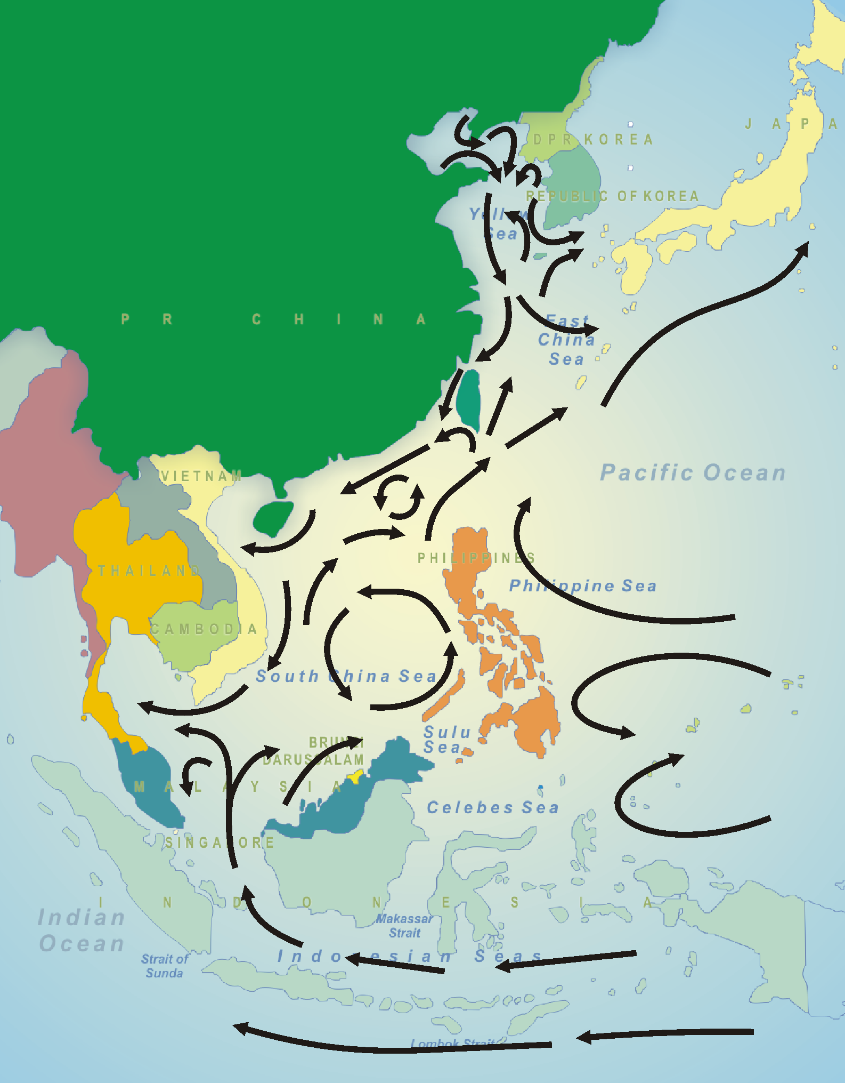

Contributions of the GEF Regional Projects (1994-2005)

In 1994, eleven countries from the region namely Brunei Darussalam, Cambodia, China, DPR Korea, Indonesia, Malaysia, Philippines, Thailand, Republic of Korea, Singapore, and Vietnam participated in a GEF/UNDP/IMO regional project on the Prevention and Management of Marine Pollution in the East Asian Seas (MPP-EAS, 1994-1999). The achievements of the regional project led to a follow-on phase on “Building Partnerships in Environmental Management for the Seas of East Asia” (1999-2005). The same countries participated in the follow-on phase, with Japan joining as the 12th member. Over the last few years, a regional partnership arrangement has emerged among the 12 countries and international and UN organizations, NGOs and the private sector who are collaborating on project activities, which is popularly known as Partnerships in Environmental Management for the Seas of East Asia (PEMSEA). A major outcome of the PEMSEA partnership was the Sustainable Development Strategy for the Seas of East Asia (SDS-SEA), and its endorsement by the concerned Ministers in the Putrajaya Declaration. Other targets under this project include the establishment of a functional regional mechanism and a technical facility (i.e., PEMSEA Resource Facility) to support the implementation of the SDS-SEA.

The 9th Meeting of the PEMSEA Programme Steering Committee (PSC), August 2003, set up an intergovernmental Working Group and charged it with developing appropriate approaches and measures for implementing the SDS-SEA, including knowledge transfer requirements, funding arrangements and regional partnership formulation.

The Working Group completed its review in September 2004 (PEMSEA/WP/2004/14). It concluded that the lack of a regional implementing mechanism would weaken the emerging foundation for regional cooperation and stifle the regional enthusiasm to continue addressing the transboundary issues confronting the Seas of East Asia. Included among its recommendations to the 10th PSC Meeting were the recognition of PEMSEA, essentially composed of the 12 participating governments of the region addressing integrated coastal and ocean governance issues over the last decade, as the de facto coordinating mechanism for the implementation of the SDS-SEA. In addition, the Working Group recommended that PEMSEA countries should formulate a non-binding agreement for a long term SDS-SEA implementing mechanism, and include the following considerations:

- PEMSEA Partnership Council
A PEMSEA Partnership Council, to be formulated and agreed upon during the ongoing GEF/UNDP/IMO regional project, would be fully operationalized, with the functions of providing policy and operational guidance, as well as steering and monitoring the progress of the SDS-SEA implementation. The Working Group further recommended that the current PEMSEA PSC be transformed into the Partnership Council, with appropriate adjustments of membership to include government and non-government representation and other concerned aspects in the future.

b) EAS Congress
PEMSEA’s EAS Congress, which was held in December 2003, would be regularized into a tri-annual regional congress, including governments, the media, NGOs, the business sector, academe and other concerned stakeholders, to monitor the progress of SDS-SEA implementation, and to include high-level policy (ministerial) meetings, sectoral and cross-sectoral seminars/workshops, and ocean sector exhibitions.

c) Regional Partnership Fund
A regional Partnership Fund would be established and governed by the PEMSEA Partnership Council as part of the financing arrangements for the SDS-SEA implementation, to channel and ensure the best use of voluntary contributions from the countries, international agencies, donors, other institutions and individuals.

d) PEMSEA Resource Facility (PRF)
A PEMSEA Resource Facility (PRF) would be set up by the end of the current initiative. The substantiation of a self-sustaining, service-providing PRF, including the delivery and mobilization of policy and technical advice, capacity building and technical support for sustainable coastal and ocean governance, as well as secretariat services to the PEMSEA Partnership Council and EAS Congress, would be confirmed as part of the future implementation programme for the SDS-SEA. The Working Group further recommended that the Regional Programme Office (RPO) for the regional project be transformed into the PRF.

The Working Group recommended the adoption of a road map and schedule to ensure that an agreement among countries concerning the proposed regional implementing mechanism for the SDS-SEA be in place before the completion of the current regional project in 2006.

The 10th intergovernmental PSC Meeting of the PEMSEA Regional Programme was held in Xiamen, PR China, from 25 to 29 October 2004. The Meeting adopted the recommendations of the Working Group, as presented. In addition, the PSC Meeting set up a drafting group to prepare a document that would detail the transformation of the existing project-based PEMSEA arrangement (i.e., PSC and RPO) into a fully functional, self-sustaining regional implementing mechanism, as well as to draft a PEMSEA Partnership Agreement 2006, which would confirm country commitments (e.g., national policies, programmes of action, and in-kind and financial resources) to the regional implementing mechanism for SDS-SEA. The Meeting also recommended that the subject agreement be endorsed by participating governments, for signature at the Ministerial Forum on the Implementation of the SDS-SEA during the EAS Congress 2006.

Project Context and Project Design

The recommendations of the 10th intergovernmental PSC Meeting remove much of the concern and uncertainty with regard to a regional implementing mechanism for the SDS-SEA. Although much work remains to formulate and achieve consensus on the proposed agreement among PEMSEA members and collaborating agencies and programmes, the mood is positive that such an agreement is achievable within the timeframe of the existing regional project. Initial discussions with the World Bank/GEF Investment Fund and GEF LME projects have been constructive, with consensus on the benefits of working collaboratively to put together the necessary partnerships, policies, capacity building, and knowledge sharing measures to ensure replication and sustainability of individual and collective initiatives in sustainable financing, public-private partnerships, coastal and ocean governance, resource conservation and pollution reduction. Other positive signs include initiatives in national coastal policy development – a major thrust of the SDS-SEA. The Republic of Korea already has a national coastal policy, and the process of developing national coastal policies has recently begun in Thailand, Malaysia and the Philippines. Many other countries have expressed interest in taking up this action. In addition, PEMSEA’s progress and experience in integrated management of marine and coastal areas, and the establishment of ICM demonstration and parallel sites in several countries of the region provide a sound basis for scaling up ICM working models and best practices across the region. Likewise, as part of the project development process, collaborative arrangements are being negotiated with key players (in addition to UNDP and IMO), such as UNEP-GPA, FAO, ASEAN, IOC/UNESCO, international NGOs, donors, financial institutions, the business community and concerned user States, in relation to the SDS-SEA implementation programme.

Over the years, numerous country and sub-regional capacity enhancement projects have been implemented by donors and UN and international agencies, primarily in environmental research, development of strategic plans and transferring skills and understanding related to problematic issues on a sector-by-sector basis. While contributing to the overall regional capacity, such projects have been short-term, sector-specific, and relatively isolated from mainstream management programmes. As a consequence, the desired changes are not being seen on-the-ground, and the pool of skilled human resources that has been nurtured by such projects remains scattered among different local, national and regional institutions and organizations. This is an area where the linkage with GEF IW Learn will be imperative. There is a need to work with GEF IW Learn in order to accelerate knowledge sharing among projects and stakeholders, identify experts and institutions within and outside the region that can contribute to on-the-ground problem solving, and facilitate smart partnerships across sectors, boundaries and levels of government.

The time is right for a concerted and collective effort to overcome these identified disparities, with the implementation of the Sustainable Development Strategy for the Seas of East Asia. The early stages of the implementation programme are the most critical in order to ensure that the momentum and commitment are maintained among the stakeholders. Success in selected priority areas will provide countries with confidence and realize on-the-ground benefits that will spur on interest and support among stakeholders for the long term SDS-SEA implementation programme.

Appendix 2

PROJECT ACTIVITIES FOR THE FULL PROJECT

The following project activities are indicative. The Block B PDF project would entail working with PEMSEA countries, GEF IW projects, World Bank and other financial institutions, as well as other collaborators to define their respective priorities and commitments to sustainable development within the framework of the SDS-SEA, and to formulate activities where support and cooperation would serve as a leverage to accelerate initiatives and/or to achieve wider beneficial impact to stakeholders.

The project is one element of a broader strategic partnership for SDS-SEA implementation, also consisting of a intergovernmental, multisectoral regional coordinating mechanism for the implementation of the SDS-SEA, and an investment fund to finance the environmental infrastructure improvements that are targeted by the regional mechanism. This would complement the activities of the 15 participating countries, the World Bank, ADB, bilateral programmes of donors and other entities, ongoing GEF IW projects in the region, the private sector and business community, as well as programmes and initiatives of other UN and international agencies and organizations, in accordance with the WSSD POI, MDG and Agenda 21. The project is not duplicative or stand alone, but would serve as a vehicle for cooperation, based on the framework and objectives of the SDS-SEA, and within the capacities of countries and their partners.

The project is identified as a series of activities covering three periods: transition; transformation and sustainable operations.

- Transitional Period: 2007-2010

Component 1: A country-owned regional mechanism for SDS-SEA Implementation

Objective: Mobilize regional partnerships, capacities and services, as well as legal, financial and institutional arrangements for the sustainable implementation of the SDS-SEA

Outcomes:
- An intergovernmental, multi-sectoral EAS Partnership Council fully operational, and working as a viable regional mechanism for SDS-SEA implementation oversight and coordination, capable of coordinating regional actions to overcome transboundary issues facing the East Asian Seas, particularly prevention and mitigation of eutrophication and unsustainable use of marine and coastal resources
- a rolling 10-year regional partnership program is in place, covering environmental hotspots of transboundary significance, including priority programs and targets, national commitments and capacities, gaps and capacity disparities, and partnership arrangements to address the inequalities.
- a prototype voluntary regional Partnership Fund, supported by countries and donors, serving to overcome disparities at the national and local levels, is evaluated and refined. The Partnership Fund would serve as a facility for countries helping countries within the region (e.g., RO Korea and DPR Korea), as well as for countries that are users of the East Asian Seas to support capacity development and the implementation of the SDS-SEA. A donors meeting is organized to capitalize the fund, with inputs from countries and donor agencies
- a country-financed PRF secretariat fully staffed by regional personnel and providing support services to the EAS Partnership Council and to established regional technical, scientific and local government networks
- A PRF policy and technical support services, implementing this project, and developing and implementing other projects funded by GEF and other organizations
- a systematic approach to environmental monitoring, evaluation and information exchange is in place, and a regional state of coasts reporting system is operational
- an EAS Congress is held every three years, with the support of governments and other stakeholders, to monitor the progress of SDS-SEA implementation, with a high-level policy ministerial meeting, sectoral and cross-sectoral seminars/workshops, and ocean sector exhibitions

Success criteria:
- A fully functional intergovernmental, multi-sectoral EAS Partnership Council, meeting every 18 months, assessing progress, taking corrective actions and continually improving the 10-year framework of programmes for SDS-SEA implementation.
- A regional Partnership Fund with seed contributions from donors and countries, operating in accordance with management and disbursement rules and operational procedures, and strengthening capacities across the region for SDS-SEA implementation.
- A PRF secretariat established and fully supported by countries. PRF policy and technical support services achieving the objectives and outputs of this project, and providing value-added services to countries and stakeholder in the region and outside of the region on a cost recovery basis.
- An EAS Congress 2009 successfully implemented, co-sponsored by governments and collaborating organizations, including a Minister’s Forum with a ministerial declaration on the implementation of the SDS-SEA from 2009 to 2012.
- A regional State of the Seas report published and distributed at the EAS Congress 2009.

Component 2: National policies and action plans for sustainable coastal and ocean development
Objective: Facilitate the development, adoption and implementation of national policy, legislative and institutional reforms aimed at integrated, multidisciplinary and multi-sectoral coastal and ocean management and the implementation of international environmental instruments.

Outcomes:
  - common methodology and indicators established for assessing contributions made by the coastal and marine areas/sectors to overall social and economic development
- national assessment of social and economic contributions of coastal and marine areas/sectors initiated
- national agenda for sustainable coastal and ocean development
- policy, legal and institutional reforms among participating countries, such as national coastal and ocean policy, ICM legislation, and programmes of action for the implementation of the Global Programme of Action and the Montreal Declaration, in conformance with paragraph 30, 32, and 33 of the WSSD POI (Appendix 1, Table 1).
- interagency and multi-sectoral mechanisms established, including identified strategic partners, to coordinate national programs supporting SDS-SEA implementation
- rolling 10-year national programs, in support of the foresaid policy and legal reforms including identification of gaps and deficiencies and capacity building goals for sustainable coastal and ocean management, particularly with regard to arresting coastal and marine pollution from land-based and sea-based activities, implementation the code of conduct for responsible fisheries and the resulting risks to ecosystems, human health and society, in accordance with paragraphs 32 and 33 of the WSSD POI (Appendix 1, Table 1).

Success criteria:
- National assessments of social and economic contributions of coastal and marine areas/sectors completed in two countries and information published and disseminated
- National strategies and action plans for sustainable coastal and ocean development initiated/adopted/implemented in at least 33% of the participating countries, including pollution prevention from land-based and sea-based activities, invasive alien species and ballast water management, effective management of marine protected areas and wetlands, and ecosystem-based management of watersheds, estuaries and coastal waters
- Interagency and multi-sectoral coordinating mechanisms established, with 10-year country programs.

Component 3: Scaling-up ICM Programs
Objective: Scale-up the application of ICM to a practical, on-the-ground response programme aimed at achieving sustainable development of coastal lands and waters in the region
Outcomes:
- national ICM policy/legislation or programmes initiated/adopted/implemented in at least 5 countries as part of national ocean policy and 10-year framework programme (Component 2), providing incentives for and facilitating ICM replication
- national and regional ICM task forces leading capacity building/technical assistance programs in ICM development and replication, improving awareness among different sectors of society, and mobilizing participation and support for pollution prevention and control projects, and restoration and sustainable management of coastal and marine resources
- technical support programmes in place, establishing national ICM training centers, and providing training of trainers, training manuals, modules, materials, and a pool of lecturers
- systematic process for monitoring, evaluating and reporting progress, outputs and impact of ICM programs, and facilitating their refinement due to changing circumstances
- site-specific/issue-specific integrated management programs implemented in four (4) selected environmental hotspots of the region (i.e., Manila Bay; Bohai Sea; Masan-Chinhae Bay; Jakarta Bay), providing lessons, practices and knowledge that is transferred to national ICM programs across the region
- an ICM Code specifying the core requirements for implementation and recognition of ICM programs developed and adopted
- a voluntary ICM certification/recognition scheme, developed and tested as an incentive for local governments and stakeholders to establish and maintain ICM programs

Success Criteria
- At least 5% of coastlines of the region covered by integrated coastal management (ICM) programmes
- 5 national and one regional ICM Task Forces established and operational
- At least 3 national ICM training centers established and operating
- A voluntary ICM Code and certification/recognition system in place and tested as an incentive for local governments to implement ICM programs
- A synthesis report on the impact of ICM implementation in the region, presented to the EAS Congress 2009

Component 4: Twinning arrangements for marine and coastal ecosystem management
Objective: To forge functional twinning arrangements of selected sites involving south-south and north-south collaboration to share knowledge and experience in innovative approaches to ecosystem based management of watersheds, estuaries and adjacent coastal and large marine ecosystems.

Outcomes:
- Twinning arrangements in place and operational involving:
  - Areas with established ecosystem-based management programmes and the locations where similar programmes are yet to be developed including Chesapeake Bay Albermarle-Pamlico Sound, Seto Inland Sea, Bohai Sea, Manila Bay, Masan-Chinhae Bay and Jakarta Bay; as well as
  - Areas sharing experience regarding the application of ICM for effective management of marine protected areas, such as the Great Barrier Reef and Sulu-Sulawesi Sea.

Success criteria:
- Innovative methodologies and approaches transferred amongst the identified areas;
- Regular workshops and exchange of project personnel;
- Knowledge on good practices in ecosystem-based management shared and related information disseminated;
- Acceleration of ecosystem-based management amongst sites, e.g., moving from single purpose management on specific resource or habitat type to more comprehensive approaches addressing the interconnections between the ecosystem components (to be further developed during the PDF-B project).
Component 5: Collaborative arrangements between and among research institutions, universities, the private sector, governments, communities, NGOs, and Areas of Excellence

Objective: Strengthen the use of the region’s intellectual capital and human resources to address policy, economic, scientific, technical and social challenges and constraints for integrated management and sustainable uses of the environment and resources in the region.

Outcomes:
The implementation of this component is in accordance with paragraph 34, WSSD POI (Appendix 1, Table 1), will result in the following:
- an internet-based capacity building, technical support system and information portal in place, building awareness, transferring knowledge and mobilizing participation among stakeholders, in syndication with the GEF IW Learn Network
- community-based programs established involving women, the youth, indigenous people, and marginalized groups, with a particular focus on restoration of habitats for enhancing nutrient reduction, protection against natural hazards, and creating alternative livelihoods, in collaboration with UNDP Small Grants Programme
- a regional network of local governments operating and committed to achieving tangible improvements in the sustainable use and development of marine and coastal areas through ICM practice
- an Areas of Excellence programme launched within existing research institutions and institutions of higher learning, providing research, education, training, expert advice and technical support to countries on management issues and other topics of concern
- a regional private sector advisory group is established and providing advice to countries on the structuring of investment projects and risk reduction techniques and requirements

Success criteria:
- At least three (3) Areas of Excellence established and providing scientific and technical input to SDS-SEA programmes at the national and regional levels;
- Knowledge-sharing programme focused on ICM experience and lessons learned in the region, functional and operating through GEF IW:LEARN Resource Center (IWRC)
- Local governments, communities and NGOs engaged in programmes supporting the achievement of sustainable development goals at local, national and regional levels
- In-country and regional local government networks effectively promoting the replication of ICM programmes
- National and regional ICM Task Teams conducting training programmes and providing technical support to national and local governments in ICM programme development and implementation
- Regional private sector advisory group contributing to EAS Partnership Council decisions concerning leveraging of private sector participation in environmental investments

Component 6: Increased Investment and Financing for Environmental Infrastructure Projects
Objective: To mobilize public and private sector investment in pollution reduction facilities and services through replication and scaling up of public-private partnership initiatives, particularly for pollution control in secondary cities and in industrial and agricultural enterprises in regional pollution hotspots.

Outcomes:
- An enabling environment for private sector participation and investment in environmental infrastructure projects at existing and new ICM sites across the region.
- Scaling up of PPP programs in at least 3 participating countries, through replication of good practices in public-private partnerships (PPP), as demonstrated under the GEF medium-sized PPP project, and other financing mechanisms.
- Private sector advisory group set up, developing proposals and guidelines for innovative policies, programmes and approaches for strengthening private sector investment in unfunded or underfunded pollution reduction programs of countries.

Success criteria:
- Good practices in public-private partnerships (PPP) and other financing mechanisms established, analyzed and promoted for replication.
- 10-year investment plans developed at selected ICM sites and regional hotspots
- Private sector investments leveraged in the development, construction, management and operation of pollution reduction facilities, in collaboration with governments and other investors
- Private sector advisory group providing advice and support to governments in establishing and promoting a policy and investment environment for promoting private sector investment.

Component 7: Coordination of a Strategic Partnership for Implementation of SDS-SEA
Objective: To coordinate a Strategic Partnership between participating countries, UNDP, IMO, the World Bank and other stakeholders in the implementation of the SDS-SEA in particular in the implementation of the GEF/World Bank Pollution Reduction Investment Fund for the LMEs of East Asia and GEF/UNDP/IMO Regional Programme for the Implementation of the SDS-SEA.

Outcomes:
- Effective inter-agency and inter-governmental coordination of the Strategic Partnership through regular meetings/ workshops, information exchange and knowledge transfer;
- Organizational arrangements in place, with World Bank as the Investment Fund Manager and PEMSEA Resource Facility as the chief advisor to the Fund(s) on all environmental/technical issues and establishment of the project preparation standards, including pre-selection of local consultants that the target clients can use in preparation of their projects;
- PEMSEA Resource Facility providing policy and technical support to national and sub-national players for the implementation of the GEF/World Bank Pollution Reduction Investment Fund, including the creation of favorable policy climates and the identification and promotion of priority investment projects in Manila Bay, Bohai Sea and other selected pollution hotspot sites throughout the region, resulting in increased public and private sector investments in sewage and sanitation, and industrial and agricultural waste treatment facilities;
- PEMSEA Resource Facility providing technical assistance to local governments and small and medium-sized enterprises in the preparation of quality project proposals for sewage and sanitation, and industrial and agricultural waste treatment systems, thereby improving accessibility to capital financing from banks, investors, donors, international agencies, and the business community, as well as facilitating a fully replicating project preparation fund, developed under the World Bank/GEF Pollution Reduction Revolving Fund project (details to be developed with World Bank during PDF-B project).

Success criteria:
- A functional and effectively coordinated Strategic Partnership involving the participating countries, UNDP, IMO, the World Bank, UNEP and other stakeholders using PEMSEA Resource Facility (PRF) as an effective secretariat for mobilizing resources to enhance SDS-SEA implementation, including knowledge and information sharing, replication of good practices as well as scaling up investment in pollution control of land-based water pollution in coastal urban and peri-urban areas of East Asia.
- Broad awareness across all Strategic Partnership entities of respective roles, progress, activities, contact points, etc.
- Preparation of bankable projects and leveraging public–private sector investment in synergy with the 10-year regional and national program for SDS-SEA implementation, particularly in improving sewage, water and sanitation facilities, industrial waste water treatment and management of agriculture wastes.
- A cost recovery mechanism for the PEMSEA Resource Facility, to maintain coordinating and technical support services
- A mid-term review involving all members of the Strategic Partnership and hosted by the EAS Partnership Council to assess progress and map new direction,

B. Transformation Period: 2010 to 2012

The detailed activities for the transformation period will be further reviewed and developed based on the outcomes of the transitional period.

Component 1: A country-owned regional partnership arrangement for SDS-SEA Implementation
Objective: Mobilize regional partnerships, capacities and services, as well as legal, financial and institutional arrangements for the sustainable implementation of the SDS-SEA

Outcomes:
- suitability and effectiveness of the EAS Partnership Council reviewed, relative to both short-term and long-term programs, objectives and targets for SDS-SEA implementation. Verification conducted on the regional partnership approach, and its effectiveness as a mechanism for achieving intergovernmental and multi-sectoral commitment and progress toward sustainable development of coastal and marine resources. Considerations such as social, economic, environmental, and political changes within the region, and externally, and their impact on the Council’s 10-year programme, would also be taken into account. The results of the Council review will be used as a basis for improving Council operations, and transforming the body into an independent regional organization.
- rolling 10-year framework of regional partnership programmes, in place with agreed set of specified targets, indicators, monitoring and evaluation program, capacity needs assessment, and training and capacity building program
- appropriate concerted action plans to facilitate integrated implementation of international instruments and areas of technical cooperation are integrated into the 10-year framework programme;
- a regional Partnership Fund, operational and capitalized through voluntary contributions of resources from countries, international agencies, donors, institutions, and individuals, serving to overcome disparities at the national and local levels
- a PEMSEA Resource Facility (PRF) providing: a) secretariat services to the EAS Partnership Council; and b) policy and technical support services to participating countries and other stakeholders, evaluating and transferring good practices from projects and programs, developing, and managing bankable projects in collaboration with those supported by GEF and other partners, and delivering specialized skills training, policy and technical advice and support on sustainable coastal and ocean governance, environmental investment projects, public-private partnership arrangements, recognition/certification of ICM sites and ports, project development and management, and other related technical activities, on a cost recovery basis.
- A regional EAS Congress regularized as a tri-annual regional congress, co-sponsored by governments, NGOs, the business sector, academe and other concerned stakeholders, including a Ministerial Forum, serving as vehicle for countries to re-confirm and/or refine their commitments to the implementation of the SDS-SEA, and an International Conference to monitor and evaluate the progress of SDS-SEA implementation.
- A systematic approach to environmental monitoring, evaluation and information exchange developed and in place, with sustainable development indicators, in collaboration with countries, other regional programmes and projects, and international agencies and organizations, facilitating the sharing of monitoring results among countries of the region and among programmes, providing a more accurate picture of the state of the East Asian Seas

Success criteria:
- An independent regional organization established and fully operational
- A self-sustaining PRF providing secretariat and policy and technical support services to the countries and their partners
- A regional Partnership Fund, capitalized by donors and stakeholders and helping to overcome in-country and cross-country capacity disparities in SDS-SEA implementation
- A tri-annual EAS Congress, fully supported by stakeholders
- A second regional State of the Seas report published and distributed at the EAS Congress 2012, as a primary reference document on the impact of the SDS-SEA program.

Component 2: National policies and action plans for sustainable coastal and ocean development
Objective: Interagency and multi-sectoral coordinating mechanisms established in participating countries, with 10-year country programs in place and functioning

Outcomes:
- National assessments of social and economic contributions of coastal and marine areas/sectors completed in 6 countries
- National policies and action plans for sustainable coastal and ocean development promoted, implemented and extended
- Interagency and multi-sectoral coordinating mechanisms aimed at improving coherence in coastal and ocean policy, legislation, regulation and enforcement at local and national levels, and providing a home base for integrated management of marine and coastal areas
- Advocacy instruments and high level regional forums, such as the Asia Forum, engaged and heightening awareness and political commitment to the developed strategies and action plans at the national and regional levels.
- 10-year country programs reviewed on 2-year basis, assessed with regard to progress, effectiveness, deficiencies in existing programs and capacity gaps and reported to national coordinating mechanisms for improvements and update of capacity building programs
- Improvements adopted and implemented in support of national initiatives under the framework of the SDS-SEA.

Success criteria:
- Regional synthesis of social and economic contributions of coastal and marine areas/sectors completed, published and disseminated
- National strategies and action plans for sustainable coastal and ocean development adopted and implemented in at least 10 participating countries
- Interagency and multi-sectoral coordinating mechanisms established in at least 10 countries
- 10-year national programs in place, and integrated into the 10-year partnership program of the EAS Partnership Council
- Comprehensive regional capacity building program implemented and monitored by the EAS Partnership Council addressing major capacity disparities within and among countries in priority program areas

Component 3: Scaling-up ICM Programs
Objective: Scale-up the application of ICM to a practical, on-the-ground response programme aimed at achieving sustainable development of coastal lands and waters in the region
Outcomes:
- national ICM policy or programmes developed and adopted in 10 countries as part of national ocean policy and 10-year framework programme (Component 2), providing incentives for and facilitating ICM replication
- 10 national and a regional ICM task forces leading capacity building/technical assistance programs for local governments in ICM development and replication, improving awareness among different sectors of society, and mobilizing participation and support for pollution prevention and control projects, and restoration and sustainable management of coastal and marine resources
- technical support programmes establishing national ICM training centers, by providing training of trainers, training manuals, modules, materials, and a pool of lecturers
- systematic process for monitoring, evaluating and reporting progress, outputs and impact of ICM programs, and their refinement due to changing circumstances
- investment programs implemented in four (4) selected environmental hotspots of the region (i.e., Manila Bay; Bohai Sea; Masan-Chinhae Bay; Jakarta Bay), addressing time-bound pollution reduction targets
- PSSHE-MS and ICM certification/recognition schemes fully tested and recognized by countries of the region

Success Criteria
- At least 10% of coastlines of the region covered by integrated coastal management (ICM) programmes
- 5 National and one regional ICM Task Forces established and operational
- At least 5 national ICM training centers established and operating
- PSSHE-MS and ICM certification/recognition systems conforming to ISO 14001 and ISO 9001 standards, serving as a guide and incentive for local actions
- A synthesis report on the impact of ICM implementation in the region, presented to the EAS Congress 2009

Component 4: Collaborative arrangements between and among research institutions, universities, the private sector, governments, communities, NGOs, and Areas of Excellence
Objective: Strengthen the use of the region’s intellectual capital and human resources to address policy, economic, scientific, technical and social challenges and constraints for integrated management and sustainable uses of the environment and resources in the region.

Outcomes:
- 5 Areas of Excellence established within existing universities and research institutions, addressing critical management issues requiring intensive scientific investigations and scientific advice to managers
- Cross-site workshops conducted to develop guidelines and manuals on approaches in: basin-wide management; determination of water quality management objectives/pollution loads; pollution reduction allocation; and market-based regulatory tools
- Training programs and internet-based capacity building programs developed and implemented to build awareness, transfer knowledge and mobilize participation among stakeholders, in collaboration with GEF IW Learn
- Community-based programs established involving women, the youth, indigenous people, and marginalized groups, with a particular focus on restoration of habitats for enhancing nutrient reduction, protection against natural hazards, and creating alternative livelihoods, in collaboration with UNDP Small Grants Programme
- A self-sustaining regional network of local governments operating and committed to achieving tangible improvements in the sustainable use and development of marine and coastal areas
- A regional private sector advisory group evaluating private sector participation in environmental investment projects and providing advice to countries and the private sector in strengthening investment projects and risk reduction techniques and requirements

Success criteria:
- 5 AOEs operational
- Community-based projects successfully implemented and alternative livelihoods created
- A self-sustaining regional network of local governments operating as an advocacy group for ICM implementation across the region
- Regional private sector advisory group contributing to EAS Partnership Council decisions concerning leveraging of private sector participation in environmental investments

Component 5: Investment and Financing Program
Objective: Mobilize private sector investment in pollution reduction facilities and services, particularly with regard to pollution control in secondary cities and in industrial and agricultural enterprises operating regional pollution hotspots, in collaboration with World Bank, other IFIs, governments, donors and the private sector.

Outcomes:
- A regional financing mechanism dedicated to pollution reduction, founded, capitalized and managed by IFIs, countries, donors and the financial industry of the region, serving to leverage public and private sector investments in project preparation, development, financing and management, on a replicating basis;
- A partnership arrangement between the PRF and the management of the regional financing mechanism, to enable the PRF to develop, promote and facilitate public and private sector investments in pollution reduction facilities and services, on a cost recovery basis, and strengthening the market demand for the financing mechanism
- An enabling environment for private sector participation and investment in environmental infrastructure projects established at ICM sites across the region.
- 10-year investment plans developed at ICM sites and regional hotspots
- Good practices in public-private partnerships (PPP) and other financing mechanisms reviewed, improved and promoted for replication.
- Private sector investment promoted and mobilized in identified projects, in collaboration with interested governments, World Bank and other IFIs, commercial and development banks, donors and operating companies
- Private sector advisory group operating and developing proposals and guidelines for innovative policies, programs and approaches for strengthening private sector investment in unfunded or underfunded pollution reduction programs of countries.

Success criteria:
- A regional financing mechanism dedicated to pollution reduction, founded, capitalized and managed on a fully replicating basis, and managed by World Bank
- PRF developing, promoting and facilitating public and private sector investments in pollution reduction facilities and services, on a cost recovery basis
- Good practices in public-private partnerships (PPP) and other financing mechanisms adopted and implemented by national and local governments, generating investment opportunities in the environmental sector.
- 10-year investment plans developed and implemented at ICM sites and regional hotspots
- Private sector investments leveraged in the development, construction, management and operation of pollution reduction facilities, in collaboration with governments and other investors

C. Sustainable Operation Period: 2013 to 2016

The final 4 years of the project would be the sustainable operation period. The GEF would exit as a major sponsor of the project, and countries and their partners would take full responsibility for SDS-SEA implementation, and the sustainability of the strategic regional partnership and its operating arrangements. The EAS Partnership Council would take over the management responsibility for the implementation of the SDS-SEA, with the PRF serving in the role of day-to day operations coordinator/manager. All operational arrangements, policies, supporting mechanisms and procedures will be in place at the start of this period. The Council, its membership and the PRF will be accountable for meeting performance targets, and for the continual improvement of the program, in order to achieve the shared vision of all stakeholders for a sustainable resource system for the Seas of East Asia.

The EAS Congress will serve as a forum for GEF and other partners to evaluate the sustainable operation of the regional organization, and to draw lessons from the experience for use elsewhere.

Detailed activities of this period will be reviewed, developed and finalized based on the outputs and outcomes of the transitional and the transformation periods and partnership reviews by the strategic partners.
PART II – PROJECT DEVELOPMENT PREPARATION

A – Description of Proposed PDF-B Activities

The PDF-B project will involve six major activities.

Activity 1: Complete country baseline assessments:

A joint team of international experts and national consultants will be contracted to assist countries with the implementation of the following:
- Conduct baseline assessments in 8 countries (Cambodia; China; DPR Korea; Indonesia; Malaysia; Philippines; Thailand; Vietnam) to identify: institutional arrangements; policies; programs; key objectives; operational budgets; actual water pollution control activities; size and source of investments; unfunded or under-funded programs; strengths, technical gaps and needs; risks and constraints; development plans; and any other issues related to SDS-SEA implementation. The baseline assessment will include IFI and donor-supported projects in aid of sustainable development, with a main emphasis on facilitating and supporting scaling up of ICM practices in coastal regions, including financing and investment policies and plans for environmental infrastructure improvement projects;

- Prepare TORs for the formulation of mechanisms and alternatives for streamlining and mobilizing national policies and institutional responsibilities in sustainable coastal and ocean development and ICM implementation, as well as accelerating investments to meet the targets and schedules of the SDS-SEA, WSSD POI and MDG. These would allow the identification of various country institutional and governance reforms, which would achieve the highest cost-benefit and least cost solution toward regional and global targets, such as:
    - at least 5% of the coastline of the region covered by ICM by 2009;
    - reducing by half the proportion of people without access to safe drinking water and sanitation facilities by 2015;
    - implementing the Global Programme of Action;
    - reversing current trends in natural resource degradation;
    - restoring fisheries to their MSY by 2015; and
    - developing and strengthening a range of activities to improve natural disaster preparedness and response.

- Consult with the PEMSEA participating countries that are not eligible for GEF support (i.e., Brunei Darussalam, Japan, RO Korea and Singapore). The objective of the consultations is to identify opportunities for implementing cost-shared project initiatives (i.e., South-South cooperation) in SDS-SEA implementation, in areas such as:: institutional reforms in coastal and ocean policy; ICM legislation; eco-system based management of watersheds, estuaries and coastal waters; pollution prevention from land-based activities; ballast water management; technical cooperation and knowledge transfer in the formulation and implementation of investments in pollution prevention, reduction and control facilities in identified regional pollution hotspots (i.e., Manila Bay; Bohai Sea; Masan-Chinhae Bay; Jakarta Bay); and related capacity building and training initiatives.

The consultants are expected to make at least two trips to each capital (i.e., data collection, collation and analysis; national consultation and consensus building), each trip approximately two weeks.

Outputs:
- Review of national policies, programs and commitments to activities in support of marine and coastal management, sustainable fisheries, pollution prevention and reduction, and natural disaster preparedness and response;
- Baseline costs of the national initiatives that are contributing to the goals and objectives of SDS-SEA;
- Confirmation of ongoing and proposed donor-assisted projects that contribute to country capacities to meet objectives within the framework of the SDS-SEA;
- Delineation of cost-sharing contributions from Brunei, Japan, RO Korea and Singapore for the implementation of SDS-SEA, including knowledge-sharing and capacity building;
- TORs for streamlining and accelerating the development of national policies and action plans for sustainable coastal and ocean development, and ICM programs in support of regional and global targets for sustainable development;
- TORs for twinning arrangements for marine and ecosystem management, involving South-South and North-South collaboration in innovative approaches to ecosystem based management of watersheds, estuaries, and adjacent coastal and large marine ecosystems.

Activity 2: Confirmation of Lao PDR, Myanmar and Timor Leste

International experts will be assigned to conduct consultations with the two countries to:
- Complete a baseline assessment of the three countries and determining their respective plans, programs, policies, capacities and needs with regard to governance of marine and coastal resources;
- Delineate ongoing and proposed bilateral and multilateral activities within the countries relative to the implementation of the SDS-SEA and specifically for: ICM scaling up programs; planning and implementation of environmental infrastructure projects, capacity-building needs assessment; and capacity building programs to fulfill institutional and human resource requirements in sustainable development programs;
- Conduct interagency and multi-sectoral workshops addressing: major challenges, benefits and risks of participation in SDS-SEA implementation; country expectations from the project; institutional arrangements for in-country and regional coordination; capacity building; and the role, responsibility and commitment of each country to the implementation program, including resource commitments; .
- Prepare TOR for the two countries’ participation in the implementation of the SDS-SEA, focusing on the reduction in existing disparities in awareness and capacities in marine and coastal resource management, and related policies and practices at the national and local levels, with a view to accelerating the adoption and implementation of national ICM programs, in partnership with interested donors and international agencies.

Outputs:
  - Review of national policies, programs and priorities in the two countries with regard to sustainable development of marine and coastal resources;
  - Assessment of capacities, gaps, needs, ongoing initiatives and risks related to participation in the implementation of the SDS-SEA;
  - Consensus on country activities to be undertaken in support of SDS-SEA implementation;
  - Commitments by the three countries to participate in the implementation of the SDS-SEA as partner countries;
  - TORs on the three countries’ participation in the implementation of the SDS-SEA.

Activity 3: Conduct National and Regional Consultations:

A key component of the PDF-B project will be stakeholder consultation and consensus-building on the cost-effective and efficient use of available resources for the implementation of the SDS-SEA. International experts and national consultants engaged in Activity 1 and 2 will assist the PEMSEA RPO with the consultation process and in the preparation of identified outputs.

National consultations/workshops will be organized to:
- formulate approaches for fully engaging institutional, intellectual and human resource capital to overcome identified challenges and barriers, including the development of national ICM task forces, Areas of Excellence, ICM training centers, etc.;
- develop collaborative activities and approaches for strengthening participation and coordination among government agencies, levels of government, donors and other major stakeholders, such as interagency and multi-sectoral coordinating mechanisms and/or in-country local government networks for ICM implementation;
- relate opportunities for alleviating poverty and improving the participation of women, the poor and other marginalized groups in coastal resource management through ICM;
- assess the demand for, and operating modalities of, a regional Partnership Fund aimed at reducing in-country and cross-country disparities in the implementation of the SDS-SEA;
- examine national programs for pollution control, including unfunded and underfunded mandates of national and local governments, relevant regulations and policies, financing programs, and incentives for public and private sector investment in environmental infrastructure;
- ascertain relevant and measurable program performance indicators, including process, stress reduction and environmental status indicators, which can be used to monitor progress and gauge changes that occur as a consequence of the project.

Regional consultations will be organized to:
- inform and confer with major international players in the region (e.g., UNDP; UNEP; IMO; FAO; IOC/UNESCO; ESCAP; World Bank; ADB; ASEAN; APEC; CI; IUCN; WI; WorldFish Center; WRI; and WWF) regarding a strategic partnership in support of SDS-SEA implementation;
- delineate collaborative activities and/or partnership arrangements with regional bodies, GEF regional projects, international agencies and financial institutions, international NGOs, donors, and the business community regarding implementation of the SDS-SEA for 2007-2009;
- identify appropriate methodologies and indicators for assessing contributions made by coastal and marine sectors to overall social and economic development in the region;
- plan the different components of the GEF Strategic Partnership with the international partners, such as UNDP, IMO, the World Bank, and UNEP, including the respective roles, responsibilities, financial commitments, contact points, targets, progress indicators, and monitoring, evaluation and reporting procedures;
- develop an organizational and functional relationship between World Bank and the PEMSEA Resource Facility (PRF) regarding the operation of the World Bank/Global Environment Facility Pollution Reduction Investment Fund for Large Marine Ecosystems of East Asia, including a replication strategy for the Investment Fund as a major source of financing for the SDS-SEA implementation;
- plan a training and knowledge sharing system with GEF IW Learn, to bridge information and knowledge gaps concerning good practices in sustainable development of marine and coastal resources among stakeholders in the region, and across GEF IW projects globally.

A regional consultative workshop on the Strategic Partnership for implementation of the Sustainable Development Strategy for the Seas of East Asia will be organized during the planning phase to establish an open dialogue among countries, concerned international agencies and financial institutions, donors, and other stakeholders. Key issues to be covered during the workshop will be: the objectives of the Strategic Partnership; organizational arrangements and operating modality; harmonization with existing initiatives; project development and approval process; performance indicators; monitoring and reporting; evaluation and transfer of information and knowledge; and a strategy for replicating good practices that are derived from the Strategic Partnership.

Outputs:
  - TORs for the development/strengthening of policy, legislative and programs reforms dealing with: a) sectoral causes of organic, nutrient and toxic releases to watersheds, estuaries, and adjacent coastal and large marine ecosystems; and b) financing programs and investment opportunities for pollution reduction and prevention, including leveraging of public and private sector investments;
  - TORs for the development and establishment of national interagency and multisectoral coordinating mechanisms, in-country local government networks, national ICM Task Forces, AOE, and ICM training centers;
  - TORs for the conduct of national assessments of social and economic contributions of coastal and marine sectors/areas;
  - Stakeholder Participation Plan, identifying major stakeholders and their roles and contributions to the implementation of the SDS-SEA at the local, national and regional levels;
  - Criteria, organizational arrangements and approval process for a UNDP Small Grants Program fund, to reinforce community-based actions for restoration management of marine and coastal resources, with particular attention to livelihood programs for women and other marginalized groups within the framework of ICM programs;
  - Needs assessment and TORs for the development and implementation of a regional Partnership Fund;
  - Concurrence among countries and other major players on performance indicators, and monitoring, evaluation and reporting procedures;
  - MOAs/MOUs with national, regional and international stakeholders covering collaborative activities under the SDS-SEA framework;
  - A replication strategy for the GEF/World Bank Pollution Reduction Investment Fund;
  - A training and knowledge sharing plan, in collaboration with GEF IW Learn;
  - GEF Strategic Partnership framework for the implementation of the SDS-SEA, including an organizational and functional relationship between World Bank and the PRF.

Activity 4: Monitoring & Evaluation Plan.

A specific monitoring and evaluation program will be developed, in accordance with the monitoring and evaluation indicators for GEF International Waters projects and the consensus established during national and regional consultations. Three levels of indicators will be developed, namely: process indicators to measure the effectiveness of the actions undertaken by countries and their partners in scaling up ICM; stress reduction indicators, such as reductions in land-based pollution of marine and coastal waters and habitat loss, sustainable fisheries, and reduced incidence of invasive marine species, as appropriate; and environmental status indicators for identifying changes in the state of the environment. These indicators will serve as the primary measures for determining the progress and achievements of the first three-year SDS-SEA implementation program, and for evaluation by all stakeholders prior to embarking on a second three-year program (i.e., 2010 to 2012).

Output:
- Monitoring and evaluation plan, in accordance with the GEF and UNDP reporting requirements

Activity 5: Preparation of the GEF Executive Summary and the GEF/UNDP Project Document

An international expert experienced in GEF project preparation will be contracted to assist the countries in the preparation of the necessary documents for GEF and UNDP appraisal and approval. The international expert will integrate the various TORs, workshop recommendations, commitments, and plans, as developed and agreed upon during the country and regional consultation process developed into a comprehensive regional project for the implementation of the SDS-SEA. The GEF Executive Summary and the UNDP Project Document are scheduled to be presented to the GEF Council in November 2006.

Output:
- A full set of GEF and UNDP project documents

Activity 6: Bridging activities

Prior to the start up of the project, technical assistance will be provided to Lao PDR, Myanmar and Timor Leste in their preparations to join the implementation process. This would entail national training workshops on ICM program development and implementation, as well as a study tour to an existing ICM site. The intent is to assist the countries to coordinate and strengthen their national commitments to and participation in the implementation of the SDS-SEA.

Output:
- Capacity needs assessment
- Introductory ICM orientation course for senior managers and policymakers
- TOR for National ICM Task Force in each country
- Study Tour to Xiamen, PR China by senior managers and policymakers

B – PDF B Outputs
- A full set of GEF and UNDP project documents, namely an Executive Summary and a Project Document;
- Confirmation of two new PEMSEA members and related agreements regarding participation in the implementation of the SDS-SEA;
- MOAs/MOUs with stakeholders covering collaborative activities and co-financing commitments within the SDS-SEA framework;
- National and regional consultative workshop reports;
- A Stakeholder Participation Plan;
- A Monitoring and Evaluation Plan;
- A GEF Strategic Partnership framework and operating modality;
- A Replication Strategy for good practices derived from the Strategic Partnership, including the GEF/World Bank Pollution Reduction Investment Fund as a major leverage for public and private sector investment in SDS-SEA implementation.

C – Institutional Arrangements
The PDF B activities will be executed by the IMO through the PEMSEA Regional Programme Office (RPO), with guidance from and in coordination with the PEMSEA Regional Programme Steering Committee, National Focal Points of PEMSEA, and UNDP Country Offices. The RPO will be responsible for the coordination of national consultants and international experts to assist countries with the development of the project design, proposal and GEF documents. The RPO will also be responsible for co-organizing national and regional workshops with participating countries, as well as implementing the proposed bridging activities in Lao PDR, Myanmar and Timor-Leste.

At the 11th Programme Steering Committee of the PEMSEA Regional Programme, the PEMSEA participating countries unanimously approved a Resolution in Support of the Strategic Partnership for Sustainable Development of the LMEs of the Seas of East Asia. In the Resolution, the countries commit their support to the GEF Project Pipeline Concepts on Implementation of the SDS-SEA and the World Bank/GEF Partnership Investment Fund for Pollution Reduction in the LMEs of East Asia, as approved by GEF. The Resolution also directs the PEMSEA RPO to collaborate closely with GEF, UNDP, World Bank and other concerned stakeholders and partners in the formulation of projects related to the sustainable implementation of the SDS-SEA.

During the 11th PSC Meeting, the PEMSEA participating countries also decided that:

- all participating countries eligible for GEF assistance be urged to endorse the PDF-B Application as soon as possible in order to facilitate the start-up of the project preparation process; and
- all countries assist and support the RPO in the completion of the Project Document, including letters of co-financing commitment by August 2006.

PEMSEA RPO will establish a strong alliance between participating countries, UNDP, World Bank and other participating regional and international agencies, institutions and programs, in forming the Strategic Partnership. The PEMSEA RPO, UNDP, the World Bank and GEF will conduct monthly face-to-face or video-conference meetings to review progress.

D – Timeline and Budget
See Annex 1 for the proposed timeline and budget. The PDF-B activities are expected to commence immediately after GEF approval of the proposal, and will be concluded by December 2006. The aim is to submit the Project Document to the GEF Council in Fall 2006.

The budget estimate is as follows:

Cost estimates for the PDF B Proposal
Activity 1: Country baseline assessments and TORs | 230,500
Activity 2: Confirmation of Lao PDR, Myanmar and Timor Leste | 103,500
Activity 3: Conduct National/Regional Consultation Workshops | 120,875
Activity 4: Monitoring and Evaluation Plan | 3,750
Activity 5: Preparation of the GEF Executive Summary and the GEF/UNDP Project Document | 97,750
Activity 6: Bridging activities | 97,500
TOTAL | 653,875

Annex 1 – Timeline and Budget:
PDF- B for the Implementation of the Sustainable Development Strategy for the Seas of East Asia

Activities | Deliverables | Cost (US $) |  | Organization Responsible for Deliverable | Deadlines
Activities | Deliverables | GEF PDF B | Co-financing | Organization Responsible for Deliverable | Deadlines
Activity 1:  Country baseline assessments | Eight (8) country baseline assessments; analyses of incremental costs and arrangements for co-financing constraints; disparities in capacities, at the national and sub-national levels. Cost-shared project initiatives with four (4) participating countries that are not eligible for GEF support | 230,500 | 76,000 (countries) | IMO/PEMSEA | January-April 2006
Activity 2: Confirmation of Lao PDR, Myanmar and Timor Leste | Confirmation of 3 new countries; 3 country baseline assessments; identification of capacity disparities and development of capacity building plan of action | 103,500 | 12,000 (countries)  19,500 (collaborating organizations/institutions) | IMO/PEMSEA | January-April 2006
Activity 3: Conduct National/Regional Consultation Workshops | Workshop reports; country and regional stakeholder consensus on Project Design; Stakeholder Involvement Plan | 120,875 | 61,000 (countries)  74,250 (collaborating organizations/institutions) | IMO/PEMSEA | January-April 2006
Activity 4: Monitoring and Evaluation Plan | Process, stress reduction and environmental status indicators, along with methodologies for monitoring, evaluating and reporting indicators to GEF, the countries and other stakeholders | 3,750 | 4,400 (countries)  2,500 (collaborating organizations/institutions) | IMO/PEMSEA | May-September 2006
Activity 5: Prepare project documents | GEF Project Document for approval | 97,750 | 44,000 (countries) | IMO/PEMSEA | September-November 2006
Activity 6: Bridging activities | Training Workshop and Study Visit Reports | 97,500 | 10,550 (countries) | IMO/PEMSEA | September-December 2006
SUB-TOTAL |  | 653,875 | 304,200
Executing Agency |  | 46,125
TOTAL |  | 1,004,200

ANNEX II

Letters of Endorsement

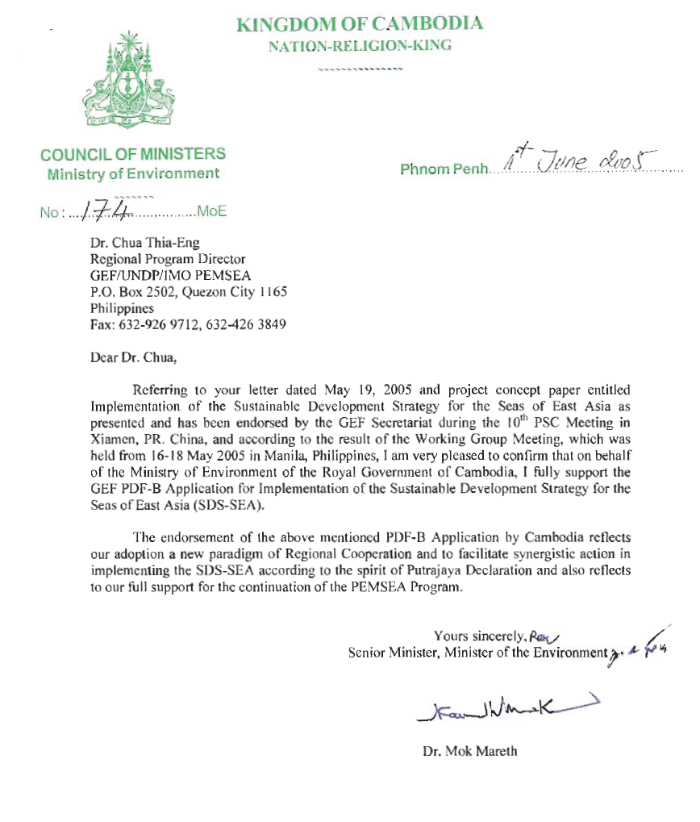

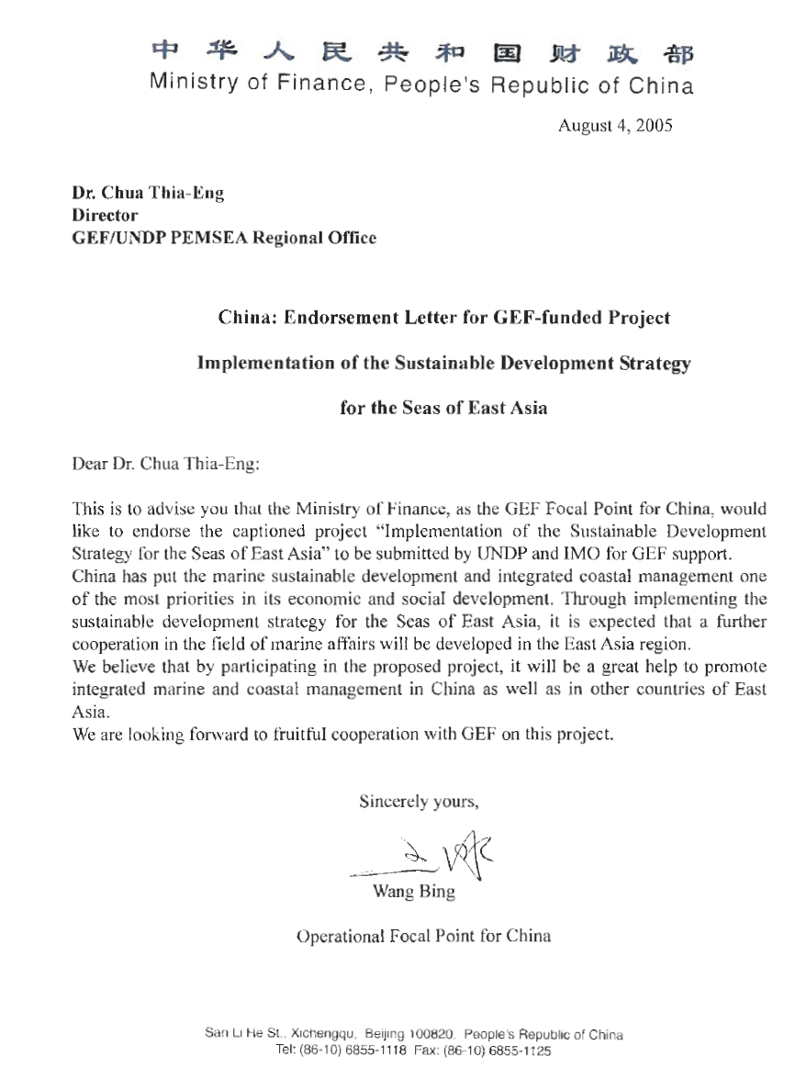
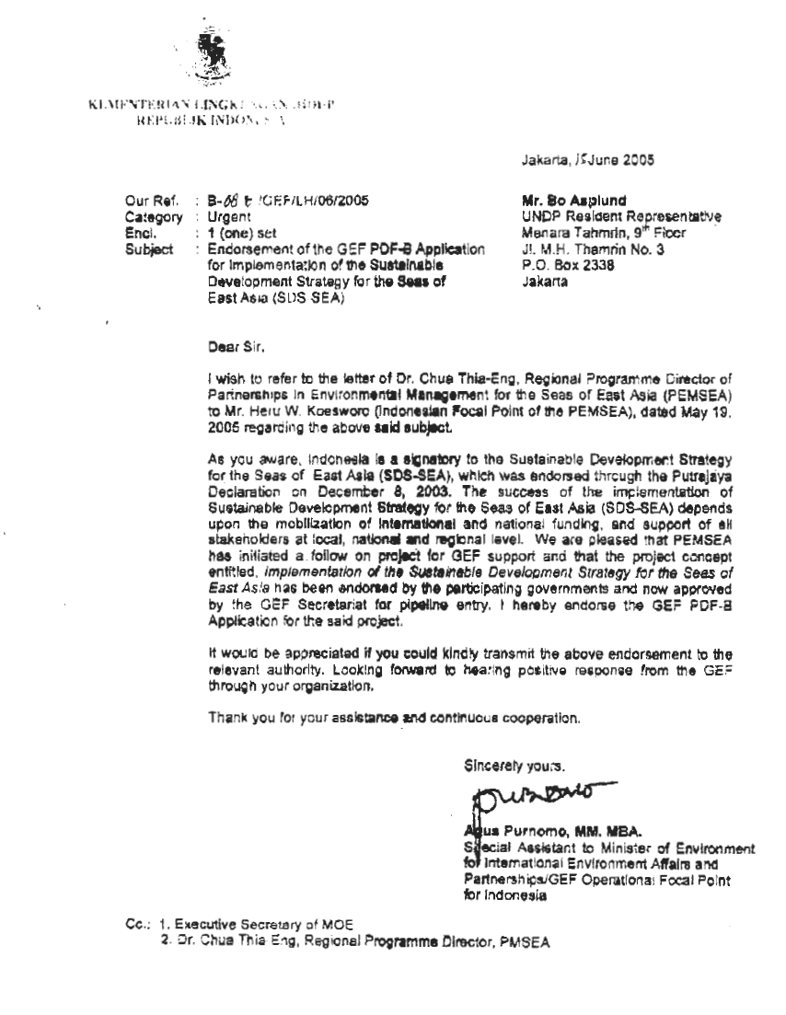
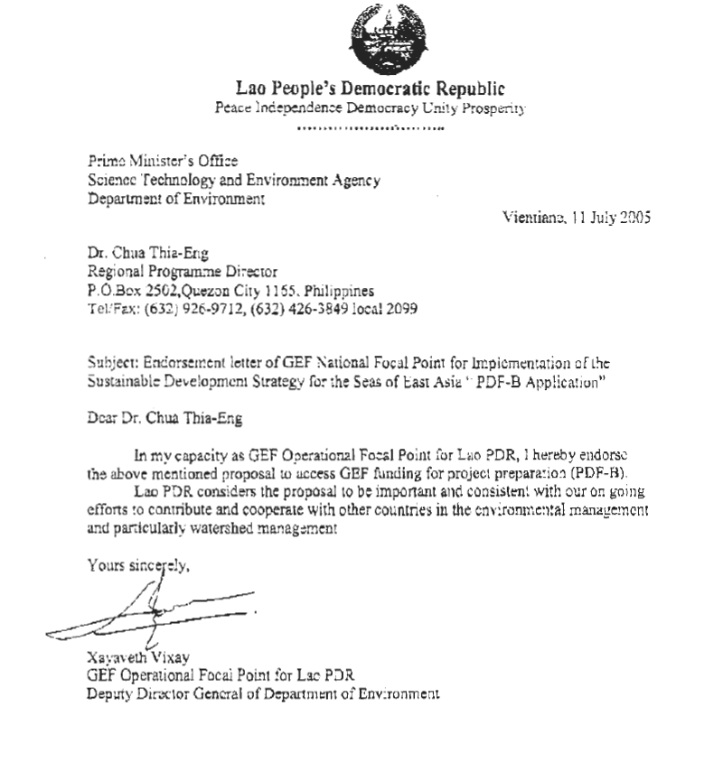
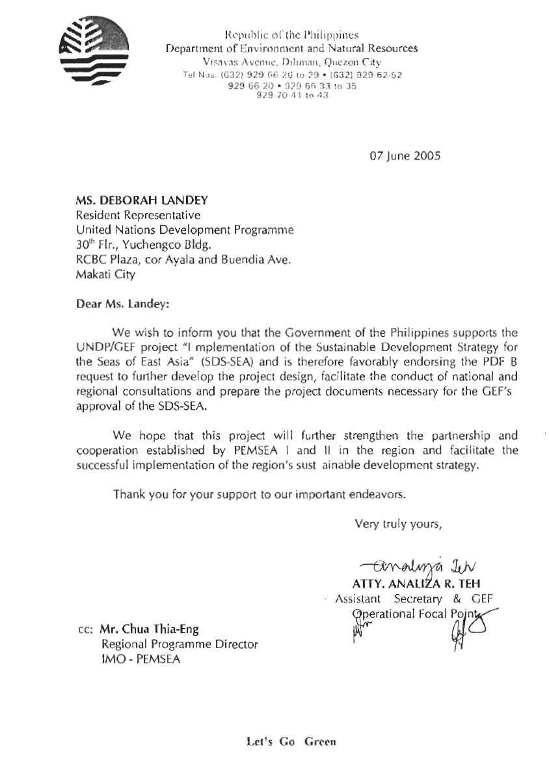
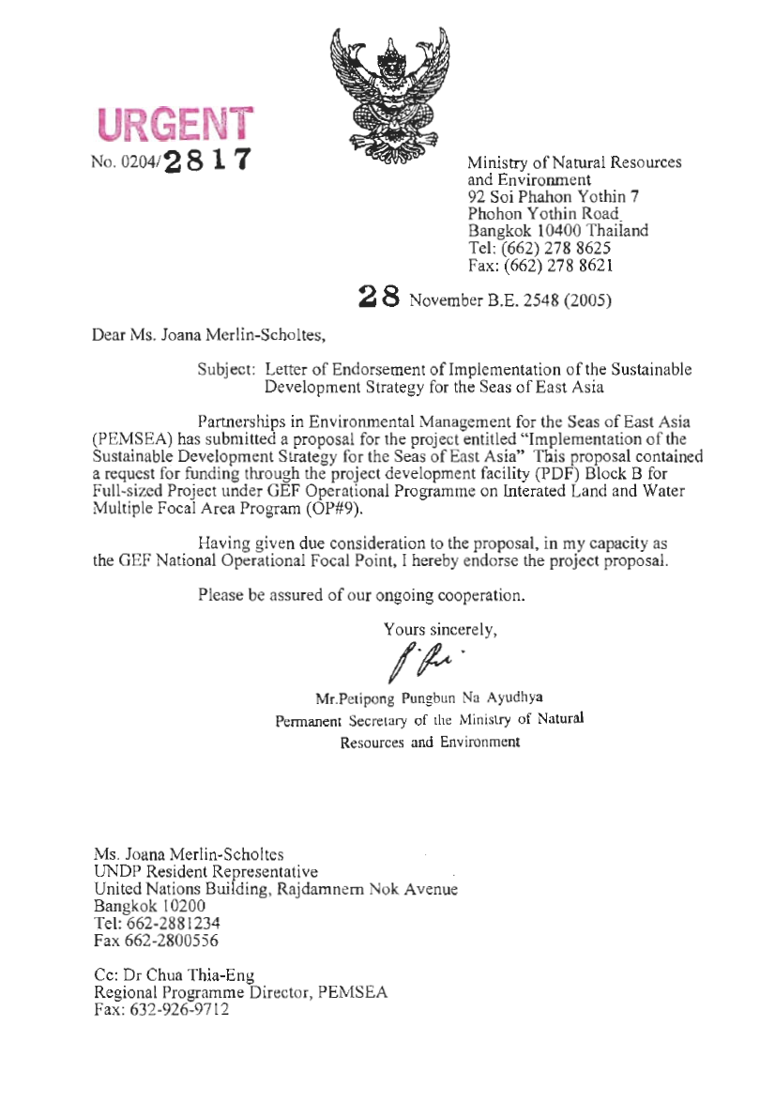
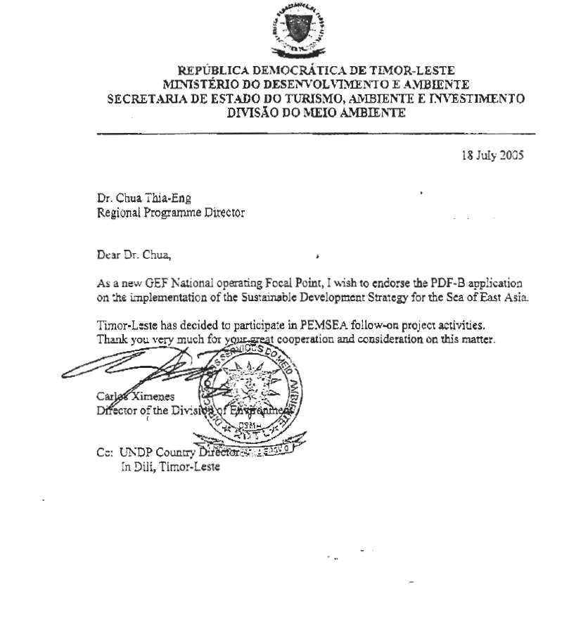
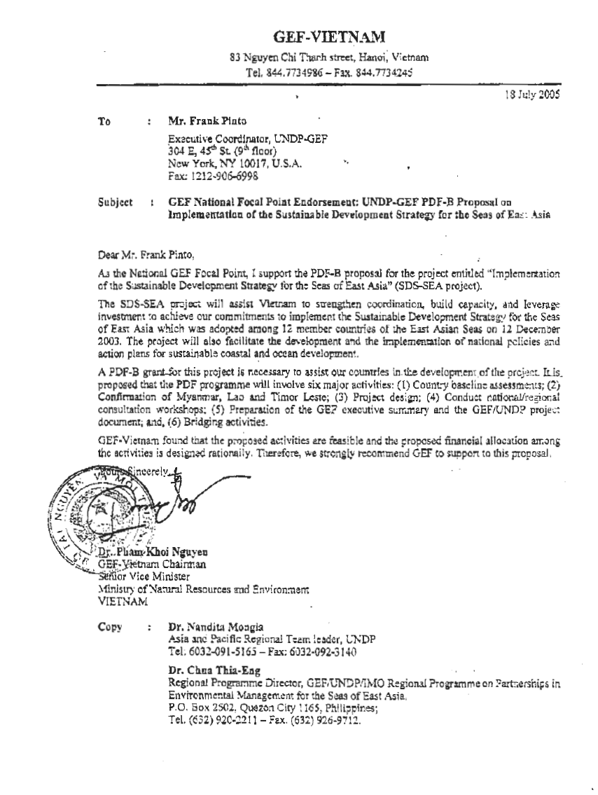

The 6 LME’s include East China Sea, Gulf of Thailand, Indonesian Seas, South China Sea, Sulu-Sulawesi Sea, and Yellow Sea.
Brunei Darussalam, Cambodia, China, DPR Korea, Indonesia, Japan, Malaysia, Philippines, RO Korea, Singapore, Thailand, and Vietnam
GEF/UNDP Strategic Action Programme for the Yellow Sea Large Marine Ecosystem
GEF/UNEP Reversing Environmental Degradation Trends in the South China Sea and Gulf of Thailand
Lao PDR and Timor Leste have responded positively to the invitation. Myanmar has not indicated a willingness to participate in the project at this point in time.
UNDP/GEF MSP on the Development and Implementation of Public Private Partnerships in Environmental Investments
World Bank/GEF PDF B on Partnership Investment Fund for Pollution Reduction in the LMEs of East Asia: Revolving Fund Component

