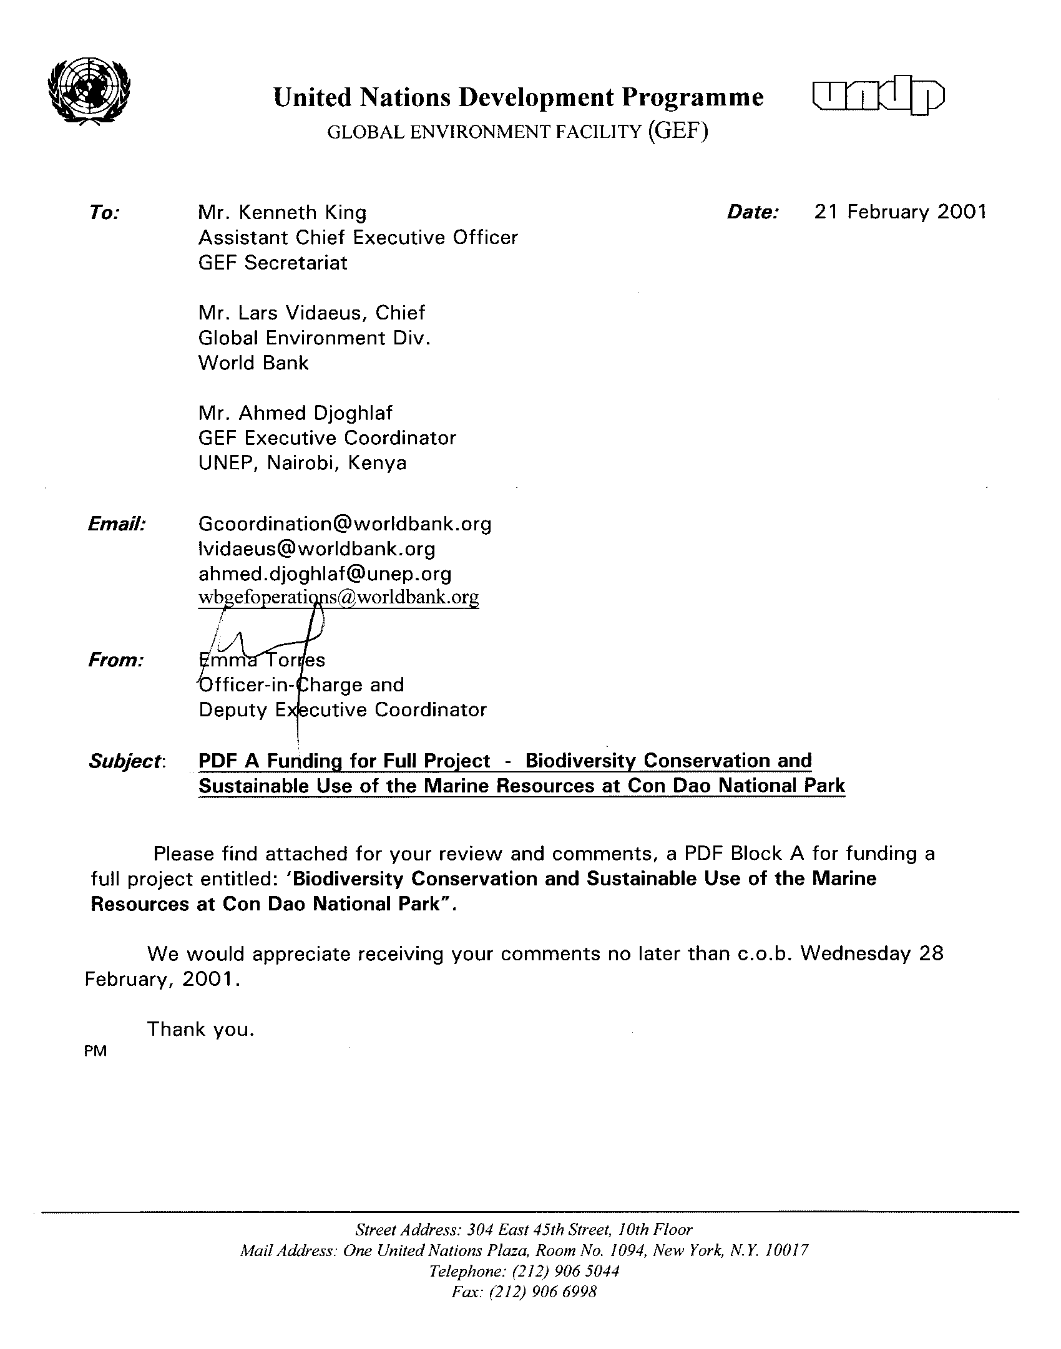
Block A PDF

Part I – Eligibility
1. Project name:  Biodiversity Conservation and Sustainable Use of the Marine Resources at Con Dao National Park | - GEF Implementing Agency:  United Nations Development Program (UNDP)
3. Country or countries in which the project  is being implemented: Vietnam. | - Country eligibility:  CBD Ratification: November 16, 1994  UNCLOS Ratification : June 23, 1994
5. GEF focal area(s), and/or cross-cutting issues: Biodiversity, with relevance to land degradation | 6. Operational program/Short-term measure:  OP2: Coastal, Marine & Freshwater Ecosystems
At a national level, commitment to the project is evident from the fact that Con Dao is specifically identified as a phase I site for implementation of priority activity M18 - Establishment of Coral Reef Protected Areas (M = Management of Important area) in the Biodiversity Action Plan (BAP) for Vietnam which was approved by the Prime Minister 22 December 1995. Conservation of globally significant biodiversity at Con Dao will also contribute to BAP priorities P2 (strengthening environmental law protection), P3 (conservation policy research), and P8 (enforcement of fisheries regulations). Furthermore, at present, a marine protected area (MPA) system is being established in Vietnam, and Con Dao has been chosen as a priority area for MPAs.
Local commitment to the project is evident from endorsement letters received from (1) the province of Ba Ria - Vung Tau and (2) Con Dao National Park (attached as Annex 2).

- GEF national operational focal point and date of country endorsement:
Dr. Pham Khoi Nguyen, Chairperson of GEF Viet Nam: 7 November 2000 (attached as Annex 2)
9. Project Rationale and Objectives

Vietnam has a long coastline of over 3,260km, characterised by a wide range of geomorphological, climatic, hydrological, economic and geopolitical conditions. A broad, shallow continental shelf follows the shape of the land, wide in the north and south and narrow in the middle. Cold sea currents sweep the coast southwards in winter and warm currents sweep north in summer. Coral reefs exist around numerous rocky islands, including Con Dao Island (see map in Annex 1). Some 295 species of corals are recorded in Vietnam waters.

In recognition of its high biological values and diverse environments, Con Dao (located at 8º34' to 8º49'N and from 106º31' to 106º43'E ) has been included in the World Bank list of "Areas of regional priority" in the Global representative marine protected areas in the world (A global representative system of marine protected areas - Volume III -1995). Con Dao is one of the most important areas of Vietnam for preservation and maintenance of coastal and marine biodiversity. There are important ecosystems such as Coral reefs, seagrass beds and mangrove still remaining in a good condition. Aside from important terrestrial biota, surveys by WWF and the Institute of Oceanography in 1994 - 1995 confirmed the species richness of marine plants and animals.

The island group consists of Con Son and 15 smaller islands and islets, with a total land surface of about 76.78km². Con Dao was declared a Protected Forest in 1984. Subsequently a national decree has changed the status to Con Dao National Park and expanded the protected area to include 6,000ha of land, and 14,000ha of marine area slated for strict protection and also a 20,500 ha marine buffer zone.

Con Son is the biggest island, with total area of 51.52km² (with the length of 15km from the east to the west and the width ranging from 1 to 9km). Some large islands include: Hon Ba island (10km²), Hon Bay Canh (5.9km²) constituted by 2 islets joining each other by a sand dune and the most eastern island of the island groups - Hon Cau island (5km²). The others are small (area < 1km²): Hon Troc, Hon Trac Lon, Hon Trac Nho, Hon Tho, Hon Tai, Hon Tre Nho, Hon Tre Lon, Hon Bong Lan, Hon Vung, Hon Anh, Hon Em and Hon Trung.

The whole population of Con Dao district, estimated to be 3,300 in 1972 (source: Encyclopedia Brittanica), is concentrated in the main island - Con Son and is distributed in three main areas: Co Ong, Con Son town and Ben Dam. Con Dao administrative system has only district level (without commune level) and is divided into 9 self-governing residential groups. Con Dao town is located in a semicircular valley with an average altitude of 3m above sea level. It is the economic and social center of Con Dao district.

Natural characteristics

Topographical characteristics:

Con Dao has two main types of topography:

Area of high mountains: includes mountains, which range between 300 meters and 600 meters. The highest one is Thanh Gia Mountain, which is 577 meters high. The sloping degree of the topography is 25 degrees.

Area of valley: there are two main areas, the central area and Co Ong area.

The central area: the land is relatively flat. One part includes hills, which are of low sloping degree. The other part consists of coastal sand strips.

Co Ong area: the land is mostly on strips close to hills. The land is of low sloping degree. Most of the land is sand strips. The ground is rather high.

Geological characteristics

The Con Son islands are mainly constituted by intrusive eruptive formations of various ages. Microgranite, diorites and rhyolite are the main formations in Con Son island. Except for diorite, the same rocks are recorded in other islands: microgranite in Hon Bay Canh, Hon Cau, rhyolite in the others. Cretaceous quartz diorite, grano-diorite and granite are the formations constituting Hon Bay Canh, Hon Cau and Hon Bong Lan islands. The same rocks (but later Mesozoic - early Cenozoic in age) are the main formations in the northern part of Con Son island. In the southern part of Con Son and Hon Ba islands, porphyric granite and microgranite are widely distributed. The age of them is unknown.

Climate characteristics:

Con Dao islands lie near to the equatorial tropical climate affected by monsoon regime. Northeast monsoon dominates from November to April (mean wind velocities vary from 4 to 5m/s), the Southeast one from June to September (mean wind velocity: 4-4.5m/s). Intermediate wind prevails in May and October with the velocity ranging from 2-3m/s; the direction is variable.

The dry season is short (November-April). Annual mean rainfall is 2.100mm (1.900mm - 94% - in wet season). Maximum monthly rainfall occurs in October (355mm).

The annual mean temperature is 26.9ºC. The highest monthly mean air temperature occurs in May (30.9ºC), mean for April and May ranging from 28-28.3ºC. The annual mean humidity is 80%, this value ranging from 80-84% in rainy season. The average evaporation ability is 1,033.7 mm.

Hydrological characteristics

Underground water sources:
Underground water sources are mainly in Con Son valley. The forming source is that rainwater falls down and is kept in the sand layer of the valley. This sand layer is thick from 12 to 20 meters.

Surface water sources:
The springs, distributed principally on the West side, pour water directly to the sea. They are nearly exhausted in the dry season.

Main lakes:
An Hai lake: southwest of Con Son town, the area is 40ha, the average depth of water is 1.50 meters.
Quang Trung I lake: the area is 20 ha, the depth of water is 1.20 to 1.50 meters. The water capacity is 200,000 m³. A lot of humus is formed on the bottom of the lake.
Muong Ky lake: the area is 8 ha, the depth of water is 1.0 to 1.50 meters. A lot of humus is formed on the bottom of the lake. The depth of water in the dry season is about 0.3 to 0.5meter.
Other lakes: Quang Trung II lake (15 ha), Co Ong (2.5ha), Suoi Ot, Dam Trau, San bay.
Seawater temperature varies in the range 25.67-29.21ºC. Highest values encountered in May and June (26.42 - 30.22), lowest one in January and February (25.25-28.7ºC).

Con Dao forests have 882 plant species belonging to 562 genus and 161 families including 44 species found nowhere else in Vietnam. Total area covered by forests in Con Dao is approximate 6000ha. There are 144 vertebrate species including 28 mammals, 69 birds, 39 reptiles and 8 amphibians. More than 1300 species of marine flora and fauna are recorded in Con Dao coastal area. Con Dao has many rare and precious animal and plant species including 44 species recorded in the Vietnam Red Data Book (2 algae, 2 mangroves, 3 corals, 12 mollusks, 1 crustacean, 4 echinoderms, 7 fish species, 7 reptiles, 5 birds and 1 mammal). Apart from that, there are probably 1,000 species recorded that are useful economically for food, export, handicraft, medicine, and tourism. Nesting colonies of birds nest swiftlets (Collocalia. francica) also occur on some of the offshore islands.

With special regard to the marine reptiles and mammals, there are endangered species such as

Green turtle Chelonia mydas is classified as endangered in the Vietnam Red Data Book, listed as endangered in the IUCN Red List of Threatened Animals, and listed in CITES Appendix I.

Hawksbill turtle, Eretmochelys imbricata, is classified as endangered in the Vietnam Red Data Book, listed as critically endangered in the IUCN Red List of Threatened Animals, and listed in CITES Appendix I.

The two species of Leatherback and Loggerhead turtles are also found in the area but no nesting sites are recorded:

Leatherback turtle Dermochelys coriacea is classified as endangered in the Vietnam Red Data Book, listed as endangered in the IUCN Red List of Threatened Animals, and listed in CITES Appendix I.

Loggerhead turtle Caretta caretta is classified as vulnerable in the Vietnam Red Data Book, listed as endangered in the IUCN Red List of Threatened Animals, and listed in CITES Appendix I.

It can be said that Con Dao has the biggest population of marine turtles in Vietnam.

Dugong Dugong dugong, is classified as endangered in the Vietnam Red Data Book, listed as critically endangered in the IUCN Red List of Threatened Animals, and listed in CITES Appendix I.

Giant Clam (Tridacna spp) is still found in a density considered as the highest in the reef waters of the region. It is classified as endangered in the Vietnam Red Data Book, also listed as critically endangered in the IUCN Red List of Threatened Animals, and listed in CITES Appendix I.

Threats to Biodiversity

It is an area of scenic attraction as well as of high historic and symbolic value to Vietnam. Off the coast of southern Vietnam and the mouth of the Mekong River (one of the biggest rivers in the Asian continent), it is strategically located in an area of high fisheries production and intensive fisheries pressure. It is being considered as a servicing location to the offshore oil industry. It has, at least by preliminary judgement, strong potential for tourism development, including its feasibility to be on the Asian regional cruise ship routes. Vietnam has done major infrastructure planning on the basis of this potential and infrastructure development has already started.

Impacts of unsuitable tourism

A tourism development plan for Con Dao has been developed without EIA and consideration of the limited water and other natural resources. Besides, pollution, habitat destruction due to tourism activities and the construction of tourism infrastructure can also cause damage to biodiversity.

At present, tourist visitation to Con Dao remains relatively small in number, with most visits during the months of April to July when the dry season makes travel by boat to and among the islands more reliable. However, Con Dao has a big potential for tourism because it possesses many natural and historical attractions and tourism is considered as one of the key economic activities of this island district. To develop tourism in Con Dao requires infrastructure construction that may well cause coastal erosion, loss of habitats, increase of sediment in seawater and degradation of coastal ecosystems (coral reefs, seagrass beds, mangrove, etc.). More domestic waste will be discharged into the coastal waters, and coral reefs will be damaged by anchorage and contact. Some species will be harvested more intensively for souvenirs and tourism services. Besides, the island groups will face a lack of freshwater.

Operation of the port and sea transportation

Transportation by sea and operation of sea port are a potential threat to the marine environment if these activities there are not well controlled in order to avoid pollution and habitat destruction.

Ben Dam port is planned to be a big seaport combined with a service center. A seafood processing enterprise is also going to be built in this area. The operation of the port, service center and the enterprise will contribute pollution sources such as oil, organic, solid waste and even heavy metals to the coastal waters.

In addition, the operation of vessels transporting cargo, food and construction materials to Con Dao have more or less affected its environment and marine resources, particularly where operations are concentrated in near wharves, swamps and bays near the Con Son island.

Besides, fishing boats from other provinces often come to Con Dao to take on fuel and ice, and repair boats or engines. When there are rough seas or strong winds, they often seek shelter close in among Con Dao islands. The anchorage of these boats causes coral breakage and death, inshore pollution due to trash and waste discharge, as well as the oil floating from anchored fishing boats.

Infrastructure building and urban development

Infrastructure construction and urban development without attention to environmental protection on the island could impact marine biodiversity.

The marine areas of Con Son are quite distant from the mainland shore of Vietnam and therefore there does not appear to be the same impacts felt from activities on the mainland. On the main island of Con Dao there is currently neither an industrial base of large scale nor a large population. Therefore pollution due to industrial and human waste has not become serious as yet. However, in recent years, improvement of the coastal road system, the building of a new sea port as well as other construction activities, have led to a situation of erosion and sedimentation which has adverse effects on near island coral reefs as well as other ecosystems.

The concentration of population, production activities and services in the areas around Con Son town, Ben Dam, Co Ong will also place more pressures on the marine resources and ecosystems.

Overfishing and destructive fishing activities

Over-fishing and destructive fishing is one of the most serious threats to the biodiversity resources in Con Dao. Most local fishers report significantly lower catches in recent years and/or more effort required to catch species that were easily caught before.

Con Dao is an important fishing ground and fishing has become one of the key economic activities in Ba Ria Vung Tau province. It is the fishing ground for not only local fishermen but also outsiders (from other provinces, even from neighboring countries). In recent years, fishery harvesting has been carried out more intensively, which is illustrated by the increase in the number of fishing boats and the size of the horsepower of their engines.

Statistical Data on the number of fishing boats

-----------------------------------------------------------------------------------------------------
Year Number of boat Power (CV)
-----------------------------------------------------------------------------------------------------
1992 2538 94.096
1993 2795 103.747
1994 2935 114.928
1995 3025 122.428
1996 3338 151.053
1997 3670 185.529
1998 4047 240.263
-----------------------------------------------------------------------------------------------------

The marine area surrounding Con Dao is suffering from the pressure of fisheries harvesting. The use of anesthetic agents (cyanide) to exploit live grouper around the island has appeared during the recent years. Capture production is sharply going down and much more effort is required to catch species, which were easily caught 10 years before.

Non-resident fishing boats also fish, using most or all of the gear types on board, within nearshore waters where regulations already prohibit these activities. Some gear types, such as trawling, if used on or near coral reefs, can be extremely destructive.

Oil exploitation

Con Dao is situated within an important national oil exploration and exploitation center i.e. the continental platform of southeast Vietnam. Con Dao is close to petroleum shipping routes that run through the Straits of Malacca, and therefore pollution caused by catastrophes is a real threat. In recent years, shoreline pollution due to the crude oil has appeared in Con Dao. This type of crude oil pollution has had noticeable effects on certain marine resources and the environment in the marine areas of Con Dao.

Besides, two petroleum companies (BP and Statoil) are going to build pipe lines from Lan Tay and Lan Do mines to the island to collect gas and sell it to Petro Vietnam. Con Dao district is going to build a service center including port and mechanical factory at Ben Dam area to support oil exploitation in the future.

ROOTCAUSE OF THREATS

Lack of environmetal awareness

Many of the threats described above, such as over-fishing, unsustainable tourism and inappropriate infrastructure development, result at least partially from a widespread lack of environmental awareness among all groups of stakeholders. For example, the District Master plan to 2010 approved five years ago at the highest national level recommended a series of activities without any environmental analysis. It didn't introduce specific conservation goals and objectives into planning of the area, and encourage an overall regional objective of sustainable use of the marine and coastal resources.

Lack of regulations and weak enforcement of existing regulations

Although Con Dao has been defined as a national park including the marine area but marine protected areas and marine biodiversity conservation are still new in Vietnam. The marine protected areas and relevant regulations are on the process of being set up.

There are some regulations regarding fish protection but they are not well understood nor obeyed by local people as well as outsiders. If they are cited for violations, they simply pay the fine and continue their activities because the fine is too low-the amount of fish harvested easily compensates them for fine levied.

Over the past years there has been coordination and cooperation between the park and local border control units, armed forces and fisheries resources protection unit. Although these efforts produced some results, they have not really been implemented in a clear and comprehensive manner. As yet the potential for an integrated full strength force for implementing and enforcing regulations in connection with resource and environmental conservation in the entire island district has not been realized.

Lack of management capacity in marine biodiversity protection

The same as all other existing protected areas in Vietnam, Con Dao National Park is under technical supervision of Forest Protection Department, Ministry of Agriculture and Rural Development. The management board's staff of Con Dao National Park has been trained for forestry and forest protection. They haven't got marine biology and marine protection background. Their experience is related to the work done with WWF through Marine turtle conservation project and the project Coastal and Marine environmental management in the South China Sea (East Sea) phase II, implemented by WWF and the ADB.

Lack of integrated coastal and marine management capacity

The Con Dao District Master plan took very little concern over the environment. Con Dao is an example where general planning was done at the time when environmental impact assessment was not formally required in Vietnam (i.e. prior to 1995) and the marine sector was considered for economic development only. All the components of this Master Plan concentrating on infrastructure building (port, roads, etc.) and population development were developed without any analysis of existing ecosystems and limited resources in Con Dao. They all will cause the major threats to the environment and biodiversity resources and lead to unsustainable development in the long run.

Lack of marine management zoning

The environmental management plan and marine functional zoning plan developed under the ADB-demonstration Project on Con Dao have not yet been implemented. This still creates the open access activities in the marine zones for all sectors and individuals so that there are difficulties in controlling economic and development activities in the coastal and marine areas. These activities could cause bad impacts to species habitat and ecosystems.

Porvety and lack of community participation in biodiversity conservation

The local communities as well as outsiders treat marine biodiversity resources as essentially common property resources. The demand for their basic needs and income generation has encouraged the maximum exploitation of marine biodiversity resources. It is both because of the lack of understanding in long-term sustainable yield, values of biodiversity and conservation and the lack of alternative livelihood support.

Population pressure

In the District's Master Plan, the areas around Con Son town, Ben Dam and Co Ong will be the center for production activities and services. The population will be more concentrated in these areas. According to the Master Plan, the population of the whole island may grow 5 fold to 15,000 in 2010. It will place tremendous pressure on the natural resources and environment.

Project Rationale and Objectives:

Problem statement

The marine areas of Con Dao National Park hold great biodiversity value. The co-existence of coral reefs, seagrass ecosystems and wetlands and the ecological relationship among them, create a favourable environment for the reproduction, hatching and protection of many marine species. This favours conservation of these offshore resources, which are very important for the sustainable development and exploitation of marine resources within the large fishing ground in the southeast of the country. The existence of certain rare zoological species like dugong, sea turtle, dolphin, greenwhale and certain other marine species provide an important opportunity for the conservation of marine biodiversity. That's why it is necessary to conserve marine biodiversity in Con Dao National Park for both economic and scientific values.

At national level, the regulator regime for the protection and management of marine biodiversity is incomplete. Regulator regime to manage the productive coastal and marine resources have been made without the necessary shift in the basic policy regime toward sustainable coastal and marine resource management and away from coastal and marine resource development and exploitation.

The fact that Con Dao National Park's management board is under Forestry Protection Department shows that it is an inappropriate management structure for a protected area conserving both terrestrial and marine areas. All technical staff have been trained in forestry/ forest protection background and have received technical assistance from the Forestry Protection Department for forest conservation task. They absolutely lack the capacity to implement marine conservation task.

Besides, there are a number of organizations enforcing maritime regulations but there are no legal agreements defining cooperation and coordination among these organizations. In case of Con Dao, the Park, local border control units, armed forces and fisheries resources protection unit are all responsible for marine resources management but to a different extent. The cooperation among those agencies has not been really close and doesn't meet current requirements for effective management of a broad marine area. Although many efforts have been made, implementation of the marine conservation remains inefficient.

Con Dao is an important fishing ground for this district as well as Ba Ria Vung Tau province and even neighboring provinces and countries. Fisheries harvesting is one of the most popular economic activities in Con Dao. Many households meet their basic needs by harvesting important marine resources beyond long-term sustainable limits and by expanding activities into areas that are environmentally sensitive. This put even more pressure on any conservation work.

Goal: The effective conservation of biodiversity of Con Dao islands and the surrounding marine resources

Objectives:
- To implement the management plan for marine areas of Con Dao National Park by developing programs of planning, zoning, boundary demarcation, park infrastructure and human resource development.
- To monitor biodiversity and marine resources, and to rehabilitate the ecosystem degraded by natural catastrophes and human impacts
- To encourage community participation in biodiversity conservation through education, awareness and joint development of livelihood support programmes.
- Develop communications strategy, education and awareness programmes for use with fishing and other coastal communities as well as local officials, and implement programmes.
- Implement a livelihood support program in the communities in Con Dao district
- Build capacity and knowledge of management, administrative and technical staff in the protected area
- To develop a demonstration for use in Vietnam for management of protected areas including both terrestrial and marine components

Baseline Scenario

The administrative structure of the district is slightly different from that of other district. They are administered from Ba Ria - Vung Tau province, but the Prime Minister and other high level authorities have an interest in the island because of its historical significance.

The Con Dao administrative system has only district level (without commune level). The district economic development zones include the areas where approximately 3,000 permanent residents live (i.e. Con Son town) as well as the area around Co Ong airport and a small area along the east coast of Ben Dam where a fishing port is being constructed. Local inhabitants are divided in 9 self-regulating residential groups.

The lands within the park are administered separately by the District of Con Dao. Con Dao National Park is under the administration of Ba Ria - Vung Tau Province for personnel, but is under MARD (Ministry of Agriculture and Rural Development) for management of the Park and its resources. The Park sometimes works on specific project separately, but informs the Con Dao District People's Committee of their activities. Park funding comes from the province through the Ministry of Finance. Additional funds can be allocated from MARD.

Environmental management in Con Dao district is the responsibility of the Economic Department. Three staff are responsible for industry, handicrafts, tourism services, natural resources, environment planning and management in this department. In fact, they lack the necessary human resources and manpower to implement their task.

There are existing regulations for fishery protection such as: Ordinance on the Conservation and Management of Living aquatic resources issued in 1989, decree No 48-CP on August 12, 1996 on the handling of administrative violations to State management in fisheries resources protection, etc. The fisheries protection team under Fisheries and Agriculture Department is responsible for enforcement of this regulation. The responsibility of this department with regard to fisheries is to develop aquaculture as well as to conserve fishery resources, especially during the breeding season or harvesting through destructive fishing methods. Enforcement is carried out by boat patrols, however the manpower and boat patrols are insufficient and after Typhoon Linda, their patrol vessels were destroyed. They do not have the budget to purchase or charter replacement vessels.

The Government of Vietnam has been promoting policies and plans related to environmental protection, fisheries and biodiversity conservation. The Biodiversity Action Plan for Vietnam has especially emphasized issues related to integrated coastal zone management, strengthening the management of protected areas, and marine pollution monitoring and control. Con Dao has been selected as a pilot Marine Protected Area for Vietnam in the Biodiversity Action Plan. IUCN are implementing a World Bank/GEF-supported marine protected area project in Hon Mon. The two projects are complementary, since they are located in different biogeographic zones of Viet Nam.

The future of Con Dao district and Con Dao National Park are influenced to a large extent by national level economic planning, which earlier generated a 1993-2000 comprehensive master plan for the District. This is the only district master plan in Vietnam to require and receive approval at this highest level, reflecting political leadership in the future of Con Dao.

The 14 islands of Con Dao Archipelago were declared a Special Use Forest on 1 March 1984 by decision 85/CT of the Prime Minister and include some 5,400ha of forest and a non-specified marine buffer zone extending to 4km from the shoreline. On 31 March 1993, the status and size of reserve was changed to a National Park. The new Park included an area of 15,400ha of which 6,400ha were terrestrial and 9,000ha comprised of marine component. In 1998, in the investment project to develop Con Dao National Park - Phase II (1998-2002), approved by Ba Ria Vung Tau province, the marine biodiversity conservation area of the park was expanded to 14,000ha, with an additional 20,500ha designated as marine buffer zone. With the technical and financial support from the demonstration project as a part of the ADB regional project for marine and coastal environmental management in the South China Sea, phase II, Con Dao National Park was chosen as a pilot site to do marine zoning in Vietnam. A marine zoning plan including eight functional zones (strict protection zone, fisheries conservation zone, marine tourism zone, fisheries rehabilitation zone, dugong conservation zone, sea turtle conservation zone, sustainable harvest zone and anchorage zone) is waiting for approval and seeking financial support for implementation.

Management of Con Dao National Park: The existing management board is under the Forest Protection Department and understandably they lack expertise or training in marine conservation and marine protected area management.

A number of smaller initiatives have been completed around Con Dao National Park for biodiversity conservation. Some investment in the National Park infrastructure and staff, as well as in the staff of Institute of Oceanography has been made. This has been by different donors, over a period of years in cooperation with WWF. This work has confirmed the global importance of the area, and future work will benefit from this solid foundation. However the area now needs a more integrated, planned and comprehensive investment in order to deal with the increasing threats from infrastructure development, population pressure, increased fishing activities and collection practices, tourism, lack of local knowledge, capacity and government resources.

- Expected outcomes:

GEF Alternative

Under the GEF Alternative, a holistic integrated coastal management approach will be used in analyzing impacts and ecological cost of development activities, and the ecological costs of development activities which will then incorporated into the existing Master Plan. This will ensure inter-sectoral coordination in planning and will be supported by a strong programme in capacity building to enable local authorities to assess the impacts of development decisions. For example, oil exploration and infrastructure will not be halted, but the conditions will be created to ensure that planning and implementation of these activities take account of environmental issues in general, and biodiversity conservation in particular. The project will create the capacity and enabling environment to transform the management structure of Con Dao National Park from a terrestrial protected area into a more integrated terrestrial and marine protected area.

Conditions for sustainable management of natural resources and conservation of biodiversity will require a more complete scientific basis for marine management and conservation, thus a number of surveys and associated studies need to be carried out. These activities will also contribute to building capacity and skills in marine biodiversity and conservation, monitoring marine resources and environment; knowledge of oceanography and methods to study marine resources; and knowledge about management of marine conservation are important for effective in marine conservation in the immediate as well as distant future.

Conservation communication and education activities need to be properly developed to provide stakeholders with the information necessary to attract their support and/or participation and cooperation in implementation of the marine zoning plan and other conservation activities. Environmental awareness will be conducted for local people so that they could support and participate in conservation activities.

In addition to building awareness and capacity, there will still be the need for policing and patrolling. Near-shore policing will be promoted through community-based activities, while the Coast Guard and Navy will be engaged in order to support more wide-range patrolling. This will contribute not only to overcoming problems associated with over-fishing, but also problems related to shipping.

Alternative livelihood programs will be provided for households which are supporting themselves by inshore net trawling, thus negatively affecting the seagrass habitat and probably disturbing the normal life of dugong and sea turtle.

- Planned activities to achieve outcomes:

Incrementality of GEF Intervention
The GEF would finance activities relating to the conservation of globally significant biodiversity, that could not be justified in terms of Vietnam’s own sustainable development interests. Co-financing would be secured to complement gaps in the baseline to finance sustainable development activities. The GEF would finance activities relating to the establishment of and strengthening of the management of conservation set asides and limited demonstrations of ways and means of overcoming barriers to sustainable use of biodiversity. Specifically, in relation to the possible project activities described in the next section, GEF funding would be applied predominantly to the following project components:
- Development and implementation of inter-sectoral development plans that incorporate biodiversity conservation.
- Participatory enforcement and biological/socio-economic monitoring; and
- Awareness and training;
while the remaining project components: sustainable economic alternatives; and the development of long-term financing mechanisms; would be largely supported through co-financing.

Expected outcomes and activities of Full Project:

- Improved enforcement of legislation and regulations affecting marine resources management of Con Dao National Park
- Conserve the biodiversity in Con Dao especially for marine resources and conservation of endangered species in Con Dao such as marine turtles and dugong
- Improved human capacity, infrastructure and facilities to meet management requirements.
- Strengthen policy, institutional and legal framework
- Community participation in conservation management
- Improved living standards of local communities through livelihood initiatives and therefore less need for unsustainable resources extraction
- Lessons learned for other marine protected areas in Vietnam and the region

Planned activities to achieve outcomes

- Resource assessment and surveys
- Clear management plan including zoning
- Park boundary establishment
- Protection and enforcement program
- Ecosystem rehabilitation
- Livelihood support, community development, and community participation in resource management
- Sustainable ecotourism development
- Public awareness, environmental education, communications programs developed and implemented for different interest groups
- Resource monitoring
- Improved management and administration
- Relevant training and capacity building for different interest groups, study tours - liaison with WWF Philippines Marine Conservation Programme, possible staff exchanges.
Operations and maintenance
12. Stakeholders involved in project:
The government host agency will be:
Con Dao National Park under the Forest Protection Department of MARD, with the support of the Ba Ria -Vung Tau provincial authorities and Con Dao district authorities.

The primary subcontractor to implement the project will be:
World Wide Fund for Nature (WWF) Indochina Programme

Partners
1. Governmental agencies:
- Fishery Protection Department (FiPD), Ministry of Fishery
- Department of Resettlement and New Economic Zones, Policy Department, Ministry of Agriculture and Rural Development (MARD)
- National Environmental Agency within the Ministry of Science, Technology and Environment

2. Local level
- Local communities
- Ba Ria - Vung Tau province Peoples Committee
- Management Board of Con Dao National Park
- Peoples Committees of Con Dao District
- Departments of Agriculture, Fishery and Forestry within the Departments of Science, Technology and Environment of Ba Ria - Vung Tau province

3. Research institutes and Universities:
- Nha Trang Institute of Oceanography (NTIO)

Part II – Information on Block A PDF Activities
13. Activities to be financed by the PDF: US$
Consultation workshops (national and local) 4,000
Translation of materials/reports into Vietnamese/English 500
Local travel and field expenses for development of the project,
including formulation of the incremental costs analysis 17,500
Formulation of FP brief 2,500

Total (money request from GEF) 24,500

WWF co-financing of PDF-A activities
Administrative/logistical support 1,000
Scientific, technical and environmental reviews 1,000

14. Expected outputs and completion dates:
Outputs to be completed in 6 months:
- Scientific, technical and environmental reports reviewed: month 1
- Draft project month 2 and 3
- Consultation workshops conducted (national and local): month 4
- Revision full project document month 5
- Final project brief translated into Vietnamese/English: month 6
15. Other possible contributors/donors and amounts:
In kind contribution from WWF of baseline co-financing and some specific project activities.
Potential sources of co-financing such as Danida, USAID to be verified during PDF-A activities.
- Total budget and information on how costs will be met (including the Block A grant):
PDF-A GEF: US$ 24,500
Full-Size GEF Project (est.): US$ 1,714,000
Co-financing WWF (in kind) US$ 500,000
Co-financing Government (in kind): US$ 300,000
Co-financing others: US$ 400,000
Total: US$ 2,938,500

Part III – Information on the Applicant Institution
- Name:  World Wide Fund for Nature (WWF)  WWF Indochina program  Address: 53 Tran Phu street, Ha Noi, Viet Nam  Tel: (844) 733 8387  Fax: (844) 733 8388  Email: eric@wwfvn.org.vn and  hien@wwfvn.org.vn |  | - Date of establishment, membership, and leadership:  Date of establishment: 1961 and in Viet Nam in early 1980s  Country representative: Mr. Eric Coull
19. Mandate/terms of reference:  Established in 1961, WWF is the world’s largest and most experienced private international conservation organization with over 5.2 millions members and a global network active in 96 countries.  WWF aims to conserve nature and ecological processes by:  - preserving genetic, species, and ecosystem diversity;  - ensuring that the use of renewable natural resources is sustainable both now and in the longer term, for the benefit of all life on Earth;  - promoting actions to reduce to a minimum pollution and the wasteful exploitation and consumption of resources and energy.  In 1991, WWF decided to expand its activities in Viet Nam and an office was set up in Ha Noi. Since then, the Indochina Programme office has coordinated the growing portfolio of projects in the country, established relations with NGOs involved in nature conservation in Viet Nam, and facilitated the provision of funds and technical assistance for various field-level activities. It also helps to manage and expand projects in Cambodia and Laos by working with WWF offices in Vientiane and Phnom Penh.  The presence of the WWF office in Hanoi has enabled the organization to respond more quickly and effectively to local conservation needs. Today, WWF's strategy involves helping to develop a functional network of well-managed protected areas, encouraging more sustainable resource-use patterns, minimizing the negative environmental impact of economic development, promoting conservation awareness, and building local expertise in nature conservation. |  |  | 20. Sources of revenue:.  Major sources of revenue are come from WWF members and international donors.
21. Recent activities/programs, in particular those relevant to the GEF
WWF was the first international non-government organizations (NGO) to work in Viet Nam for conservation. Representatives from WWF first came to Viet Nam in early 1980s and established a permanent office in Hanoi in 1991.
Since 1985, together with IUCN, WWF help develop a national conservation strategy for Viet Nam. It has served as a foundation for many of the conservation initiative operating in Viet Nam today.
Beginning in 1993, WWF implement a GEF project for education and capacity building. The project has been the core of WWF's efforts to assist and build capacity in Viet Nam's conservation sector. During the 6-year project period, nearly 2,000 conservation officials from all 61 provinces in Viet Nam received training in variety of field courses, study tours, international short courses, and graduate degree fellowships. Three GEF field centers have been set up in Cuc Phuong, Bach Ma, and Cat Tien national park.
From 1995 to 2000, WWF implemented a nature reserve conservation project with funding from the Royal Netherlands Government where the new large mammal species Sao La had been found. The conservation project has the twin aims of nature protection and management, as well as sustainable development of residential communities in the buffer zone of the reserve.
Since 1997, WWF has executed the 5-years Cat Tien National Park project. The park's best known resident is the Javan Rhinoceros (Rhinoceros sondaicus), the most endangered large mammal in the world. WWF also implements a lot of small grants to support conservation in Viet Nam and implements several regional project to encourage cooperation on conservation in the region such as:
Subregional Biodiversity Forum for Cambodia, Laos, Viet Nam and Thailand; and
Coastal and marine environmental management in the South China Sea including Cambodia, Viet Nam and the provinces of Quangxi and Hainan in China.
Since the beginning of 2000, WWF execute the Strengthening Protected Area Management Project. This project aims to support FPD to strengthen management objectives and strategies, institutional and regulatory systems and create a financial framework for the National Protected Area System.

Regarding Con Dao National Park, WWF became involved in the conservation activities of the Park in 1995 when a successful Sea Turtle conservation project was begun and extensive staff training carried out. Since then, WWF has supported the park annually with further marine conservation training. In 1997, Con Dao was struck by Typhoon Linda, which caused extensive damage to forest, coral reef, and seagrass ecosystems. WWF continues to support post-typhoon marine resource assessment through the training of Park staff in monitoring techniques. The development of infrastructure for ecotourism has also been a priority and some of the recommendations made in a WWF-supported Ecotourism Management Plan have been taken up and approved in a government ecotourism plan. More recently WWF has begun a program for training Park staff and selected members of the District government in environmental communication techniques. In 1999 and 2000, Con Dao was chosen to be a demonstration project site for an ADB regional technical assistant project on coastal and marine environmental management in the South China Sea. The project was implemented in Viet Nam by GEC and WWF. With this demonstration project, three components of ecotourism, marine zoning and district environmental management planning were first time tested in Viet Nam at the protected area and district levels.

The proposed project is complementary to the ongoing World Bank GEF-supported marine protected area project in Hon Mon because it addresses both terrestrial and marine biodiversity conservation, covers ecosytems not covered in the Hon Mon project, and is formally part of the national park protected area system.

Part IV – Information to be completed by Implementing Agency
22. Project identification number:
23. Implementing Agency contact person: Tim Boyle, GEF Regional Co-ordinator BD/IW, RBAP. tim.boyle@undp.org
24. Project linkage to Implementing Agency program(s): This project is in line with UNDP Vietnam's focal area on Environment and Natural Resources Management. UNDP has been helping Vietnam develop approaches that ensure sustainable use of natural resources. Currently, Vietnam is together with Laos, Cambodia and Thailand participating in a GEF regional project entitled "Mekong River Basin Wetland Biodiversity Conservation and Sustainable Use Program" (RAS/97/G42). The proposed project will cooperate with the regional project in Mekong wetland in sharing knowledge, information and lessons learned. There will also be opportunities for linkage with a UNDP/GEF MSP intervention in the Red River Delta.

On environmental issues in Vietnam, in close cooperation with the government, UNDP works on:

- Improving the national regulatory framework and incorporating incentives and self-regulatory tools in environmental management;
- Training policy makers on the relationship between economic and environmental policies;
- Promoting public awareness on environmental issues; and
- Mitigating natural disasters.

Emphasis will continue to be placed on the prevention aspects of environmental policy and on a more integrated approach to environmental protection and economic development. With regard to the objective of incorporating environmental concerns into decision-making, in order to complement ongoing efforts to promote voluntary compliance with environmental protection standards (through environmental awareness, education and training), UNDP will assist the Government in further developing environmental legislation and regulatory instruments for sound environmental management. Assistance will also be provided for environmental valuation, monitoring and reporting and assessment of policies and programmes. Indicators of success will include the fuller incorporation by the Government of environmental concerns into investment and public policy decision-making, including at the local level, as measured by the introduction of market-based instruments, strengthened environmental compliance, increased awareness of decision makers and increased budget allocations.

Besides the environment, the two other areas in which UNDP provides assistance to the Government of Vietnam are poverty elimination and social policies, and reform and development management. Both the specific themes of the environment sector, and the general goals of the other two sectors are obviously highly relevant to the proposed project. Thus, a substantial amount of UNDP’s core resources of over $40 million will serve as co-financing towards the full project.

ANNEX 1
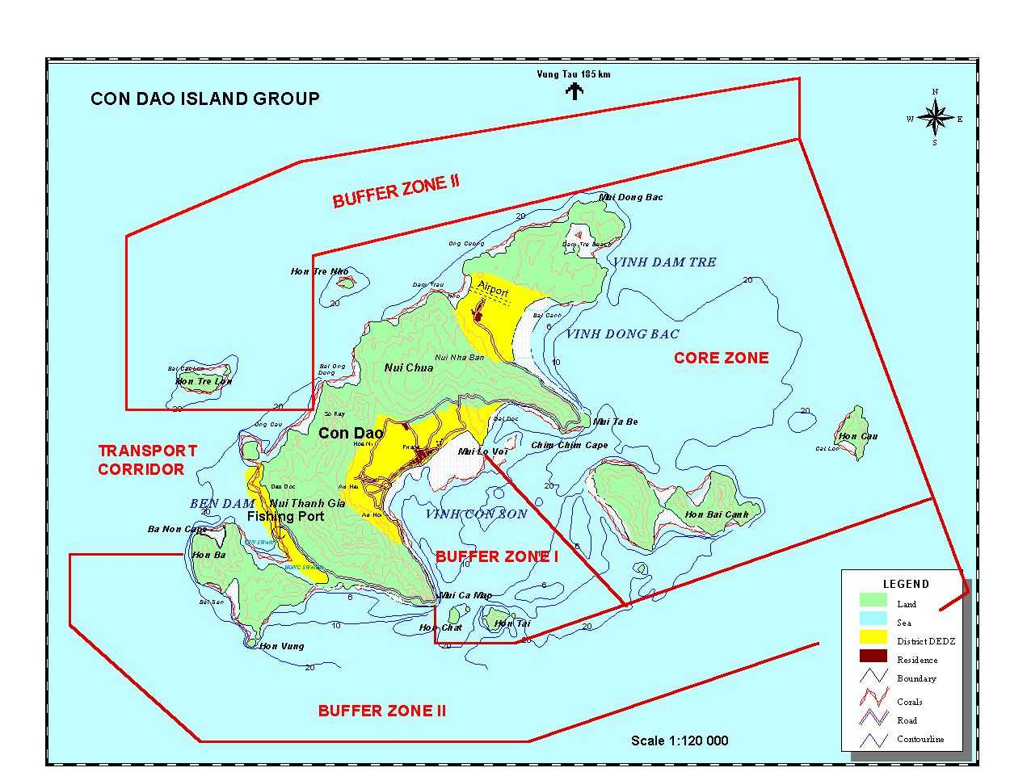
Map of Con Dao N.P.
ANNEX 2

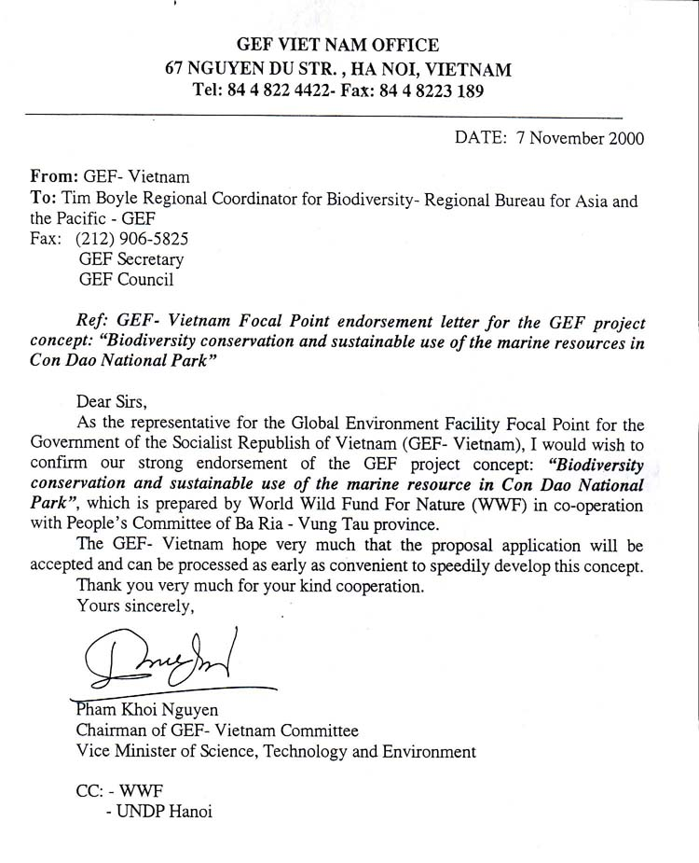

Provincial People's Committee of Ba Ria Vung Tau  CON DAO NATIONAL PARK  No: 50A/VQG.TH  Re: Cooperating to implement the "Biodiversity Conservation and Sustainable Use of Marine Resources in Con Dao National Park" Project | SOCIALIST REPUBLIC OF VIETNAM  Independence- Freedom- Happiness  ________________________  Con Dao, August 21st, 2000

To: Provincial People's Committee of Ba Ria Vung Tau

The Marine area of Con Dao National Park has been evaluated as an area of high potentials and biodiversity benefits which are not only valuable for science and tourism purposes but also for maintaining and development of fisheries resources in southeast Vietnam.

During the recent years, the Con Dao National Park has been able to maintain an effective cooperation with World Wide Fund for Nature (WWF) Indochina Programme - Vietnam Office, in conservation of Con Dao nature. In order to continue and promote this cooperation, to strengthen the capacity in marine conservation in Con Dao, the Con Dao National Park cooperates with WWF Indochina Programme to propose project: "Marine biodiversity Conservation and Sustainable Use of Marine Resources in Con Dao National Park". UNDP- the Implementing agency for Global Environmental Facility (GEF) - has expressed its consensus to the concept of this project and required a full project proposal for submitting to UNDP, Ministry of Science, Technology and Environment MOSTE) and Ministry of Planning and Investment (MPI) for review and approval.

Con Dao National Park would like to report to the Provincial People's Committee (PPC) of Ba Ria Vung Tau and requests the PPC allow the Park to cooperate as well as to present the PPC's opinion to the related Ministries so that the project will be fully accepted and deployed.

With Best Regards.
Director of Con Dao National Park
(sealed and signed)
Le Xuan Ai
To: As above
WWF Vietnam
As achieve
PROVINCIAL PEOPLE'S COMMITTEE  OF BA RIA VUNG TAU  No: 2860/UB-VP  Re: "Biodiversity Conservation and Sustainable Use of Marine Resources in Con Dao National Park" Project | SOCIALIST REPUBLIC OF VIETNAM  Independence- Freedom- Happiness  ________________________  Vung Tau, August 22nd, 2000

To: Ministry of Science, Technology and Environment
Ministry of Planning and Investment
National GEF Committee of Vietnam

Con Dao island - in Ba Ria Vung Tau province - is a well-known place for its historical and cultural vestiges as well as natural values that need to be conserved and developed.

The fact that Con Dao National Park works in cooperation with the World Wide Fund for Nature (WWF) Indochina Programme to propose the project: "Biodiversity Conservation and Sustainable Use of Marine Resources in Con Dao National Park" is necessary and relevant, especially to be overcome and promptly recover the marine ecosystems in Con Dao National Park that were strongly affected by the Linda storm in 1997.

The Provincial People's Committee (PPC) of Ba Ria Vung Tau highly appreciates the projects and activities that WWF Vietnam Office has been implementing in cooperation with Con Dao Nation Park and Binh Chau Phuoc Buu Nature Reserve within the in the province locality. These projects have contributed an important part in the efforts to conserve and develop biodiversity resources of the province. Therefore, Ba Ria-Vung Tau PPC is fully in consentaneity to support for the cooperation between the Con Dao National Park and WWF Vietnam Office in proposing and implementing the project "Biodiversity Conservation and Sustainable Use of Marine Resources in Con Dao National Park".

We would like to request the Ministries and National GEF Committee to kindly consider and support for the project to be implemented.

On behalf of the Ba Ria Vung Tau PPC
P.P the Chairman
Vice Chairman

(sealed and signed)

Tran Minh Sanh

To: As above
WWF Vietnam
Con Dao National Park
As achieve in Administration Unit and Filings

A summary report: TheVietnam Biodiversity Action Plan-three year review Workshop, 1998
Document 135 TTg of the Prime Minister.

