BLOCK A PDF
MAKING THE LINK: THE CONNECTION
AND SUSTAINABLE MANAGEMENT OF KON KA KINH AND KON CHA RANG NATURE RESERVES

PART I – ELIGIBILITY
1. Project name:  Making the link: the connection and sustainable management of Kon Ka Kinh and Kon Cha Rang Nature Reserves | 2. GEF Implementing Agency:  United Nations Development Programme UNDP
3. Country in which the project is being implemented: Vietnam | 4. Country eligibility:  Convention on Biodiversity ratified in 1994
5. GEF focal area(s), and/or cross-cutting issues: Biodiversity | 6. Operational programme/Short-term measure:  OP 12: Integrated Ecosystem Management
7. Project linkage to national priorities, action plans and programmes:
As of August 2000, this project concept is included as a "highest priority project" within Vietnam's new national GEF strategy.

Kon Ka Kinh and Kon Cha Rang Nature Reserves were rated priority B in the 1995 Biodiversity Action Plan for Vietnam (GEF Project VIE/91/G31).

New investment plans for Kon Ka Kinh and Kon Cha Rang Nature Reserves, revising and expanding the original protected areas, were submitted by Gia Lai People's Committee and approved by the Ministry of Agriculture and Rural Development (MARD) in 1999 and 2000 respectively.

A proposal to expand Kon Ka Kinh and Kon Cha Rang Nature Reserves further is contained within the revised list of Special-use Forests, currently awaiting endorsement by the Government. The same recommendation is made in Wege et al. (1999)¹ and by MacKinnon (1990)².

An investment plan for Kon Ka Kinh Nature Reserve was recently completed under the European Union-funded project entitled, Expanding the protected areas network in Vietnam for the 21st century, jointly implemented by the Forest Inventory and Planning Institute (FIPI) and the BirdLife International Vietnam Programme.

By addressing improved management of degraded forest land, this project supports the Government decree 661, also know as the Five Million Hectares Reforestation Programme.
_________________________
¹ Wege, D. C., Long, A. J., Mai Ky Vinh,Vu Van Dung and Eames, J. C. (1999) Expanding the protected areas network in Vietnam for the 21st century: an analysis of the current system with recommendations for equitable expansion. Hanoi, Vietnam: BirdLife International Vietnam Programme.
² MacKinnon,J.R. (1990) Forestry sector review: tropical forestry action plan, Vietnam. The nature conservation system, national parks and protected areas. Hanoi, Vietnam: Ministry of Forestry, UNDP and FAO (VIF/88/037 Technical Report 3)
8. GEF national operational focal point and date of country endorsement:
Dr. Pham Khoi Nguyen, Chairperson of GEF Viet Nam: 22 November 2000

9. Project rationale and objectives:
Kon Ka Kinh and Kon Cha Rang Nature Reserves were selected for survey by the Forest Inventory and Planning Institute (FIPI) and the BirdLife International Vietnam Programme. During 1999, FIPI and the BirdLife International Vietnam Programme researched and prepared project investment documents for both sites. These two, almost contiguous, forest areas are located in northern Gia Lai province, in the Central Highlands of Vietnam. These two sites were prioritised for survey for the following reasons:

- Both sites were included on Government of Vietnam decree number 194/CT, which officially established the system of Special-use Forests (protected areas system), and both sites were ranked as priority B in the Biodiversity Action Plan.

- Both sites were biologically poorly known (their ranking as priority B was a provisional and subjective assessment made prior to any comprehensive biological survey of either site).

- The height of Kon Ka Kinh Mountain (1,748 m asl) and its geographical isolation from other high peaks in the Central Highlands, indicated it may support undescribed endemic fauna and flora.

- The geographical position of Kon Ka Kinh Mountain mid-way between the Kon Tum Plateau and Da Lat Plateau centers of endemism (termed Endemic Bird Areas by BirdLife)¹, indicated this site could be of biogeographical importance.

Conservation importance
The FIPI/BirdLife programme of fieldwork has shown that the conservation importance of the two protected areas is significantly higher than was previously believed, based on the following findings:

- Kon Ka Kinh Nature Reserve supports a range of montane forest formations and vegetation types, contrasting with Kon Cha Rang Nature Reserve, which supports lowland/montane transitional habitats and vegetation types. Thus, their landscapes and habitat types are complimentary.

- Kon Ka Kinh Nature Reserve includes a 2,000 ha plateau supporting mixed coniferous and broad-leaved forest, dominated by the globally threatened conifer Fokienia hodginsii.

- Kon Cha Rang Nature Reserve supports an extensive tract of undisturbed riverine forest. This ecotone is seriously under represented in Vietnam's protected area system.

- In terms of biodiversity, Kon Ka Kinh and Kon Cha Rang Nature Reserves are complimentary.

- Fresh Tiger Panthera tigris tracks were found at both sites. These are the only two of three protected areas in Vietnam at which Tiger has been positively identified in the last two years. The presence of Truong Son Muntjac Muntiacus truongsonensis was confirmed at Kon Ka Kinh Nature Reserve. This species was recently described and is known only from a single other protected area.
_________________
¹ Stattersfield, A.J., Crosby, M.J., Long, A.J. and Wege, D.C. (1998) Endemic birds areas of the World: priorities for biodiversity conservation. Cambridge, UK: BirdLife International

- A previously undescribed taxon of laughingthrush, Garrulax, and up to eight undescribed butterfly taxa were discovered on Kon Ka Kinh Mountain.

- Kon Ka Kinh and Kon Cha Rang Nature Reserves are only 12 km apart and are linked by intervening forest areas currently under the management of two state forest enterprises (Tram Lap and Dak Rong).

Conservation urgency
The project investment plans for Kon Ka Kinh and Kon Cha Rang Nature Reserves have recently been approved by the Government of Vietnam thus creating two new protected areas. However, the integrity of the two protected areas is threatened by the on-going loss of forest within the two nature reserves, and by the continued clearance of forest and the subsequent settlement of land, in the two state forest enterprises that lie between the two protected areas.

Analysis of vegetation data shows that an area of 8,247 ha, equivalent to 20% of Kon Ka Kinh Nature Reserve has been degraded by past commercial logging activities and continuing illegal timber extraction. A further 12,286 ha or 29% of the nature reserve, has been cleared at one time or another by commercial logging or shifting cultivation and now supports a range of secondary vegetation types.

Within the nature reserves and the two intervening state forest enterprises, exploitation of forest resources is occurring at unsustainable levels. Although the human population density within the state forest enterprises is less than 20 people/km², this area is an increasing focus for spontaneous migration from other parts of Vietnam, particularly the northern provinces. For instance, in 1997 and 1998, a total of 413 migrants settled in Lo Ku commune, amounting to 17% of the current population of the commune. Migration poses two major threats to these two nature reserves. Firstly, it increases pressures on natural resources within the protected areas. Secondly, since both sites are individually too small to support viable populations of larger mammals, the clearance of forest land between them will inevitably result in local extinctions. New equilibriums of biodiversity will be established below that which they currently support. The two nature reserves will then have a lower international conservation value.

The Gia Lai People’s Committee (the proposed grant recipient), FIPI and BirdLife (who will provide technical support for implementation) strongly believe that the amalgamation of both sites into a single conservation management unit will prevent local extinctions of globally threatened species, and the overall conservation gain will be significantly greater than if the two sites were to be managed separately.

This claim is based on the widely accepted principle that larger protected areas can support greater species diversity than smaller protected areas ¹.

Both protected areas are situated within the same administrative unit (province), and given their close proximity to one another, their administration as a single unit would be more cost-effective for Gia Lai People’s Committee. Although amalgamation would increase the overall conservation area, the edge-to-area ratio would diminish, meaning a reduced commitment of scarce forest protection resources.

The biological and financial case, therefore, for maintaining forest cover between Kon Ka Kinh and Kon Cha Rang Nature Reserves is strong. How that may be best achieved will be the focus of the PDF-A. Obvious options for consideration include: developing a sustainable forest management strategy for the intervening secondary forest areas comprising Tram Lap and Dak Rong State Forest Enterprises, and using timber revenues derived to underwrite the long-term management costs for the two protected areas; and/or the incorporation of all or part of the two state forest enterprises into the two nature reserves.

An advantage of the first option would be that a matrix of habitats could be maintained between the two nature reserves, which will enhance overall levels of biodiversity. Provided that a sustainable forest management regime could be implemented, revenues could be used to make the nature reserves self-financing. The success of such an approach would be conditional on preventing human settlement in the state forest enterprises. Such an approach would provide a model for sustainable forest management and income generation for protected area management that would be applicable elsewhere in Vietnam. This management mechanism would be new in the Vietnamese context. In order to achieve this, the technical expertise of a commercial timber company would be required. The introduction of a certification scheme accrediting the timber as being from a sustainable source, would assist conservation and long-term forest management interests in Vietnam and provide an important commercial marketing opportunity. An additional advantage of this approach would be that, if there were a sufficient standing volume of timber of commercial interest, a commercial forestry company could provide project co-funding. Thus a commercial co-funder would have a unique opportunity to play a major role in an innovative approach to biodiversity conservation, sustainable resource-use and mitigation of global warming, through sequestration of carbon.

The second option would create a much larger protected area, which would have significant conservation benefits. However, a long-term financing strategy for the protected area is less obvious and a potential opportunity for project co-financing would be lost.

The PDF-A activities will determine the project approach based on an assessment of sustainable timber values in the intervening area and the preference of the Gia Lai Provincial People's Committee. Regardless of the option chosen, the project will include sustainable management of forest resources by improving the sequestration of carbon and enhancing soil and water conservation as a means of green-house gas reduction and land degradation improvements.

We are now faced with a unique opportunity which will never re-occur. Kon Ka Kinh, and Kon Cha Rang Nature Reserves are newly established and provide “clean slates” for introducing solid conservation management techniques. Both protected areas are in good condition and support extensive tracts of primary habitats. However, the intervening secondary forest area is threatened by non-sustainable forestry and agricultural practices which can only increase as in-migration proceeds. We are now presented with a window of opportunity to make a lasting contribution to biodiversity conservation in Vietnam and the world.
________________________
¹ Diamond, J. M. (1975). The island dilemma: lessons of modern biogeographic studies for the design of natural reserves. Biological Conservation. 7: 129-146

Objectives:
- Through consultation with all stakeholders, research, produce and implement a management plan for the project area, incorporating Kon Cha Rang and Kon Ka Kinh Nature Reserves and Tram Lap and Dak Rong State Forest Enterprises.

- Raise awareness of the need for, and generate support amongst stakeholders for, sustainable management of the project area.

- Through training and provision of infrastructure and equipment, build the capacity of the nature reserve authorities, comprising Gia Lai Forest Development and Protection Departments, along with Tram Lap and Dak Rong State Forest Enterprises.

- Develop effective enforcement to prevent settlement, encroachment and illegal exploitation of natural resources in the project area.

- Elaborate, promote and implement sustainable forest management strategies, including carbon sequestration and soil and water conservation, that will directly enhance the conservation of biodiversity, reduce green-house gas emissions, and decrease land degradation in the project area.

- Create synergies within local government, especially by linking the provincial Forest Development and Protection Departments and the state forest enterprises which will promote better biodiversity conservation and green-house gas reduction.

- Integrate the project area into wider social and conservation development visions by changing the preferential policies for new migrants in the project area.

10. Expected outcomes:
- A management plan for Kon Cha Rang and Kon Ka Kinh Nature Reserves, and Tram Lap and Dak Rong State Forest Enterprises, based on the principle of sustainability, prepared and implemented.
- Local community support for management plan implementation generated.
- Enhanced capacity amongst the provincial Forest Development and Protection Departments and state forest enterprises to manage the project area.
- Government endorsement of the management plan.
- Reduced levels of encroachment and non-sustainable use of the nature reserves.
- Sustainable forest management of the Tram Lap and Dak Rong State Forest Enterprises.
- Better conservation management in Gia Lai province.

11. Planned activities to achieve outcomes:
- Biological survey of the nature reserves, and Tram Lap and Dak Rong State Forest Enterprises.
- Silvicultural assessment of Tram Lap and Dak Rong State Forest Enterprises.
- Formulation and implementation of a management plan, incorporating appropriate sustainable forest management strategies using participatory methods to engage and understand the interests and aspirations of local stakeholders, particularly Tram Lap and Dak Rong State Forest Enterprises.
- Conduct a training needs assessment and design and implement a training programme for provincial Forest Development and Protection Departments and Tram Lap and Dak Rong State Forest Enterprise staff.
- Engage local communities and government in a process to raise awareness and incorporate local concerns into the nature reserves' management.
- Promote the approval of the management plan at provincial and central government levels.
- Provide financial and material support to Gia Lai Forest Development and Protection Departments to facilitate the establishment of protected area infrastructure in Kon Cha Rang and Kon Ka Kinh Nature Reserves.
- Creation of a project board of trustees to ensure implementation of the management plan.

12. Stakeholders involved in project: Relevant communities in K’bang and Mang Yang Districts, Tram Lap and Dak Rong State Forest Enterprises, Gia Lai Forest Development and Protection Departments, Gia Lai Provincial People's Committee, and all government, bi-lateral and multi-lateral organizations, NGOs, and commercial interests concerned with natural resources management in Gia Lai Province.

PART II – INFORMATION ON BLOCK A PDF ACTIVITIES
13. Activities to be financed by the PDF:
- Conduct a literature search and review of existing information on the protected areas and state forest enterprises, and government plans and proposals in the project area and province.
- Conduct a needs assessment among district and provincial institutions charged with natural resources management and conservation in the project area.
- Conduct a preliminary silvicultural assessment of Tram Lap and Dak Rong State Forest Enterprises.
- Conduct a preliminary biodiversity assessment of Tram Lap and Dak Rong State Forest Enterprises.
- Hold a workshop in the provincial capital, Pleiku, to review planning and development initiatives in the project area and review project content.
- Identify those project inputs which will measurably improve conservation of biodiversity in the project area.
- Draft project documents.
- Ensure all institutional and operational procedures and responsibilities are clearly elaborated in an MoU between Gia Lai People’s Committee and BirdLife International.
- Incorporate reviewer's comments and submit proposal to GEF Secretariat.

14. Expected outputs and completion dates:
Completed project proposal as required (including logical framework, work plan and terms of reference) within 4 months. Note that the contribution from BirdLife can only be provided prior to 28/2/2001. Beyond that date BirdLife will not have financial resources to conduct the preliminary biodiversity assessment.
15. Other possible contributors/donors and amounts: The BirdLife International Vietnam Programme is currently exploring two sources of co-financing. It is proposed that regional components of the new BirdLife project to be submitted to the European Commission, addressing biodiversity components within the Government of Vietnam's project 661 (the 5 Million Hectares Reforestation Programme) would be one source of co-financing. A second source could be ScanCom and the Tropical Forest Trust, providing there is sufficient standing timber volume. Gia Lai People's Committee is expected to make contributions in-kind.
16. Total budget and information how cost will be met (including the Block A grant):
GEF PDF-A: US$ 24,500
GEF: US$ 950,000
Co-financing: European Commission US$ 200,000, ScanCom/Tropical Forest Trust US$ 500,000; Government of Vietnam US$ 20,000.
TOTAL: US $ 1,670,000

Budget for Block A grant

Items |  | Total (US$) | GEF | BirdLife | ScanCom/TFT
Consultant services
Conservation planner (expatriate) |  | 9,000 | 9,000
Conservation planner (local) |  | 1,200 | 1,200
PRA specialist (local) |  | 1,200 | 1,200
Forest management specialist (expatriate) |  | 10,000 |  |  | 10,000
Forest management specialist (local) |  | 1,200 |  |  | 1,200
Conservation biologist (expatriate) |  | 7,000 | 1,000 | 6,000
Conservation biologist (local) |  | 1,200 |  | 1,200
Consultation
Workshops |  | 800 | 800
Liaison with government |  | 3,000 | 2,000 | 1,000
Translation and administration |  | 2,000 | 2,000
Communications |  | 700 | 400 | 300
Development of Project Brief |  | 3,000 | 3,000
Travel
International travel |  | 2,700 | 1,200 |  | 1,500
Local flights ( Hanoi-Saigon-Pleiku) |  | 2,000 | 500 | 1,000 | 500
Vehicle hire |  | 2,400 | 800 | 800 | 800
Misc. field costs/ equipment |  | 400 | 400
Per diems for field team |  | 4,000 | 1,000 | 2,500 | 500
Coordination
Staff time |  | 1,027 |  | 1,027
Total |  | 52,827 | 24,500 | 13,827 | 14,500

PART III – INFORMATION ON THE APPLICANT INSTITUTION
17. Information on the applicant institution:  - Gia Lai People’s Committee is the provincial governing body for Gia Lai province. Its agencies, the Forest Development Department and Forest Protection Department, are designated by the Ministry of Agriculture and Rural Development to manage state-owned forests, including Special-use Forests, such as Kon Ka Kinh and Kon Cha Rang Nature Reserve, and state-owned forest enterprises.  - BirdLife International is a global conservation federation with a worldwide network of partner organizations, representatives and committed individuals. In Vietnam, BirdLife implements a conservation programme from a representative office located in Hanoi, in collaboration with ministries, research institutions and local government, focusing on the identification and establishment of protected areas. BirdLife has a long history of association with the sites that are the subject of this proposal.  - It is agreed by Gia Lai People’s Committee and BirdLife International that Gia Lai People’s Committee will be the Applicant Institution for this medium-sized GEF application. It is further agreed that BirdLife International will be the recipient of the PDF Block A grant. | 18. Date of establishment, membership, and leadership:  1. People's Committee was established in 1975 based on a decision issued by Government of Vietnam.  Chairman of the Gia Lai People's Committee:  Nguyen Vi Ha  Vice-chairman: Le Viet Huong  Office address: 01 Hai Ba Trung  Pleiku, Gia Lai Province  2. The rights and obligations of BirdLife International Vietnam are stipulated in the Regulations on the Operation of Foreign Non-Governmental Organizations in Vietnam promulgated in accordance with Decision No. 340 TTg dated 24 May 1996 of the Prime Minister of the Socialist Republic of Vietnam.  The BirdLife International Vietnam Programme Permission No. 035/UB-GP, issued by PACCOM on 15/11/1997  Mailing address:  #11, Lane 167, Tay Son  Dong Da, Hanoi  Vietnam  Tel/Fax: 84 4 8517217  Programme Manager: Jonathan C. Eames
19. Mandate/terms of reference:  1. Gia Lai People's Committee  - To organize, introduce and implement regulations, and laws of the Government of Vietnam.  - To ensure and protect the quality of life for the people in Gia Lai province  2. BirdLife International Vietnam Programme  Mission statement  The BirdLife International Vietnam Programme seeks to promote the conservation of habitats, sites and species by working with government and non-government partners to:  - Provide support for improved planning and management of important habitats, sites and species;  - Introduce and advocate new ideas for integrating biodiversity conservation into planning and policy;  - Stimulate greater public interest in birds and biodiversity, and awareness of the need for biodiversity conservation;  - Develop capacity for improved management of habitats; sites and species; and  - Provide information on biodiversity and protected areas to planners, policy makers and other interest groups. | 20. Source of Revenue:  1. Gia Lai People's Committee derives its budget  from central government in Hanoi and from provincial sources.  2. BirdLife International Vietnam Programme is funded by the European Union, Royal Netherlands Embassy, Royal Danish Embassy, Danida, and the World Bank.
21. Recent activities/programs, in particular those relevant to the GEF:
The BirdLife International Vietnam Programme has recently received a PDF Block A grant, via the World Bank, for development of a project to address the conservation of Chu Yang Sin Nature Reserve in Dak Lak province.
PART IV – INFORMATION TO BE COMPLETED BY IMPLEMENTING AGENCY
22. Project identification number: VIE/
23. Implementing Agency contact person: Craig Leisher, Environmental Advisor, United Nations Development Programme, 25-29 Phan Boi Chau, Hanoi, Vietnam.
Telephone: (84 4) 8257 495/ Ext. 163. Fax (84 4) 8259 267. E-mail: leisher@undp.org.vn

Website: www.undp.org.vn
24. Project linkage to Implementing Agency program(s): UNDP in Vietnam works to assist the government alleviate poverty, achieve rational and sustainable use of natural resources, and to mainstream environmental concerns in sectoral activities. This project will address the needs of the people in the project area, conserve endangered and potentially valuable biological resources, and work with local government to plan rational management.

Annex 1: Letter of Endorsement
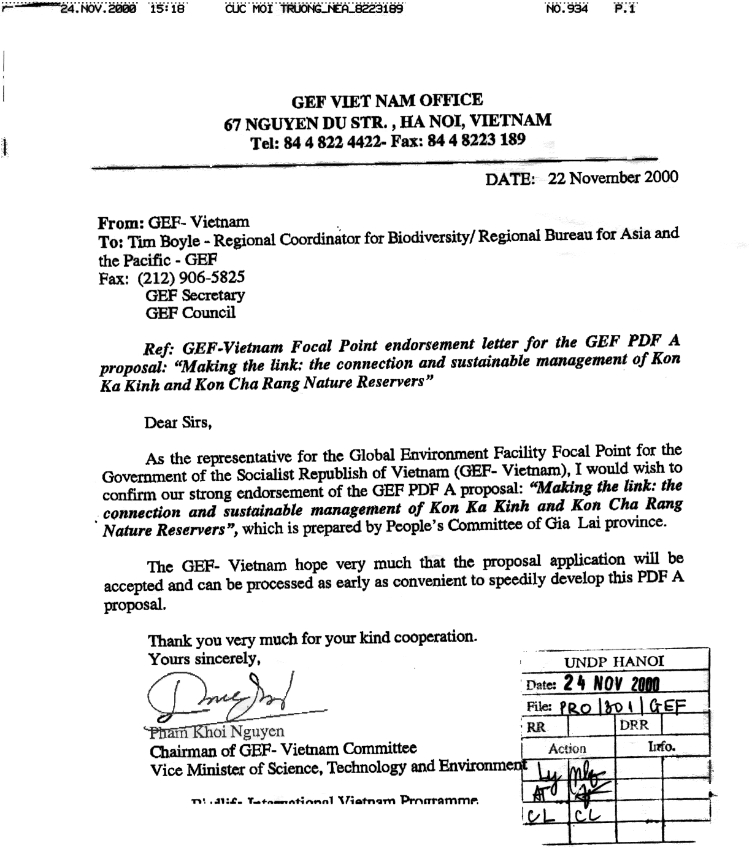
Annex 2: Copnceptual Model
Raise awareness of the need for, and generate support amongst stakeholders for, sustainable management of the project area
Elaborate, promote and implement sustainable forest management strategies that will directly enhance the conservation of biodiversity, reduce of green-house gas emissions, and decrease land degradation in the project area
Through training and provision of infrastructure and equipment, build the capacity of the nature reserve authorities, comprising Gia Lai Forest Development and Protection Departments, and Tram Lap and Dak Rong State Forest Enterprises
Create synergies within local government, especially the provincial Forest Development and Protection Departments and the state forest enterprises which will promote better biodiversity conservation
Through consultation with all stakeholders, research, produce and implement a management plan for the project area, incorporating Kon Cha Rang and Kon Ka Kinh Nature Reserves and Tram Lap and Dak Rong State Forest Enterprises
Integrate the project area into wider social and conservation development visions
Develop effective enforcement to prevent settlement, encroachment and illegal exploitation of natural resources in the project area.
Lack of support for and understanding of biodiversity conservation amongst provincial decision makers
Inadequate funding for protected areas
Lack of capacity in protected areas management
Lack of capacity in state forest enterprise management
Management regimes in state forest enterprises
focused on short term gain
No provision for biodiversity conservation or ghg reduction in state forest enterprise management
Kon Tum Plateau EBA not incorporated into provincial planning process
Current controls on settlement ineffective
Protected areas too small
Protected areas discontiguous
Inappropriate management regimes

Settlement of migrants into Kon Tum Plateau EBA
Protected areas separately will not support viable populations of key species
Encroachment
Timber extraction
Use of natural resources by local people unregulated
Declining standing timber volume

Conversion of natural forest to agriculture
Loss of natural forest due to shifting cultivation
Current protected areas unable to adequately conserve biodiversity
Natural resource use in state forest enterprises unsustainable
Loss of biodiversity in Kon Tum
Plateau EBA

Poor enforcement of protected areas management regulations

Poor enforcement of forestry regulations

INTERVENTIONS
UNDERLYING CAUSES

IMMEDIATE THREATS
CORE PROBLEM

